Siegbert E. Lapp appointed new chairman of the supervisory board, company co-founder Ursula Ida Lapp becomes honorary chairwoman
Generational Handover at Lapp Holding AG

Stuttgart, 22 January 2015

The Stuttgart-based Lapp Group has set its course for the future. As of 21 January 2015, the Lapp Holding AG has a new Chairman of the Supervisory Board: Siegbert E. Lapp (62), who was formerly the board member responsible for research and technology. Company co-founder Ursula Ida Lapp (84) was named honorary chairwoman of the supervisory board. “This generational handover is an important step in our long-term succession planning. We are a family business, and we want to ensure this remains the case,” explains Siegbert Lapp.

The new chairman is a passionate businessman and a highly regarded expert in the field of connection technology. Siegbert Lapp has a natural talent for research and technology and, together with his brother Andreas, has created a world-renowned company. As a young man, Siegbert E. Lapp trained as a toolmaker and studied industrial engineering. Following graduation, and after he had worked abroad for various companies in the cable industry, he took up a role within his parents’ company in 1980. The firm was founded in 1959 by his father Oskar Lapp (1921–1987) and mother Ursula Ida. The first company Siegbert Lapp launched himself is today known as Lapp Systems. With numerous patents and inventions, he has since established the Lapp Group as an innovative international company. Lapp is married and has two sons, Alexander and Matthias, who have both already assumed positions within the family business. In his role as President of the “Kind E.V.” association, Lapp has successfully campaigned for better child care facilities near the workplaces of working parents. Speaking about his new appointment within the Group, Lapp says: “I’m looking forward to the challenge and will continue to run the company in the same vein as my parents, doing all that is necessary to ensure the sustainable growth of our family business.”

Ursula Ida Lapp has played a key role in shaping the company since it was founded in 1959. She and her husband Oskar Lapp made history in the German industrial sector and created an internationally renowned company. The success story began in the late 1950s. Oskar Lapp was a brilliant inventor who revolutionized connection technology by developing ÖLFLEX®, the first industrially manufactured connecting and control cable. When Oskar Lapp passed away in 1987, Ursula Ida took over the company’s reins, together with her sons Siegbert and Andreas. Under her leadership, the firm’s internationalization continued at pace. Oskar Lapp had already established the Lapp Group within Europe and the USA, and Siegbert and Andreas now added a number of new companies and production plants in Asia. Today the Lapp Group is one of the leading suppliers of brand-name products and integrated solutions in cable and connection technology. In fiscal 2012/13, it generated consolidated revenues of 830 million euros. Lapp employs around 3,200 people worldwide, has over 18 production sites and more than 40 sales companies, and cooperates with around 100 foreign representatives.

Ursula Ida Lapp will continue to be a part of the business as an honorary member of the supervisory board. She also runs the Oskar Lapp Foundation, together with her sons. The foundation was set up in 1992 in honour of her husband Oskar Lapp, who passed away after a heart attack. It offers young scientists additional incentives to undertake research in the field of cardiology. A 12,000 euro Oskar Lapp Research prize is awarded every year, and every two years the foundation donates 20,000 euros worth of research equipment and materials as part of the Oskar Lapp Scholarship.

Ursula Ida Lapp is not the only board member to announce their departure. After 14 years of service, Heinz Kisgen has also decided to leave the supervisory board. He is succeeded by Dr Hans Schumacher, chairman of the board at Dürr Systems GmbH. Siegbert Lapp’s previous position as head of technology and innovation has been filled by Georg Stawowy (45), who had previously led the Lapp Group’s technology and innovation division as Chief Technical Officer since October 2013.

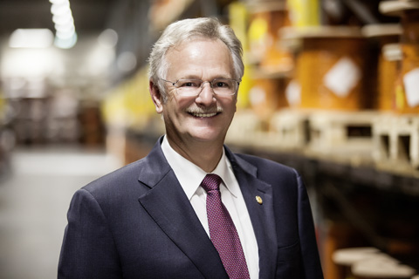
Siegbert E. Lapp was elected Head of the Supervisory Board of Lapp Holding AG
Find the image in printable quality here

Ursula Ida Lapp was named honorary Head of the Supervisory Board
Find the image in printable quality here

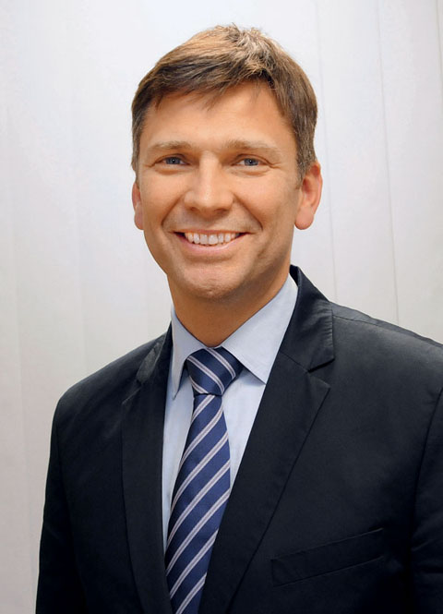
Find the image in printable quality here
www.lappkabel.com/press

About the Lapp Group:
Headquartered in Stuttgart, Germany, the Lapp Group is a leading supplier of integrated solutions and branded products in the field of cable and connection technology. The Group's portfolio includes standard and highly flexible cables, industrial connectors and screw technology, customised system solutions, automation technology and robotics solutions for the intelligent factory of the future, as well as technical accessories. The Lapp Group’s core market is in the industrial machinery and plant engineering sector. Other key markets are in the food industry as well as the energy and the mobility sector.

The Lapp Group has remained in continuous family ownership since it was founded in 1959. In the 2012/13 business year, it generated a consolidated turnover of 830 million euros. Lapp currently employs approximately 3,200 people across the world, has 18 production sites and over 40 sales companies. It also works in cooperation with around 100 foreign representatives.

