Stuttgart-based Lapp Group starts qualification programme for refugees
New apprenticeships for refugees

Stuttgart, 10 January 2016
The Stuttgart-based Lapp Group is taking responsibility in the refugee crisis and has decided to allow nine recognised refugees to train to become machinery and plant operators in the next three years (2016-2018). "If we want refugees to integrate well into our society, businesses also need to take responsibility and give them the chance to do an apprenticeship and work, as work is the key to integration", says Andreas Lapp, Chairman of the Board of Directors, about the family company's commitment. He is also convinced that being around colleagues will not only help refugees learn German quicker, but will also help them better understand the culture. "This gives refugees the best opportunity to find a new home here. We want to do our part", said Andreas Lapp.

The qualified refugees will be selected in the coming weeks in cooperation with German language schools and the Federal Labour Office. German teachers can suggest who would be suitable for an initial one-week internship at the Lapp Group's training centre. Here, applicants must complete a range of theoretical and practical tests. Team games are also planned in order to test cooperation, along with computer training and assembling components. Three refugees will then be chosen to complete the six-month Chambers of Commerce entry qualification this year. This entry qualification will prepare the participants for their machinery and plant operator apprenticeships. The training centre and production division will host seminars, although the courses also require apprentices to attend vocational college classes in German, business studies and social and community studies, as well as E-learning and team training. Three months before the end of the entry qualification, the decision will be made as to whether the participants can begin the standard apprenticeship from August. 2017 and 2018 will each see three refugees given the chance of an apprenticeship at Lapp.

"We understand that refugees need more support in everyday problems than other apprentices who have grown up in Germany or central Europe", explains Chief Instructor Thilo Lindner. Lapp will therefore pay for a season ticket for local public transport, as well as provide assistance for finding accommodation and dealing with the authorities. "We're happy to do this. We want to help and give the refugees prospects for the future with us", says Lindner. Lapp has already had good experiences with refugees. A refugee from Eritrea has been completing the entry qualification since January, and was accepted in September as a regular apprentice. Several refugees were also able to work at Lapp during last summer's holidays.

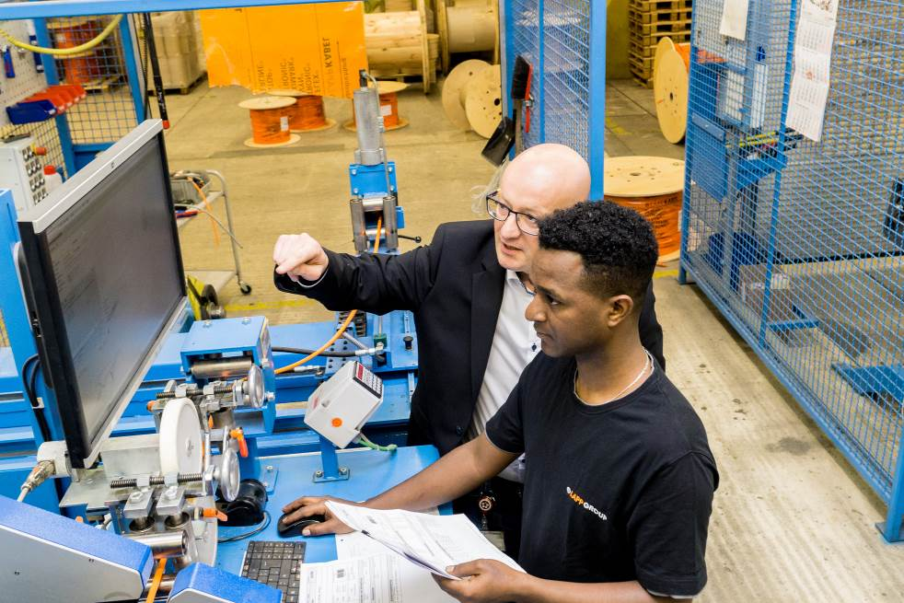
Lapp has decided to allow nine recognized refugees to train to become machinery and plant operators in the next three years. Tedros Gebru, refugee from Eritrea, already started an apprenticeship in September 2015.

Find the image in printable quality here
www.lappkabel.com/press

About the Lapp Group:
Headquartered in Stuttgart, Germany, the Lapp Group is a leading supplier of integrated solutions and branded products in the field of cable and connection technology. The Group’s portfolio includes standard and highly flexible cables, industrial connectors and screw technology, customized system solutions, automation technology and robotics solutions for the intelligent factory of the future, as well as technical accessories. The Lapp Group’s core market is in the industrial machinery and plant engineering sector. Other key markets are in the food industry as well as the energy and the mobility sector.

The Lapp Group has remained in continuous family ownership since it was founded in 1959. In the 2013/14 business year, it generated consolidated revenue of 820 million euros. Lapp currently employs approximately 3,200 people across the world, has 18 production sites and over 40 sales companies. It also works in cooperation with around 100 foreign representatives.

