Foundation promotes young scientists in cardiovascular research
Oskar Lapp Foundation awarded research prize and grant

Stuttgart, 29. April 2016

The Oskar Lapp Foundation has again awarded two important prizes to young cardiac researchers. In 2016, The Oskar Lapp research prize of 12,000 euros went to Dr. med. Constanze Schmidt, junior doctor at the medical clinic of the University of Heidelberg, Cardiology Department. She discovered a new therapeutic target that could suppress dangerous atrial fibrillation. The 2016 Oskar Lapp grant was received by Dr. med. Ingo Hilgendorf, medical assistant at the University Heart Centre Freiburg-Bad Krozingen. His research subject is centred on atherosclerotic plaque formation: there are two kinds of scavenger cells in the vessel wall: those that are already invested before birth, and those that are only recruited during the course of the disease. Using the mouse model, the research project investigates how, and to what extent, these two populations participate in atherosclerotic plaque formation. The scholarship is worth €20,000 and is to be used for material resources. It offers up to a two-year period of sponsorship. Both research prizes were awarded at the 82nd annual conference of the Deutsche Gesellschaft für Kardiologie – Herz und Kreislaufforschung e.V. (DGK, German Cardiac Society) in Mannheim.

The Oskar Lapp Foundation was founded in 1992 in honour of the Stuttgart-based businessman Oskar Lapp, who died on 25 April 1987 as a result of a heart attack. His widow, Ursula Ida Lapp, is chair of the foundation’s board of trustees. The foundation aims to provide young scientists with incentives to effectively engage them in cardiovascular research. "There is a lot of work to be done in cardiovascular research. There is still a need for much better research into prophylaxis, diagnostics, therapy and rehabilitation for coronary heart disease,” said Ursula Ida Lapp, justifying her commitment.

Along with the founding family, the members of the Oskar Lapp Foundation Board of Trustees are Prof. Gunther Arnold (former Director of the Deutsche Gesellschaft für Kardiologie – Herz und Kreislaufforschung e.V.), Prof. Anton Both (retired Medical Director, Klinikum Stuttgart, Katharinenhospital), Dr Rolf Thieringer (first mayor of the state capital of Stuttgart), Prof. Roderich C. Thümmel (lawyer), Prof. Thomas Nordt (Medical Director, Klinikum Stuttgart, Katharinenhospital) and Konstantinos Papoutsis (Director of the Deutsche Gesellschaft für Kardiologie – Herz und Kreislaufforschung e.V.). For donations, the Oskar Lapp Foundation's bank details are as follows: IBAN: DE68600501010002076087, BIC: SOLADEST600.
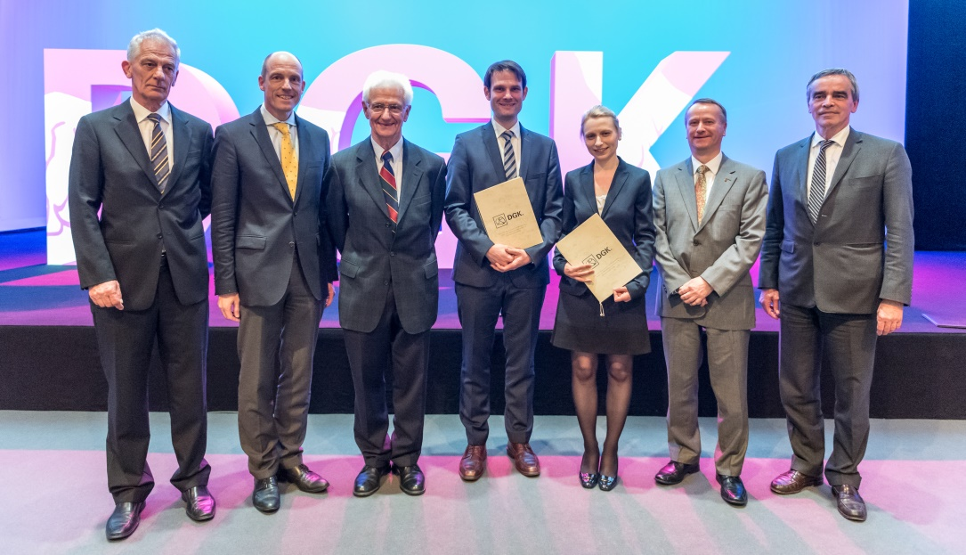
Image caption:
Award ceremony of the Oskar Lapp Research Prize 2016 and the Oskar Lapp Grant 2016: from the left Conference President Prof. Dr. Andreas Michael Zeiher, Prof. Dr. Thomas Nordt, Prof. Dr. Anton Both, Dr. Ingo Hilgendorf, Dr. Constanze Schmidt, Volker Lapp and DGK President Prof. Dr. Karl-Heinz Kuck. Image: DGK/Thomas Hauss

The image is available in printable quality here

www.lappkabel.com/press

About the Lapp Group:
Headquartered in Stuttgart, Germany, the Lapp Group is a leading supplier of integrated solutions and branded products in the field of cable and connection technology. The Group’s portfolio includes standard and highly flexible cables, industrial connectors and screw technology, customized system solutions, automation technology and robotics solutions for the intelligent factory of the future, as well as technical accessories. The Lapp Group’s core market is in the industrial machinery and plant engineering sector. Other key markets are in the food industry as well as the energy and the mobility sector.

The Lapp Group has remained in continuous family ownership since it was founded in 1959. In the 2014/15 business year, it generated consolidated revenue of 886 million euros. Lapp currently employs approximately 3,300 people across the world, has 17 production sites and over 40 sales companies. It also works in cooperation with around 100 foreign representatives.

