Birthday celebration for Ursula Ida Lapp
Outstanding entrepreneur marks her 85th birthday

Stuttgart, Germany, 1 June 2015

Ursula Ida Lapp has celebrated her 85th birthday at Möhringen Town Hall in Stuttgart, in the company of around 500 guests. A remarkable woman who made German business history, she is also an outstanding entrepreneur. More than 50 years ago, together with her husband Oskar Lapp (1921–1987), she put her heart and soul and her feel for the market into founding a company that has gone on to gain international recognition.

At her birthday celebration last Saturday she was joined by a number of friends, acquaintances, customers, many employees and, of course, the entire Lapp family. “Our mother is a great role model for us,” explained Andreas Lapp, Chairman of the Board at Lapp Holding AG. “Everything she does and believes today is still shaped by a sense of responsibility towards the company and family, as well as a sense of social responsibility – a desire to make things better.” Others guests who came to sing her praises included Thomas Strobl, the member of German parliament and state chairman for CDU Baden-Württemberg, Stuttgart mayor Isabel Fezer, and Professor Anton Both, member of the board of trustees for the Oskar Lapp Foundation. Music was provided by the Stuttgart Chamber Orchestra and Max Raabe, who took guests on a musical journey through the 1930s – the years when Ursula Ida Lapp was growing up in Thüringen.

Making a social contribution remains very important to Ursula Ida Lapp today. That is why, to mark the occasion, she asked for donations to the Oskar Lapp Foundation. The Foundation was created in 1992 in memory of the Stuttgart businessman Oskar Lapp, who passed away following a heart attack on 25 April 1987. It aims to give young scientists additional incentives to carry out research into cardiovascular diseases, which remain one of the most common illnesses and the number one cause of death in Germany today. Every year, the Oskar Lapp Foundation awards a 12,000 euro research prize. Additionally, every two years, a grant of up to 20,000 euros is awarded for new equipment and other resources. Additionally, the completion of Möhringen Town Hall was only possible thanks to a donation from the Lapp family. In recognition of this, the hall where the birthday celebration took place is named after Ursula Ida Lapp herself.

The success story that is the Stuttgart-based Lapp Group began in the late 1950s. Ursula Ida Lapp’s husband Oskar Lapp was a brilliant inventor who loved to tinker with technology. The company founder and honorary chairman of the supervisory board, who can still frequently be found in her office on the fifth floor of the firm’s headquarters, explains: “My husband was an engineer by trade and quickly saw that electricians had trouble matching up the right wires when connecting cables. It involved a time-consuming process of manually inserting single cores and switching strands into the outer sheaths. Furthermore, all the wires were grey or black, had very wide cross-sections and weren’t very flexible.”

Oskar Lapp solved this problem by inventing colour-coded wires with significantly smaller diameters. A Wuppertal-based cable manufacturer then produced the first prototypes based on Oskar Lapp’s designs: the first industrially produced connector and control cable was born. This was followed by an additional innovation: Mr and Mrs Lapp created the ÖLFLEX® brand – which has come to stand for especially oil-resistant and flexible cabling.

U.I. Lapp KG was founded in 1959 with an initial capital of 50,000 Deutsche Mark. The abbreviation U.I. stands for Ursula Ida. The firm started off in the garage of their home in Stuttgart-Vaihingen. Ursula Ida Lapp says: “My husband went on the road and visited the companies who could benefit from ÖLFLEX®. That’s how we got our first orders.” Meanwhile, Mrs Lapp stayed at home, as they still had three young children. In the evenings she wrote marketing letters and did the accounts. She often travelled to the freight depot with a push cart, to label and forward on the cables that had been delivered in rings.

ÖLFLEX® was the right product at the right time. With this brand, Mr and Mrs Lapp set the quality standards that still apply in international cable production today. Lapp even offered fully finished cables with up to 130 colour-coded wires. Demand was extremely high. The firm’s first factory opened as early as 1963, enabling it to manufacture its own ÖLFLEX® cables. Then, in 1965, the company headquarters moved to Schulze-Delitzsch Strasse in Stuttgart-Vaihingen – which to this day remains the home of this successful business.

When Oskar Lapp died in 1987 after a long battle with cardiovascular disease, Ursula Ida Lapp and her sons Siegbert and Andreas took over management of the company. Under their leadership, the company’s internationalization continued. Today the Lapp Group is a leading supplier of integrated solutions and branded products in the field of cable and connection technology. The group’s portfolio includes standard and highly flexible cables, industrial connectors and screw technology, customized system solutions, automation technology and robotics solutions for the intelligent factory of the future, as well as technical accessories. The Lapp Group’s core market is in the industrial machinery and plant engineering sector. Other key markets are in the food industry as well as the energy and the mobility sector. In the 2013/14 business year, the family firm generated consolidated revenue of 820 million euros. Lapp currently employs approximately 3,200 people across the world, has 18 production sites and over 40 sales companies. It also works in cooperation with around 100 foreign representatives.

Ursula Ida Lapp has significantly shaped the spirit of the company. This international family-run business cultivates and maintains a unique corporate culture, which can be defined as being customer-oriented, friendly, innovative and success-driven. Acting in a sustainable way and taking responsibility for their employees are always firmly in focus. And Ursula Ida Lapp’s greatest desire – for her grandchildren to continue the work of her husband – also seems to be becoming a reality. Two of her grandchildren already have an active role within the company. The future is looking bright.

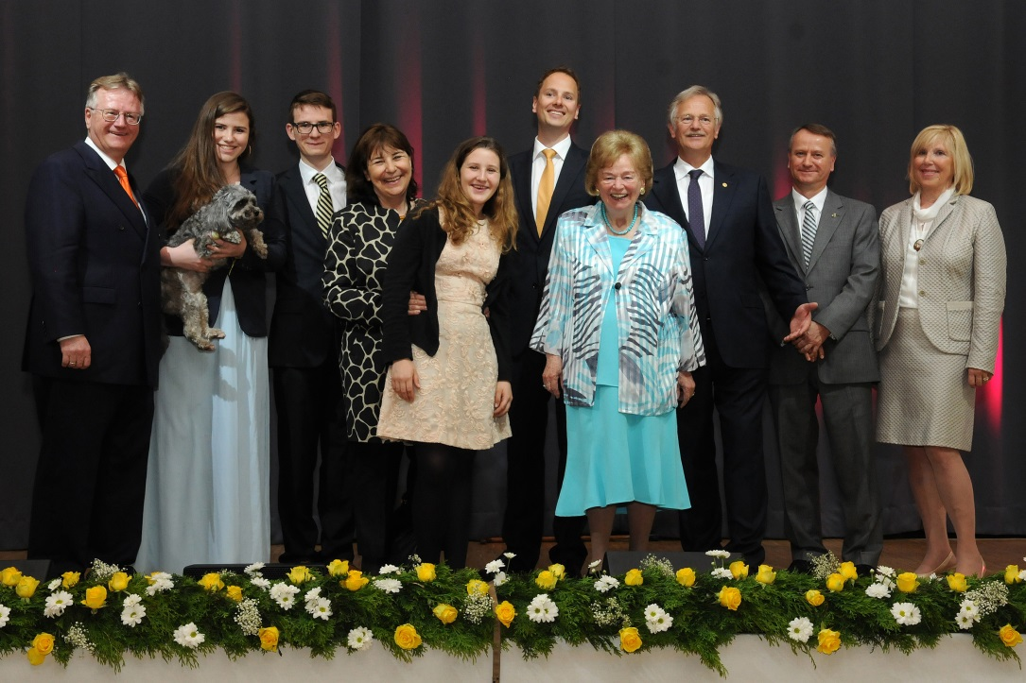Company founder Ursula Ida Lapp with her family in the Ursula-Ida-Lapp-room at Stuttgart-Möhringen civic center
Find the image in printable quality here

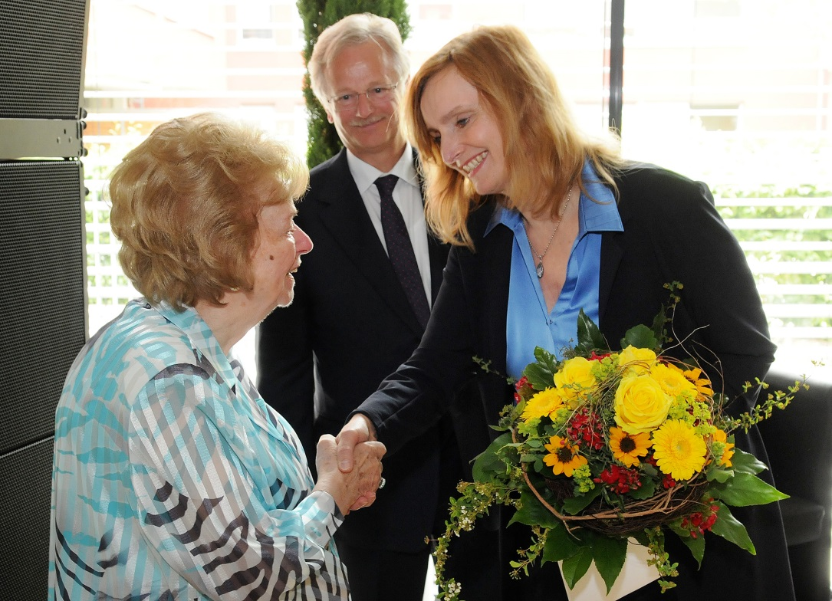
Isabel Fezer, mayor of the city of Stuttgart, congratulating Ursula Ida Lapp, son Siegbert E. Lapp in the background
Find the image in printable quality here

www.lappkabel.com/press

About the Lapp Group:
Headquartered in Stuttgart, Germany, the Lapp Group is a leading supplier of integrated solutions and branded products in the field of cable and connection technology. The Group’s portfolio includes standard and highly flexible cables, industrial connectors and screw technology, customized system solutions, automation technology and robotics solutions for the intelligent factory of the future, as well as technical accessories. The Lapp Group’s core market is in the industrial machinery and plant engineering sector. Other key markets are in the food industry as well as the energy and the mobility sector.

The Lapp Group has remained in continuous family ownership since it was founded in 1959. In the 2013/14 business year, it generated consolidated revenue of 820 million euros. Lapp currently employs approximately 3,200 people across the world, has 18 production sites and over 40 sales companies. It also works in cooperation with around 100 foreign representatives.

