Hannover Messe trade fair 2014: Lapp Group presents the innovative multi-cable entry system with gel insert

Increased efficiency thanks to gel technology

Stuttgart, 7 April 2014

From the bicycle saddle to the control cabinet: the Lapp Group from Stuttgart presented a new model of its proven multi-cable bushing system, the SKINTOP® CUBE MULTI at the Hannover Messe trade fair. With the new multi-cable entry system, a particularly high packing density and optimum strain relief on the whole cable bundle are achieved. In addition, very secure assembly is also made possible. These benefits are due to the use of a high-strength gel that has previously been used in sporting equipment or medical engineering. “Interesting examples of where these type of gels have been used up to now include gel cushions in bicycle saddles or insoles,” explains product manager Cornelia Kuntzer. The cable is simply routed through the gel membrane. The static friction between the gel and the cable ensures a secure grip and also provides a reliable seal.

The elastic gel technology used for the sealing element enables large, variable clamping ranges. This means it is not necessary to remove individual inserts to install the cables, thus eliminating several work steps from the installation process − a clear gain in efficiency. Finally, the material also makes it possible to route more cables through the system than conventional methods. The subsequently increased packing density also increases efficiency in another way, as housings can be made smaller in the future.

The SKINTOP® CUBE MULTI is intended for use in a temperature range of between -30°C and +100°C. It is resistant to oil, grease, UV rays and ozone, and has protection rating IP 65. To ensure the safety of the entire application, fire behaviour in accordance with UL 94V-2 can be confirmed − in the event of fire the cable bushing system is self-extinguishing. A UL approval for application in the North American market is currently in the pipeline.

The SKINTOP® CUBE MULTI is used wherever cables and wires need to be safely inserted into housings without the use of connectors and compressed air hoses. It can be used for the installation of cables that are not pre-assembled and of media hoses in the construction of control systems, control cabinets and apparatuses, as well as in automation technology. When it comes to packaging machines for example, numerous pneumatic and electrical cables need to be rapidly installed and routed in the smallest spaces. Systems with a high packing density provide an excellent solution for this problem.

The SKINTOP® CUBE MULTI can be supplied both in standard configurations and in configurations that are individually tailored to customer requirements. The SKINTOP® CUBE system also makes it possible to use separable sealing modules for assembled cables in the same frame as the SKINTOP® CUBE MULTI system. The variability simplifies the technical documentation and increases the flexibility of application. Anyone interested can view this product in three-dimensions using the Augmented Reality app from Lapp. Simply scan the catalogue page with your smartphone and you will be able to see the multiple entries from different perspectives. Furthermore, the entire SKINTOP® portfolio is now classified in ETIM 5.0, which means it is even easier and quicker for users to find the right product and perform the Design-In.

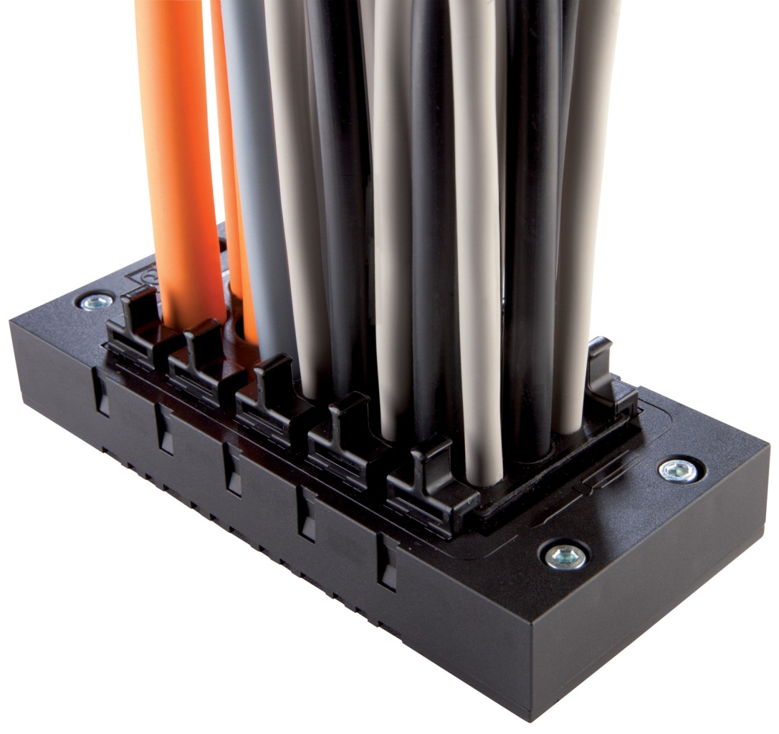
Thanks to its innovative gel technology, the SKINTOP® CUBE MULTI has a very high packing density and optimum strain relief on the whole cable bundle

Find the image in printable quality here
www.lappkabel.com/press

About the Lapp Group:
Headquartered in Stuttgart, Germany, Germany, the Lapp Group is a leading supplier of integrated solutions and branded products in the field of cable and connection technology. The Group's portfolio includes standard and highly flexible cables, industrial connectors and screw technology, customised system solutions, automation technology and robotics solutions for the intelligent factory of the future, as well as technical accessories. The Lapp Group’s core market is in the industrial machinery and plant engineering sector. Other key markets are in the food industry as well as the energy and the mobility sector.

The Lapp Group has remained in continuous family ownership since it was founded in 1959. In the 2012/13 business year, it generated a consolidated turnover of 830 million euros. Lapp currently employs approximately 3,200 people across the world, has 18 production sites and over 40 sales companies. It also works in cooperation with around 100 foreign representatives.

