Lapp Group offers new solutions for electric mobility

Spiral, light and even more compact

Stuttgart, 07 April 2014
Weight and space requirement – alongside cost, these are the crucial factors that are taken into account by car manufacturers when choosing the appropriate charging cables for their electric vehicles. At the Hannover Messe, the Stuttgart-based Lapp Group will be launching the LAPP DOUBLE HELIX, an optimised version of the innovative LAPP HELIX charging cable. The new charging cable for electric and hybrid vehicles combines the same length with an even smaller diameter than its predecessor. The packing height is lower as the plug and coupling are on the outside when the cable is rolled into a spiral – meaning that the complete charging system takes up only half of the space and weighs only half of conventional charging systems. And it is 25 percent cheaper too.

The LAPP DOUBLE-HELIX is based on the same principle as the LAPP HELIX, which has a spiral shape to make it very lightweight and compact. The DOUBLE-HELIX combines these advantages with the properties of conventional spiral cables: Higher reset forces result in an even better clear up function. The charging cable is available as a three-phase 20 A version or as a 32 A single phase cable.

To accompany the LAPP DOUBLE-HELIX, the Type 1 LAPP CHARGE coupling is also available now in ergonomic Lapp design, and was developed in cooperation with Bals Elektrotechnik. The dual-chamber system ensures that the moving parts, i.e. the clamp and push button, are partitioned from the terminal housing. As a result, the entire connector system achieves a protection rating of at least IP44. The LAPP CHARGE is also secured by a locking eye for a U-lock. Customers can purchase the charging connector in various colour combinations and with company-specific labelling. The Type 1 LAPP CHARGE coupling is available in 20 and 32 A versions.

At the Hannover Messe, Lapp is continuing to present itself as a supplier of complete systems for the electric mobility sector. With everything from connection, data and control cables, cable glands and other system products for charging posts, to complete charging systems, through to high-voltage cabling in the vehicle and connections for the individual battery cells in the energy store, Lapp meets all the cabling needs of this young market. Interested visitors can discover Lapp's electric mobility innovations on Stand C03 in Hall 11 of the Hannover Messe.

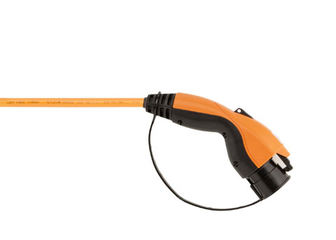
Find the image in printable quality here
www.lappkabel.com/press

About the Lapp Group:
Headquartered in Stuttgart, Germany, Germany, the Lapp Group is a leading supplier of integrated solutions and branded products in the field of cable and connection technology. The Group's portfolio includes standard and highly flexible cables, industrial connectors and screw technology, customised system solutions, automation technology and robotics solutions for the intelligent factory of the future, as well as technical accessories. The Lapp Group’s core market is in the industrial machinery and plant engineering sector. Other key markets are in the food industry as well as the energy and the mobility sector.

The Lapp Group has remained in continuous family ownership since it was founded in 1959. In the 2012/13 business year, it generated a consolidated turnover of 830 million euros. Lapp currently employs approximately 3,200 people across the world, has 18 production sites and over 40 sales companies. It also works in cooperation with around 100 foreign representatives.

