Stuttgart-based family company expands worldwide presence
Lapp inaugurates first own production plant in South America

Stuttgart, 30 October 2014

The Stuttgart-based Lapp Group is heading for growth. The company recently opened its first production plant in South America, which will join plants already operating in Europe, North America and Asia. Investments have also been made in new, expanded sales subsidiaries in Poland and Russia. Overall, the family company is increasing its presence in key growth markets.

Investing in a new plant in South America has major strategic significance for the Lapp Group. It is located in the booming industrial region of Camaçari in the Brazilian state of Bahia, on the largest industrial park in South America. With around 200 million inhabitants, Brazil is the biggest economic power in Latin America and therefore a very important market for the Lapp Group. "Thanks to our new production plant, we are closer to our clients and are able to supply them with our branded products more quickly. The first major contracts show that we have made the right decision", said Siegbert E. Lapp, Member of the Board of Lapp Holding AG at the inauguration ceremony, which was attended by the Lapp family and around 200 invited guests.

The new Cabos Lapp Brasil plant comprises a production area of 6,200 square metres and is expected to expand to a total of 10,000 square metres in the near future. An administration building of 750 square metres will also be added. Around 40 people are currently employed in the new production plant and the number will double by the end of the year. In the medium term, the number of jobs will be increased to 180. Total investment amounts to 18 million euros. A distribution centre, which currently employs 41 people, has also been based in Osasco near Sao Paulo for over ten years.

Cabos Lapp Brasil has established a positive brand image in Brazil as a result of its recognised high product quality and excellent applications advice. The new plant means that Lapp will be able to offer the South American market tailored products that are not yet included in the product range. In addition, the company will no longer be affected by fluctuations in the foreign exchange rate and will be able to avoid high import duties.

Production already began at the start of this year. At the plant, ÖLFLEX® connecting and control cables, as well as more basic cables and lines, are to be manufactured for mechanical engineering companies, plant construction firms, and the mining and petrochemical industries in particular. The company meets the latest requirements for quality management and is certified in accordance with DIN ISO 9001. The latest local regulatory requirements have also been implemented. At the start of production, Cabos Lapp Brasil estimated an annual turnover of over 40 million euros. Long-term, production is to extend to Brazil's neighbouring countries in South America.

Major investments have also been made in Poland. A new sales and logistics centre was opened in Biskupice Podgorne early this year. The Lapp Group's new premises in Poland is in the industrial area of Wroclaw, one of the country's largest cities. Global companies such as Philips and Linde have also opened facilities in the immediate vicinity. The building is eleven metres high and contains 4,300 square metre warehouse for more than 2,000 cable drums, four state of the art cutting machines, a packaging line and 1.500 square metres of office space. The Lapp Group has had its own subsidiary in Poland for 14 years now. This new building will allow the company to keep pace with the growing demand in the Polish market. A total of 4.1 million euros was invested in the new building.

In Russia, the foundation stone of a new sales and logistics centre in Samara was recently laid. The new building is due to be completed next autumn and will comprise around 1,000 square metres of office space and 3,500 square metres of warehouse. Previously, the warehouse and offices were separate. The new sales centre will provide a much better service to customers in the future. It will also provide sufficient capacity for further expansion in new sectors such as the metalworking industry, food & beverage and assembly. A total of around five million euros was invested in the new location.

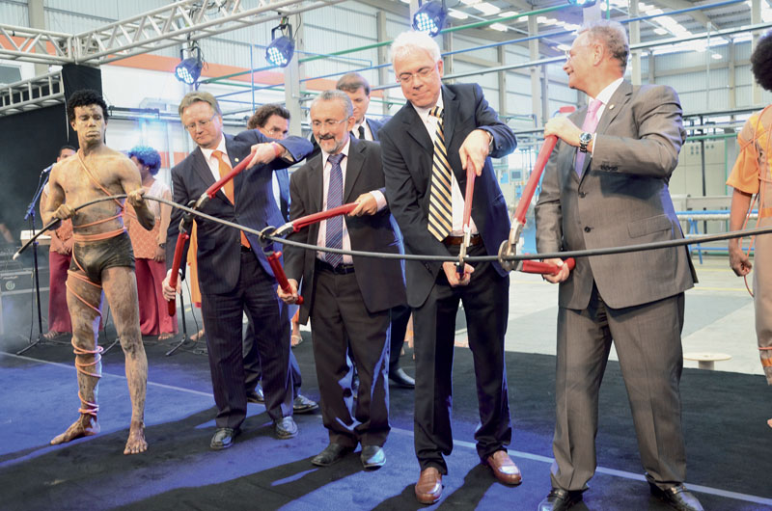
Andreas Lapp, Mayor of Camaçari Ademar Delgado, Secretary of Industry, trade and mining James Correia and Siegbert Lapp (from left) inaugurated The Lapp Group's first plant in South America at Camaçari in Brazil

Find the image in printable quality here

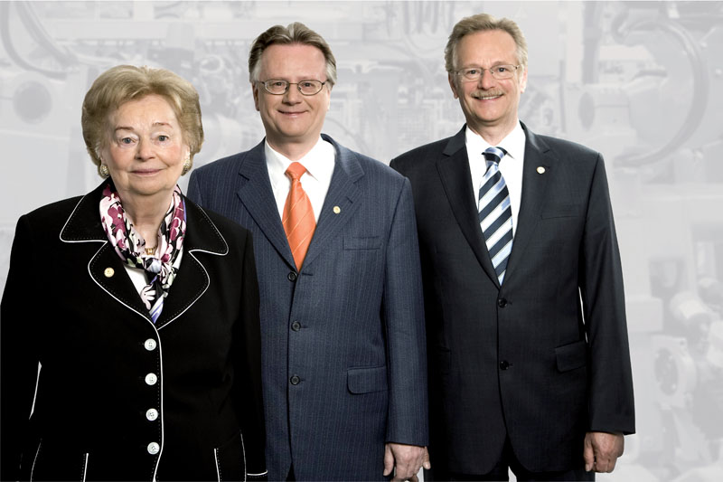
Lapp Group founder Ursula Ida Lapp with her two sons Andreas and Siegbert

Find the image in printable quality here

www.lappkabel.com/press

About the Lapp Group:
Headquartered in Stuttgart, Germany, the Lapp Group is a leading supplier of integrated solutions and branded products in the field of cable and connection technology. The Group's portfolio includes standard and highly flexible cables, industrial connectors and screw technology, customised system solutions, automation technology and robotics solutions for the intelligent factory of the future, as well as technical accessories. The Lapp Group’s core market is in the industrial machinery and plant engineering sector. Other key markets are in the food industry as well as the energy and the mobility sector.

The Lapp Group has remained in continuous family ownership since it was founded in 1959. In the 2012/13 business year, it generated a consolidated turnover of 830 million euros. Lapp currently employs approximately 3,200 people across the world, has 18 production sites and over 40 sales companies. It also works in cooperation with around 100 foreign representatives.

