SPS IPC Drives in Nuremberg: Lapp Group presents cabling solutions for food and beverage industry

Food-safe cabling solutions from Lapp

Stuttgart, 27 November 2014
The Lapp Group presented several innovative products for the food and beverage industry at the SPS IPC Drives 2014 trade fair in Nuremberg. One of the highlights was the new SKINTOP® HYGIENIC stainless steel cable gland. Its suitability for use in food and beverage production is confirmed by certifications from ECOLAB® and design according to EHEDG requirements. In addition to this, numerous cables and accessories have received ECOLAB® certifications.

Three key features ensure that the SKINTOP® HYGIENIC can easily be cleaned and allow it to be used under the most stringent hygiene standards: shape, precision fit and material. “The rounded shape with no corners or angles, and the precision fit with very low tolerances in production mean that there is nowhere for residue to accumulate,” says product manager Cornelia Kuntzer. The material used for the SKINTOP® HYGIENIC is stainless steel class V4A (1.4404), which guarantees long-term resistance to the demanding ambient conditions, and the sealing materials are food-safe. This means that the SKINTOP® HYGIENIC is suitable for direct contact with foodstuffs in production.

The ongoing tests for the EHEDG certification, conducted by the Weihenstephan Institute in Freising, are exceptionally tough. In the past, to gain the EHEDDG Hygienic Design certification components only had to pass a theoretical testing process involving inspection of the design plans and the materials used. From October 2014, the testing procedure has been altered to include practical tests under extreme conditions. The SKINTOP® HYGIENIC was the first product to be tested under the new, exceptionally stringent requirements. “We expect to be awarded the certification by the end of 2014,” explains product manager Cornelia Kuntzer. In those tests, the cable gland was immersed in test media in a closed piping system at a defined pressure, to test for possible ingress of liquids into very tiny cavities. No residue that cannot be cleaned away can remain. The test medium may not get into tiny cavities in the cable gland during the test. In addition, no germ formation or bacterial growth can be possible or demonstrable after the cleaning process. The special elastomer that is being used for the sealings also guarantees extremely high strain relief on the cable. The SKINTOP® HYGIENIC will be available from the Lapp Group by January 2015.

Numerous other branded products from Lapp have been awarded the ECOLAB® certification, confirming their suitability for use in sensitive areas of food and beverage production. For example, the SILVYN® FG NM protective cable conduit consists of food-safe PVC. Due to its smooth surface it is easy to clean and at the same time prevents microbial contamination. ECOLAB® certified are also the stainless steel cable gland SKINTOP®, best sellers like the ÖLFLEX® CLASSIC 110 and other control cables, several UNITRONIC® data cables, ETHERLINE® network cables, and FLEXIMARK® marking solutions.
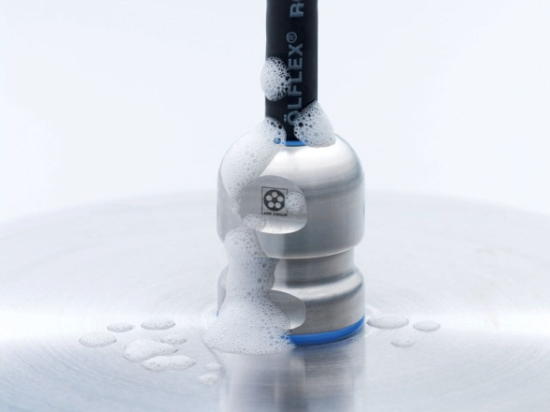
The SKINTOP® HYGIENIC stainless steel cable gland was specially developed for use in the food and beverage industry.

Find the image in printable quality here
www.lappkabel.com/press

About the Lapp Group:
Headquartered in Stuttgart, Germany, the Lapp Group is a leading supplier of integrated solutions and branded products in the field of cable and connection technology. The Group's portfolio includes standard and highly flexible cables, industrial connectors and screw technology, customised system solutions, automation technology and robotics solutions for the intelligent factory of the future, as well as technical accessories. The Lapp Group’s core market is in the industrial machinery and plant engineering sector. Other key markets are in the food industry as well as the energy and the mobility sector.

The Lapp Group has remained in continuous family ownership since it was founded in 1959. In the 2012/13 business year, it generated a consolidated turnover of 830 million euros. Lapp currently employs approximately 3,200 people across the world, has 18 production sites and over 40 sales companies. It also works in cooperation with around 100 foreign representatives.

