New products for the food industry from the Lapp Group
Hygienic and robust

Stuttgart, 24th November 2015

The Stuttgart-based Lapp Group showcases their complete service portfolio for the food and beverage industry at the SPS IPC Drives trade fair in Nuremberg (Hall 6, Stand 258). Lapp's product range for the sector includes highly resistant cables, hoses, cable glands and connectors, as well as accessories such as cable ties. The components meet strict international requirements, such as EHEDG design specifications or compatibility with ECOLAB® cleaning agents.
New products in detail:

ETHERLINE® ROBUST: The full package for the food industry
One highlight at the trade fair stand is the new ETHERLINE® ROBUST, the last piece of the puzzle in Lapp's ROBUST range. The connection experts now offer a full service portfolio for the food industry. This industrial Ethernet cable offers excellent resistance to weather, ozone and UV radiation. It is also free of halogen, and allows for regular cleaning with hot steam and acidic or alkaline cleaning agents. These properties make it particularly well suited for the food industry, as well as for medical engineering, laundries or car washes. The double screening ensures high transfer reliability in applications sensitive to electromagnetic interference. Cables in the ETHERLINE® ROBUST FR configuration are available for increased flame retardance. Both ETHERLINE® ROBUST series are developed to the Profinet standard, and are available for transfer categories from Cat.5 to Cat.7.
Those searching for tough power and control cables for the food and beverage industry will find what they are looking for in the ÖLFLEX® ROBUST series. The cable insulation is made from special TPE. The cables are available with VDE certification or UL certification for the North American market. Material resistance and function tests to ECOLAB® standard prove that the lines and cables can withstand regular cleaning with standard industrial cleaners and disinfectants. The UNITRONIC ROBUST series offers cables for the food industry for low-frequency data network cables, while optical data transmission cables can be found in the HITRONIC ROBUST range.

Other new products at the trade fair:

EPIC® ULTRA H-B: Safely closed, even when open
Lapp also offers accessories for the proven rectangular connectors from its EPIC series, specially tailored to the requirements of the food industry. The EPIC® ULTRA H-B protective cover makes the base of the connector water proof, even if the connections are separated during the cleaning process. It is made from blue plastic with stainless steel anti-corrosion locking elements, and is approved by the Food and Drug Administration in the United States.

SKINTOP® HYGIENIC meets the toughest hygiene standards thanks to its design and material. This cable gland is made from stainless steel, with FKM elastomer used for the seals. It has no corners and edges to which food residues could adhere. SKINTOP® HYGIENIC became the first product to undergo a test based on the new EHEDG certification guidelines – this was conducted by the Weihenstephan Institute in Freising, Germany.
SILVYN® HYGIENIC, the new, hygienically designed conduit gland, is suitable for use in the product zone when combined with the right SILVYN® HYGIENIC hose.

Visitors to the Lapp stand at the SPS IPC Drives will find the new product catalogue "The World of Lapp – Food & Beverage", which summarises the full range of connection technology for this sector.

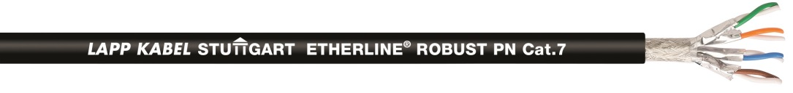
The ETHERLINE® ROBUST completes Lapp's service portfolio for the food industry.

Find the image in printable quality here

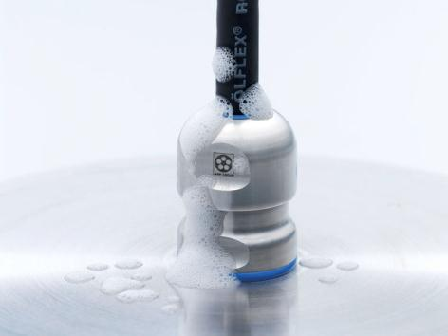
One highlight in Lapp's product range for the food and beverage industry is the EHEDG-certified SKINTOP® HYGIENIC

Find the image in printable quality here
www.lappkabel.com/press

About the Lapp Group:
Headquartered in Stuttgart, Germany, the Lapp Group is a leading supplier of integrated solutions and branded products in the field of cable and connection technology. The Group’s portfolio includes standard and highly flexible cables, industrial connectors and screw technology, customized system solutions, automation technology and robotics solutions for the intelligent factory of the future, as well as technical accessories. The Lapp Group’s core market is in the industrial machinery and plant engineering sector. Other key markets are in the food industry as well as the energy and the mobility sector.

The Lapp Group has remained in continuous family ownership since it was founded in 1959. In the 2013/14 business year, it generated consolidated revenue of 820 million euros. Lapp currently employs approximately 3,200 people across the world, has 18 production sites and over 40 sales companies. It also works in cooperation with around 100 foreign representatives.

