Tram line U12 now also stops at Lapp Group headquarters
Get to work faster, thanks to the Lapp Kabel stop

Stuttgart, 04 May 2016

It is finally done: On 13th May Lapp Group’s “own” tram stop will be inaugurated. An extension to Stuttgart’s U12 tram line and the new tram stop named “Lapp Kabel” will be officially opened. This means that the business park in which Lapp Group’s headquarters are located will be connected to Stuttgart's tram network. “We are very pleased that SSB has improved the connection to the Vaihingen-Möhringen business park with the extension of the U12 line. We employ around 1,200 people here whose route to work will now become faster and less stressful. This makes the company more attractive as an employer, and naturally we are proud of the fact that a tram stop has been named after our company,” said a delighted Andreas Lapp, Chairman of the Board at Lapp Holding AG. After all, Lapp Kabel is a long-standing company at the location. The supplier of cables and connection technology has been developing and manufacturing there since the start of the 1960s. This means that Lapp Kabel is the oldest company in the Schulze-Delitzsch-Strasse.

Currently, about 600 companies with over 20,000 employees are based in so-called Synergiepark Stuttgart. And further company settlements are planned. Up until now, the U12 line terminated at the train station in Vaihingen. All employees used to have to travel further by bus or on foot – now they can travel rapidly and comfortably by tram right into the centre of the business park. The family company is attached to the Vaihingen-Möhringen site for reasons of conviction and commitment. For this reason, a new Lapp European Centre for about 400 employees is currently being built at the company headquarters and will be ready to open at the end of the year.

Andreas Lapp also sees the extension as an opportunity and an obligation to make the business park more attractive. “The extension to the U12 line and the Lapp Kabel tram stop are heading in the right direction, but they are just a drop in the ocean.” The traffic infrastructure in the business park as a whole is entirely inadequate. On work days, apart from during the lunch hour, there is regularly traffic chaos there. “Due to the compensatory measures for the tram line extension, further parking spaces have disappeared and additional tree planting on important roads obstruct the flow of traffic. We ultimately need a coherent traffic concept that sustainably relieves the burden on residents rather than burdening them further”, demands Andreas Lapp.

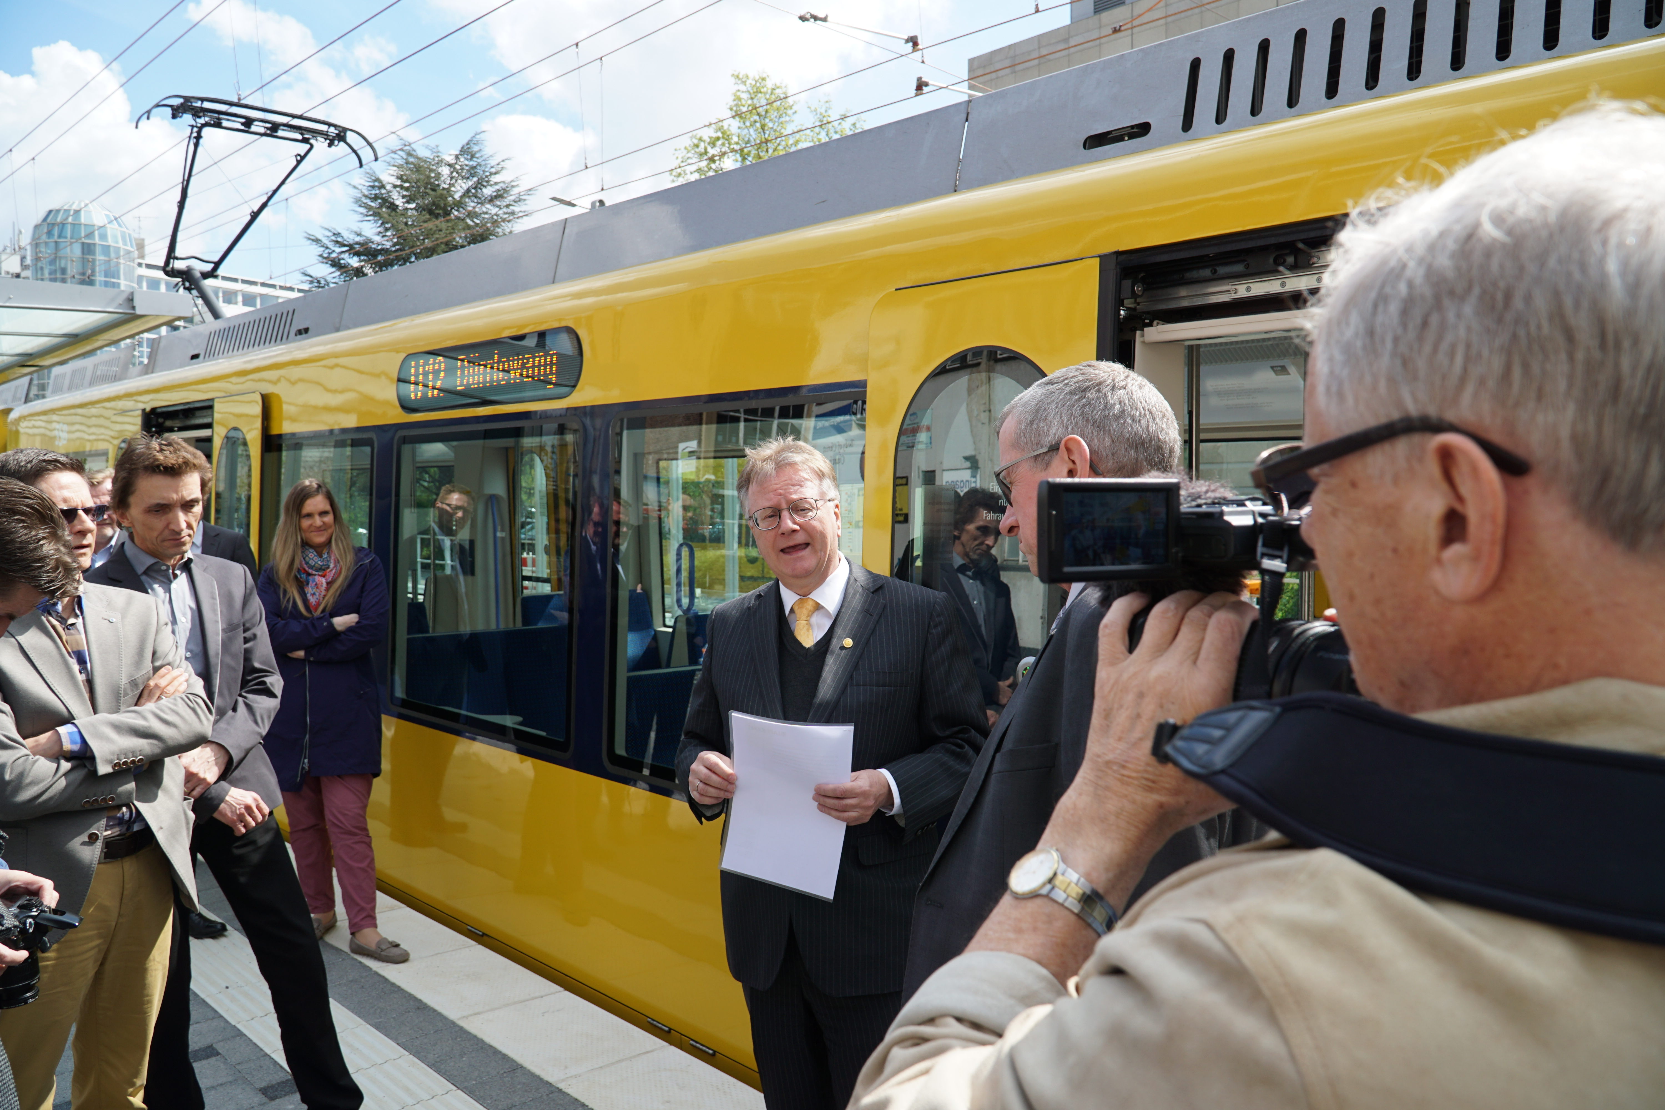Entrepreneur Andreas Lapp is delighted about the extension to the U12 tram line and the Lapp Kabel tram stop that is named after the company.

Das Bild in druckfähiger Qualität finden Sie hier

www.lappkabel.de/presse

Über die Lapp Gruppe:
Die Lapp Gruppe mit Sitz in Stuttgart ist einer der führenden Anbieter von integrierten Lösungen und Markenprodukten im Bereich der Kabel- und Verbindungstechnologie. Zum Portfolio der Gruppe gehören Kabel und hochflexible Leitungen, Industriesteckverbinder und Verschraubungstechnik, kundenindividuelle Konfektionslösungen, Automatisierungstechnik und Robotiklösungen für Industrie 4.0 und die Smart Factory. Der Kernmarkt der Lapp Gruppe ist der Maschinen- und Anlagenbau. Weitere wichtige Absatzmärkte sind die Lebensmittel-, Energie-, Mobilitäts- und die Life Science Industrie.

Die Unternehmensgruppe wurde 1959 gegründet und befindet sich vollständig in Familienbesitz. Im Geschäftsjahr 2014/15 erwirtschaftete sie einen konsolidierten Umsatz von 886 Mio. Euro. Lapp beschäftigt weltweit rund 3.300 Mitarbeiter, verfügt über 17 Fertigungsstandorte und mehr als 39 internationale Vertriebsgesellschaften und arbeitet mit Partnerunternehmen in weiteren 100 Ländern.

