Lapp and BELECTRIC OPV conclude strategic partnership
New connection technology for organic photovoltaics

Stuttgart, Nuremberg 12 September 2016

The Lapp Group, a leading manufacturer of connection solutions, and Belectric OPV, the market leader in organic photovoltaics (OPV), have concluded an agreement establishing a close partnership. Georg Stawowy, Member of the Board for Technology and Innovation at Lapp Holding AG, and Dr. Ralph Pätzold, CEO of Belectric OPV, signed the contract at Belectric OPV's production site in Kitzingen. The two companies want to jointly develop new technologies for connection and cabling of flexible organic photovoltaic modules. The aim is to create a solution that is more versatile than those to date and is suitable for any film materials. In addition, Module Access Points (MAP) - the contact point between the film and cable - are to be made more compact. This is important to enable the film modules to be integrated unobtrusively into building façades, where they generate clean power. This will give designers and architects the greatest possible design freedom. "Development is already underway and should be completed with a product ready for series production in 2017", says Reinhard Probst, Market Manager Solar at the Lapp Group.

Long-standing partnership
The collaboration is nothing new for Lapp and Belectric OPV, merely the continuation of a long-standing partnership. Lapp developed a connection point for Belectric OPV, which was used in the solar modules for the German pavilion at Expo 2015 in Milan. The solar sculptures reached up into the air like giant ferns, with the power fed into the cable through almost invisible connection points, which looked like fine branches on the "leaves".

More flexible process planned
The process developed by Lapp was a big advance in the use of organic photovoltaics. The connection points in the Milan pavilion are exceptionally compact and totally waterproof. These are properties that the new solution will also have, but it will be significantly more flexible in terms of the choice of material and the thickness of the carrier film. It will also be possible to attach the connection point regardless of where the modules are produced, guaranteeing high flexibility in production.

Patented technology
The partners remain tight-lipped about exactly how the whole thing will work, until the patent process has been initiated. The two companies want to maintain exclusive rights to this technology for a specified period. During this time, Belectric OPV will obtain the connection points from Lapp and Lapp will supply them exclusively to Belectric OPV. "We've known each other for a long time and have a great deal of trust in one another, and at the Lapp Group we believe that organic photovoltaics is a future technology with huge potential", said Georg Stawowy. "The strategic partnership was therefore the next logical step."

"With this strategic cooperation with Lapp, we are consistently continuing on the path of industrialising organic photovoltaics", added Ralph Pätzold. "OPV cannot be compared to conventional PV technologies that are primarily defined by the modular concept. Therefore, and to fully tap into the uniqueness of OPV for customers, we are constantly focusing on the final overall system, which also includes the electrical system components. With a strong partner in Lapp, we want to work together to develop these."

Further projects planned
The Lapp Group and Belectric OPV are already planning further projects making use of the new process. One idea is to utilise existing surfaces better. "Thanks to the new system technology, we can provide architects with a connection system that can be visually integrated into the overall look of a building, emphasising the key aesthetic advantages of OPV integration", said Hermann Issa, Director of Business Development at BELECTRIC OPV. As well as integration into buildings, surfaces can be used that were never previously a focus - for example roofs, which could not be used in the past for static reasons. "Of course, this system is much lighter and its shape and, to some extent, colour can easily be adapted to the building or the surroundings", said Reinhard Probst.

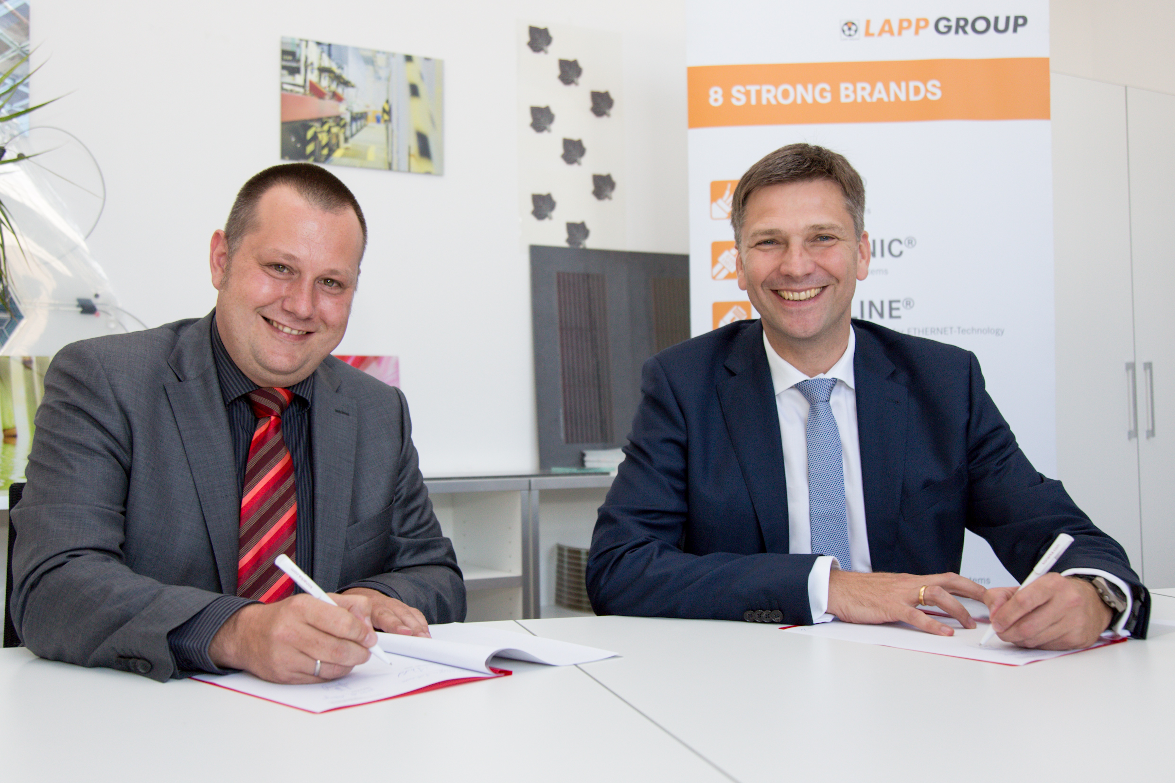
The image is available in printable quality here

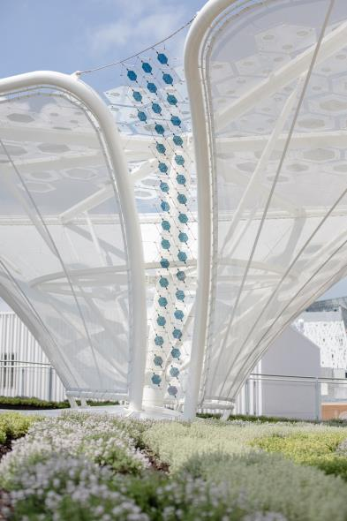
Solar modules from Belectric OPV featuring Lapp connection technology have already contributed to the impressive look of the German pavilion at Expo 2015 in Milan.

www.lappkabel.de/presse

Über die Lapp Gruppe:
Die Lapp Gruppe mit Sitz in Stuttgart ist einer der führenden Anbieter von integrierten Lösungen und Markenprodukten im Bereich der Kabel- und Verbindungstechnologie. Zum Portfolio der Gruppe gehören Kabel und hochflexible Leitungen, Industriesteckverbinder und Verschraubungstechnik, kundenindividuelle Konfektionslösungen, Automatisierungstechnik und Robotiklösungen für Industrie 4.0 und die Smart Factory. Der Kernmarkt der Lapp Gruppe ist der Maschinen- und Anlagenbau. Weitere wichtige Absatzmärkte sind die Lebensmittel-, Energie-, Mobilitäts- und die Life Science Industrie.

Die Unternehmensgruppe wurde 1959 gegründet und befindet sich vollständig in Familienbesitz. Im Geschäftsjahr 2014/15 erwirtschaftete sie einen konsolidierten Umsatz von 886 Mio. Euro. Lapp beschäftigt weltweit rund 3.300 Mitarbeiter, verfügt über 17 Fertigungsstandorte und mehr als 39 internationale Vertriebsgesellschaften und arbeitet mit Partnerunternehmen in weiteren 100 Ländern.

About BELECTRIC OPV:
BELECTRIC OPV, based in Nuremberg and Kitzingen, is the market leader in organic photovoltaics. BELECTRIC OPV produces organic solar cells, with a focus on customised solutions. In addition, BELECTRIC OPV is committed to research and development, continuously offering customers creative and innovative solutions. BELECTRIC OPV uses a unique manufacturing process based on a combination of printing, lamination and laser structuring methods. This leads to an exceptional advantage due to the high level of scalability and the possibility of producing customised designs. BELECTRIC OPV supports its customers with system solutions when it comes to integration of OPV into existing and totally new products. BELECTRIC OPV has two product lines: "Solarte" for architects and designers and "Power Plastic" for large-scale industrial applications. BELECTRIC OPV products stand for innovation, quality and design.

