Lapp acquires Italian innovation leader in data communication systems
The Lapp Group buys CEAM and Fender

Stuttgart, 24 October 2016
The Stuttgart-based Lapp Group, the leading supplier of integrated solutions and branded cable and connection technology products, has acquired CEAM Cavi Speciali. The company employs a staff of 110 in Monselice, Italy, and is one of the leading European manufacturers of data cables for Industrial Ethernet and fieldbus network systems. Lapp has also acquired S.C. Fender Cables, a company employing a staff of 20 in Cluj-Napoca, Romania. It specialises in cables for alarm and fire protection systems and, along with CEAM, was part of COFIMA Holding. “The acquisition of CEAM strengthens Lapp’s leading role in industry-standard data communication systems,” said Andreas Lapp, Chairman of the Board of Lapp Holding. “Lapp has thus attained additional expertise and manufacturing capacities, especially in the fast growing Industrial Ethernet and fieldbus systems markets.” The acquisition took effect on October 13; the parties agreed not to disclose the purchase price.

Long-standing partnership
Lapp has acquired CEAM, an innovative and profitable family company. Its turnover in 2015 was €23 million; Fender generated around €3.5 million in revenue in this year. CEAM and Fender were formerly part of COFIMA Holding, a business run by founders Franco and Carlo Magon. Lapp has a long-standing partnership with CEAM. Georg Stawowy, Chief Technical Officer at Lapp Holding AG, said: “The takeover will help us to boost our successful branded products – UNITRONIC® and ETHERLINE®. This will help Lapp to become the innovation leader in cable-based data communication systems in the field of automation.” Franco Magon, one of CEAM and Fender founders, emphasized that the Lapp Group and CEAM fit together well not only in terms of technology and products but also in their values: "Ethics, innovation, performance and service - these values have been guidelines for CEAM, and they have brought our small family business together with the global player Lapp.” And Carlo Magon adds:" This acquisition is very good news for CEAM, for our employees and for our customers, as is creates entirely new opportunities for growth and development." CEAM will continue to supply CEAM products to their existing customers.

Competence centre in Monselice
Lapp will continue to run and support the production sites. The Lapp Group wants Monselice to be its competence centre for industry-standard data transfer technology with a research and development team and a test centre. One of the group's plans is to develop solutions for fast and flexible data transmission for Industry 4.0 here.

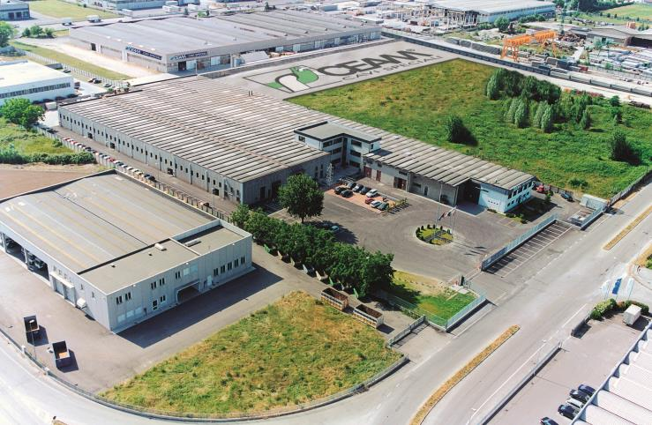
The acquisition of CEAM strengthens Lapp’s leading role in industry-standard data communication systems

The image is available in printable quality here

www.lappkabel.com/press

About the Lapp Group:
Headquartered in Stuttgart, Germany, the Lapp Group is a leading supplier of integrated solutions and branded products in the field of cable and connection technology. The Group’s portfolio includes standard and highly flexible cables, industrial connectors and screw technology, customized system solutions, automation technology and robotics solutions for the intelligent factory of the future, as well as technical accessories. The Lapp Group’s core market is in the industrial machinery and plant engineering sector. Other key markets are in the food industry as well as the energy and the mobility sector.

The Lapp Group has remained in continuous family ownership since it was founded in 1959. In the 2014/15 business year, it generated consolidated revenue of 886 million euros. Lapp currently employs approximately 3,300 people across the world, has 17 production sites and over 40 sales companies. It also works in cooperation with around 100 foreign representatives.

