The German Federal Ministry for Family Affairs elects the most family-friendly companies in Germany
LAPP reaches the final round of the "Success Factor Family 2016" competition

Stuttgart, 25 January 2016
The U.I. Lapp GmbH was nominated for the final round of the "Success Factor Family 2016" competition from over 400 applications. With this competition, the German Federal Ministry of Family Affairs, Senior Citizens, Women and Youth regularly distinguishes the most family-friendly companies in Germany. U.I. Lapp GmbH, a Lapp Group company, already received the "berufundfamilie" (work&family) certificate back in 2013.

There is a lot of family at Lapp. The "family-oriented" company value is a way of life at the world's leading supplier of cables and accessories from Stuttgart and sense of family has a long history: "There are currently three generations of our family working in the company and my mother Ursula Ida Lapp had to balance work and family at a time when that was anything but customary", explains Andreas Lapp, Spokesman of the Board at Lapp Holding AG. This is why family-concious personnel policies are part of the company's DNA at Lapp.

There are many aspects of family friendliness at Lapp. "Better time control thanks to family-concious shift planning, suitable scheduling of on-site events such as meetings, close contact with employees during parental leave, work structuring that takes the age and ageing of employees into account, as well as the promotion of reconciliation issues by the managers are just some of the areas where we specifically implement family friendliness", explains Sabine von Rechenberg, Head of Human Resources at U.I. Lapp GmbH. Flexible working time models and childcare, and above all an atmosphere of warmth and respectful cooperation are permanent fixtures in the Lapp culture. Family friendliness takes all generations into account: "As well as the next generation, we are increasingly involved in the topic of care", reports the Head of Human Resources.

The auditors from the berufundfamilie Service GmbH expert partner are currently inspecting the family-friendly measures on site at the Lapp Group. A top-level jury then selects the winners. The ceremonial presentation of the "Success Factor Family 2016" company competition is held in Berlin in June 2016.
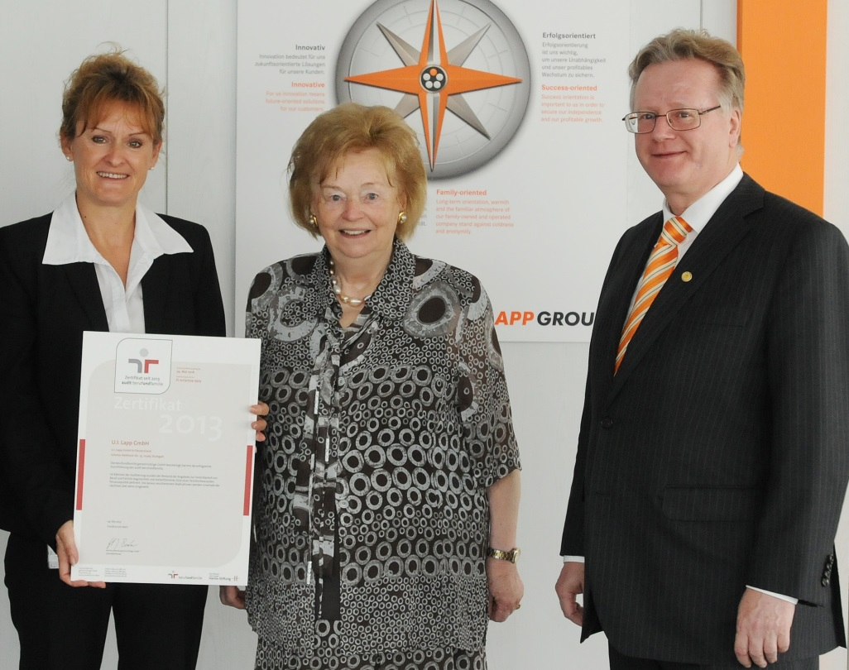
U.I. Lapp GmbH has been nominated for the final round of the "Success Factor Family 2016" company competition. Head of Human Resources Sabine von Rechenberg, company founder Ursula Ida Lapp and Spokesman of the Board Andreas Lapp (l to r) were already able to accept the berufundfamilie certificate in 2013

Find the image in printable quality here
www.lappkabel.com/press

About the Lapp Group:
Headquartered in Stuttgart, Germany, the Lapp Group is a leading supplier of integrated solutions and branded products in the field of cable and connection technology. The Group’s portfolio includes standard and highly flexible cables, industrial connectors and screw technology, customized system solutions, automation technology and robotics solutions for the intelligent factory of the future, as well as technical accessories. The Lapp Group’s core market is in the industrial machinery and plant engineering sector. Other key markets are in the food industry as well as the energy and the mobility sector.

The Lapp Group has remained in continuous family ownership since it was founded in 1959. In the 2013/14 business year, it generated consolidated revenue of 820 million euros. Lapp currently employs approximately 3,200 people across the world, has 18 production sites and over 40 sales companies. It also works in cooperation with around 100 foreign representatives.

About the "Success Factor Family 2016" company competition:
The "Success Factor Family 2016" company competition elects the most family-friendly employers in Germany. In order for SMEs to have just as fair a chance of winning as big corporations or publically-owned employers, there are overall winners in three size categories: Small employer (up to 100 employees), medium-sized employer (up to 1000 employees), large employer (over 1000 employees). The prize money for the winner of each category is € 5000. There are three additional special prizes. These are awarded in the categories "Father-friendly personnel policies"; "Company cooperation with partners on site" and "Innovation: Reconciliation in the world of digital work".

The "Success Factor Family 2016" company competition takes place within the framework of the "Success Factor Family" company programme. "Success Factor Family" bundles information about the topic of family friendliness in the company. It provides examples of successes and experience reports from companies that practise family-concious personnel policies using innovative measures. The "Success Factor Family" company programme is promoted within the framework of the "Reconciliation of Family and Work" programme by the German Federal Ministry of Family Affairs, Senior Citizens, Women and Youth and the European Social Fund.

More information is available at: www.unternehmenswettbewerb-erfolgsfaktor-familie.de and www.erfolgsfaktor-familie.de.

