The latest award for Stuttgart’s Lapp Group
Lapp is the 2017 Global Market Leader Champion
Stuttgart, 14 December 2016

In the University of St. Gallen’s annual ranking of the best in their industry, the Lapp Group was crowned champion of the “Integrated Solutions for Cable and Connection Technology” category. Technological leadership, international presence and customer focus are important criteria for companies wanting to be included in the Global Market Leader Index (or the Weltmarktführerindex in German). This is the third prestigious elite award in quick succession that the Stuttgart-based manufacturer of cable and connection solutions has won. In summer, the company made it onto the TOP 100 list of the most innovative SMEs. Lapp was also nominated as the most family-friendly company in Germany in the Success Factor Family 2016 (Erfolgsfaktor Familie 2016) competition run by the German Federal Ministry for Economic Affairs and Energy (BMWi). “We are delighted by these awards. We see them as an incentive to continue expanding on our position as an innovative company and attractive employer in Germany and abroad. The fact that we have been nominated as a market leader in integrated cabling technology solutions shows us that we are heading in the right direction with our ÖLFLEX CONNECT initiative,” said Andreas Lapp, Chairman of Lapp Holding AG. The Lapp Group has standardised and expanded its range of all-round, ready-to-install cabling solutions worldwide under the ÖLFLEX CONNECT name.

Customer focus, innovation and family atmosphere at the brand’s core
The successes have not been totally unexpected. The owner-operated company has developed a corporate culture based on values. “The core of our entrepreneurial action is in the focus on our customers, our family-oriented corporate culture and the emphasis on innovation and success. The Lapp Group is active in around 140 countries with its own production and logistics facilities on four continents. We also facilitate constant close exchange with our customers around the world in a wide range of industries. We use our understanding of the requirements of both our customers and the markets specifically to develop solutions that accurately reflect the latest trends. As a result of this close collaboration, we can develop innovative solutions for our customers and their markets,” explained Dr Matthias Kirchherr, Chief Sales Officer (CSO) for EMEA and South America.

The Global Market Leader Index is yet more proof that Lapp sets standards here. The University of St. Gallen’s Henri B. Meier School of Entrepreneurs created the index in collaboration with the Akademie Deutscher Weltmarktführer (ADWM). Professor Christoph Müller is responsible for compiling the index. It started with a database with more than a thousand entries of potential global market leaders in Germany, Austria and Switzerland. These companies were then researched and selected in an elaborate process. The creators have committed to a scientifically sound and transparent selection process and the selection criteria have been made public. The criteria include requirements relating to company turnover (> €50 million), how much of the turnover comes from international sources (>50%) and sales being made on at least three continents.

Innovative and family friendly
Lapp’s success in the Global Market Leader Index is not the company’s first award of the year. In June, the company was included in the TOP 100 list of the most innovative SMEs. The list was based on scientific criteria and was compiled by Prof. Nikolaus Franke from the Institute for Entrepreneurship and Innovation of Vienna University of Economics and Business. Lapp excelled in all five assessment categories: “innovation-promoting top management”, “innovation climate”, “innovative processes and organisation”, “innovation marketing/outward orientation” and “innovation success”. U.I. Lapp GmbH also won the “Success Factor Family 2016” competition in June for its HR policy, which is oriented towards various life stages, and was thus named the most family-friendly company in Germany in the SME category.

Information on the global market leaders is available in German at: www.weltmarktfuehrerindex.de. The entire Global Market Leader Index and the accompanying report is available on our media partner WirtschaftsWoche’s portal (www.wiwo.de). Information on the other awards is available at:
http://www.lappkabel.com/press.html
http://www.lappkabel.de/presse/presseinformation.html
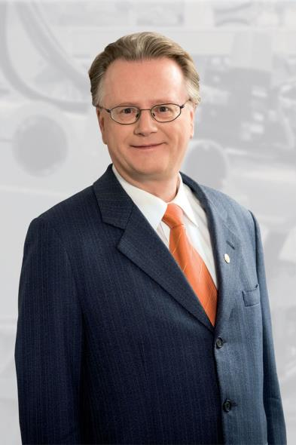
Andreas Lapp, Chairman of Lapp Holding AG
The image is available in printable quality here

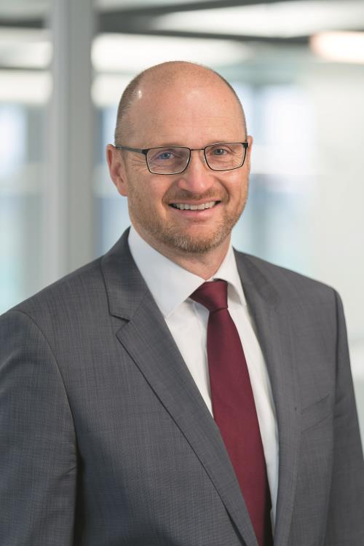
Dr Matthias Kirchherr, Chief Sales Officer (CSO) for EMEA and South America
The image is available in printable quality here

www.lappkabel.com/press
http://www.lappkabel.com/press/latest-press-releases.html
About the Lapp Group:
Headquartered in Stuttgart, Germany, the Lapp Group is a leading supplier of integrated solutions and branded products in the field of cable and connection technology. The Group’s portfolio includes standard and highly flexible cables, industrial connectors and screw technology, customized system solutions, automation technology and robotics solutions for the intelligent factory of the future, as well as technical accessories. The Lapp Group’s core market is in the industrial machinery and plant engineering sector. Other key markets are in the food industry as well as the energy and the mobility sector.

The Lapp Group has remained in continuous family ownership since it was founded in 1959. In the 2014/15 business year, it generated consolidated revenue of 886 million euros. Lapp currently employs approximately 3,300 people across the world, has 17 production sites and over 40 sales companies. It also works in cooperation with around 100 foreign representatives.

