Food industry: Dynamic market with innovation potential
Lapp plans growth with new sectors
Stuttgart, 01.03. 2016
There is significant growth potential for the Lapp Group in tailored solutions for selected high-growth sectors. Lapp uses its application expertise from existing customer relationships and develops solutions that are exactly tailored to the sector requirements. Following the successful positioning of innovative connection technology in the renewable power and e-mobility branches, Lapp has now launched a portfolio for the food & beverage sector. With this, the Stuttgart-based manufacturer plans to increase turnover from its current € 25 million to € 100 million in the coming years.
Georg Stawowy, Head of Technology & Innovation: "The growing world population requires more and better food and consumer habits are changing in Western countries too. This means that better quality foodstuffs have to be produced more efficiently and in greater diversity. To do so, we need tailored connection technology that fulfils the highest hygiene standards". This is also emphasised by a study by KPMG which showed that investment in new products and processes is a top priority for top managers in the foodstuffs industry. Beyond the food and beverage producers themselves, machinery manufacturers who produce filling and packaging systems, metering and portioning machines, cutters, mixers as well as many other machines for the food and beverage industry are also potential Lapp customers.

How Lapp identifies the needs of the sector
In order to define the machinery and plant construction requirements of the sector precisely, Lapp carried out classic primary and secondary market research. The worldwide Lapp network of sales employees and product managers was used for this purpose. They asked the customers directly about the relevant information and needs. Findings from expert discussions at institutes such as EHEDG or with suppliers such as ECOLAB were also included. Field tests were also carried out at selected customers. The analysis showed that a very important criterion in the sector is resistance to mechanical and chemical stress since this is a weak point, especially when it comes to cleaning foodstuffs plants. Up to 30% of the daily capacity of plants is lost to necessary cleaning work, this time is required for foaming, scrubbing, disinfecting and rinsing. However, it is not just machinery downtimes, whether planned or unplanned, that are an issue in the sector, staff safety at the machine is even more important as they would be exposed to the risk of electric shock if unsuitable electrical connection solutions were used. Georg Stawowy: "Generally, the manufacturer does not want to have to deal with cabling in detail, it would not be productive for the operator of a production facility. Instead, they want the certainty that the plant and all its components work reliably and safely and comply with hygiene and durability requirements. Lapp can guarantee this for its cabling."

Highest hygiene standards
With all of its products, Lapp deserves to be called a technology leader – This also applies to the food industry. The requirements for the products used are particularly high due to high continuous temperatures at times, as well as moisture and resistance to chemicals and cleaning agents. This has an impact on product design. In classic mechanical engineering, the domed cap nut of a cable gland, for instance, must have as much grip as possible to ensure that it holds in place properly. Although the wrench on a dough-kneading machine should grip well, foodstuff residue and germs should not hold. For this reason, Lapp developed the SKINTOP® HYGIENIC stainless steel cable gland. Instead of a hexagon, there are only two surfaces on which the wrench can grip. Thanks to special machining, the surface also has a very low roughness level. Instead of standard seals, special formed parts are used, ensuring completely smooth transitions throughout without chinks or gaps where soiling could accumulate.

Lapp offers a full product portfolio for meeting the requirements of the food and beverage industry. The components meet strict international requirements, such as EHEDG design specifications or compatibility with ECOLAB® cleaning agents. These products are now being sold in every region around the world, with the share of turnover constantly increasing. One of the ways in which Lapp stands out from its competition is through its extensive portfolio, from cables to cable glands, connectors and cable marking systems. This means Lapp is a solutions provider for companies who operate food and beverage technology. Consulting is also becoming more and more important. 95 percent of firms in the food industry are small or medium-sized companies with fewer than 250 employees. They generally have little knowledge about the cabling used in their systems. "Our consulting and solution expertise is our trump card. After all, every contractor knows that downtimes for maintenance and repairs have to be minimised in order to produce as efficiently as possible", explains Stawowy.
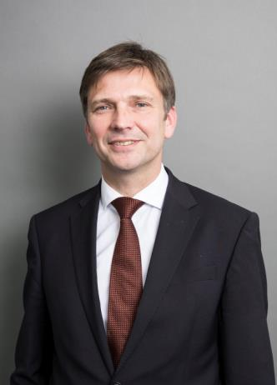
Georg Stawowy, Chief Technical Officer at Lapp Holding AG
Find the image in printable quality here

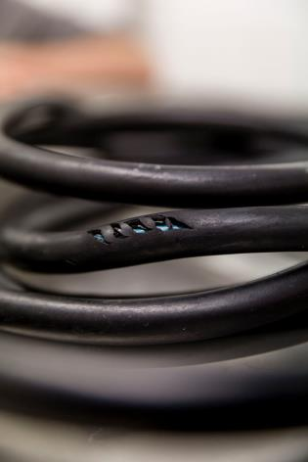
Not all cables are suitable for the demanding conditions in the food and beverage industry – this can be dangerous for employees.
Find the image in printable quality here
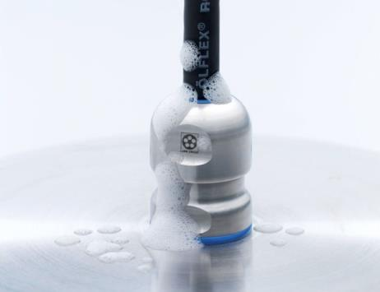
The SKINTOP® HYGIENIC stainless steel cable gland is specifically developed for the requirements of the food and beverage industry
Find the image in printable quality here

www.lappkabel.com/press

About the Lapp Group:
Headquartered in Stuttgart, Germany, the Lapp Group is a leading supplier of integrated solutions and branded products in the field of cable and connection technology. The Group’s portfolio includes standard and highly flexible cables, industrial connectors and screw technology, customized system solutions, automation technology and robotics solutions for the intelligent factory of the future, as well as technical accessories. The Lapp Group’s core market is in the industrial machinery and plant engineering sector. Other key markets are in the food industry as well as the energy and the mobility sector.

The Lapp Group has remained in continuous family ownership since it was founded in 1959. In the 2014/15 business year, it generated consolidated revenue of 886 million euros. Lapp currently employs approximately 3,300 people across the world, has 17 production sites and over 40 sales companies. It also works in cooperation with around 100 foreign representatives.s

