Werner Knies succeeds Dr Roland Kern
New supervisory board member at Lapp Holding AG

Stuttgart, 27 May 2016
Change in the Lapp Holding AG supervisory board: Werner Knies (63) has been appointed to the supervisory board with effect from 3rd February 2016. He succeeds Dr Roland Kern, who is retiring from the supervisory board at the age of 75. Dr Kern has been a member of the supervisory board for 18 years.

Werner Knies has been connected to the family company for more than 20 years. He was most recently Member of the Board for Finance and Controlling in Lapp Holding AG for ten years, and has been Member of the Board for Human Resources and Organisational Development since 2011. “Mr Knies is an outstanding manager, who has shaped our company over many years and knows it extremely well. I'm sure he will be an excellent addition to the supervisory board”, stated Siegbert E. Lapp, Chairman of the Supervisory Board at Lapp Holding AG.

The supervisory body at Lapp Holding AG currently has three members: Chairman Siegbert E. Lapp, Dr Hans Schumacher, Chairman of the Board of Management at Dürr Systems GmbH, and Werner Knies. Company founder Ursula Ida Lapp is Honorary Chairwoman of the Supervisory Board at Lapp Holding AG, and also serves as the Chairwoman of the Supervisory Board at U.I. Lapp GmbH.

The Chairman of the Board of Lapp Holding AG, Andreas Lapp, will assume the responsibiliy for Human Resources and Organisational Development until the position is retaken.

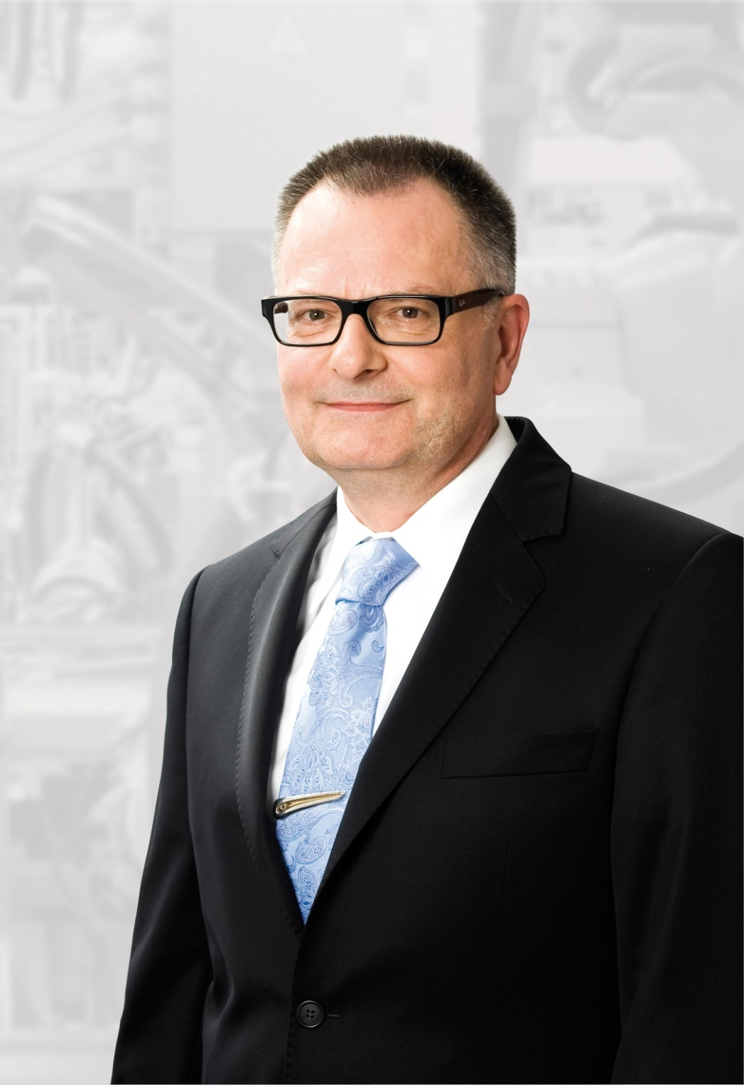
Werner Knies moves from the management board to the supervisory board at Lapp Holding AG

The image is available in printable quality here

www.lappkabel.com/press

About the Lapp Group:
Headquartered in Stuttgart, Germany, the Lapp Group is a leading supplier of integrated solutions and branded products in the field of cable and connection technology. The Group’s portfolio includes standard and highly flexible cables, industrial connectors and screw technology, customized system solutions, automation technology and robotics solutions for the intelligent factory of the future, as well as technical accessories. The Lapp Group’s core market is in the industrial machinery and plant engineering sector. Other key markets are in the food industry as well as the energy and the mobility sector.

The Lapp Group has remained in continuous family ownership since it was founded in 1959. In the 2014/15 business year, it generated consolidated revenue of 886 million euros. Lapp currently employs approximately 3,300 people across the world, has 17 production sites and over 40 sales companies. It also works in cooperation with around 100 foreign representatives.

