Barack Obama and German chancellor Angela Mrkel visits Lapp’s booth at Hanover Trade Fair
Obama and Merkel impressed with ÖLFLEX ROBOT’s flexibility

Stuttgart/Hanover, Germany, 25 April 2016

The Stuttgart-based Lapp Group received a visit from some very important guests at its booth at the 2016 Hannover Messe trade fair today: US President Barack Obama and German Chancellor Angela Merkel learned all about the latest innovations from the Swabian family-run business.

One of the booth’s major highlights was a basketball-playing robot made by Lapp’s customer Comau, incorporating robust and highly flexible Lapp cables. “The ÖLFLEX® ROBOT cables, which are laid inside the robot arm must stand quick and precise movement under high torsion, tight bending radii and severe acceleration. „Over a robot’s service life, this means that cables will be twisted 15 million times over 1400 degrees along their own axis,” explained Chairman Andreas Lapp.” Actually, a cable cannot possibly withstand that kind of punishment, but our engineers still made it possible. This way, Comau can give full eight years of warranty on their robots.”

Apart from the special solution for Comau, Lapp offers all kinds of cabling solutions for robots, and in this context the Internet of Things is becoming more and more important. Andreas Lapp also presented to the President and the Chancellor a set of data and power cables for robots. Internet of Things means that robots and other machines have to be increasingly networked. The rising data volumes and challenging mechanical requirements are extremely challenging for the cables. The ETHERLINE® TORSION Cat.6_{A} for example can transmit up to 10 Gigabits of data per second even under permanent twisting. “Only Lapp can deliver such complete solutions, in this we are a world market leader,” declared Andreas Lapp proudly.

Andreas Lapp accompanied his guests as they strolled through the cable specialist company’s “Walk of Fame”. The walk featured actors dressed up as film stars Marilyn Monroe and Charlie Chaplin, in honour of this year’s partner country, the USA – and also revealed the latest highlights from the Lapp portfolio. “I am impressed at how a family-owned business like Lapp has found international success,” said Chancellor Markel. President Obama added: “Lapp serves as an excellent role model for US businesses.”

In conversation with President Obama, Andreas Lapp highlighted the US market’s significance for the Lapp Group: “In the USA we’ve recently experienced particularly good growth of more than 20%.” The market’s importance is also underlined by the fact that one of Lapp’s key areas of focus at the trade fair was its UL-certified products, accredited especially for use in North America.
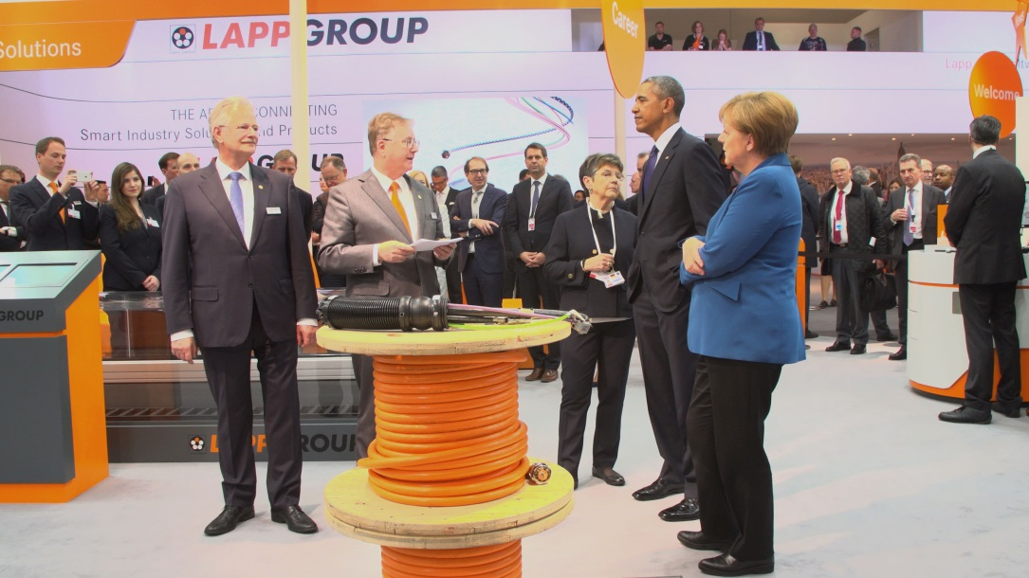
Andreas and Siegbert Lapp present robotics cabling solutions by Lapp to US President Barack Obama and Chancellor Angela Merkel

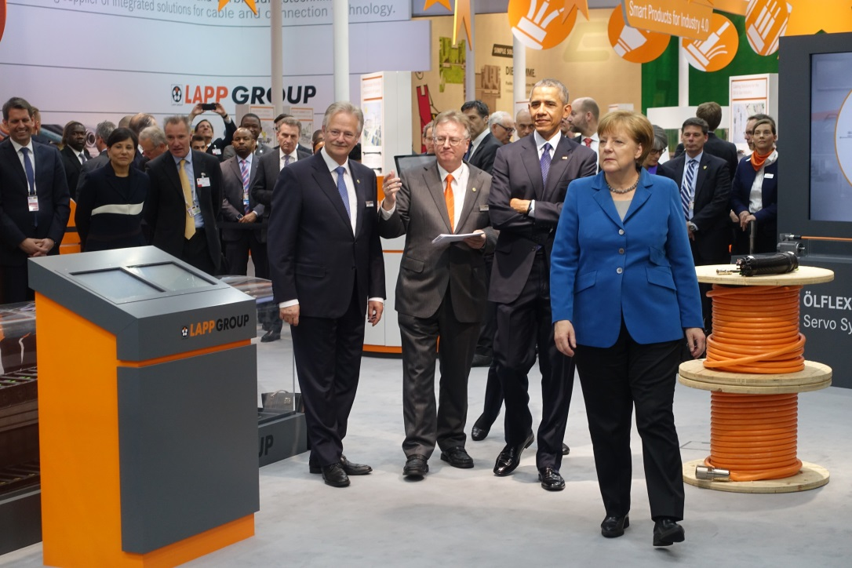
Very important guests at the Lapp stand at Hannover Messe: Barack Obama and Angela Merkel were impressed

www.lappkabel.de/presse

About the Lapp Group:
Headquartered in Stuttgart, Germany, the Lapp Group is a leading supplier of integrated solutions and branded products in the field of cable and connection technology. The Group’s portfolio includes standard and highly flexible cables, industrial connectors and gland technology, customized system solutions, automation technology and robotics solutions for Industry 4.0 and the intelligent factory of the future, as well as technical accessories. The Lapp Group’s core market is in the industrial machinery and plant engineering sector. Other key markets are the food industry as well as the energy, mobility and life science sectors.

The Lapp Group has remained in continuous family ownership since it was founded in 1959. In the 2014/15 business year, it generated consolidated revenue of 886 million euros. Lapp currently employs approximately 3,300 people across the world, has 17 production sites and over 39 sales companies. It also works in cooperation with around 100 partner companies in other countries.

