Lapp makes it into the TOP 100
The Stuttgart-based company has become one of Germany’s elite innovators / Company to receive award from TOP 100 mentor Ranga Yogeshwar

Stuttgart, 27 June 2016
The TOP 100 companies, a title bestowed upon the most innovative German SMEs, are to be named in the 23rd edition of this competition. The Lapp Group is among the innovative elite this year. The Stuttgart-based company had taken part in a demanding scientific selection process to achieve this status. The Group’s innovation management and success in innovation were examined. The mentor of the innovation competition, Ranga Yogeshwar, will present the award for Top Innovator during the German SME Summit on 24 June in Essen.
The innovative strength behind the Lapp Group, which has been awarded the TOP 100 seal, has a name: “technology and innovation management”, or TIM for short. The workshops of the same name run by the Stuttgart-based experts in connection technology are a breeding ground for new ideas. Employees from around the world working in a wide range of roles are invited to develop new solution approaches for customers three or four times per year. There are also a number of smaller TIM workshops in various departments throughout the company. “Our aim is for our employees to view innovations as part of their day-to-day work going forward so that they no longer need managers in order to come up with innovations,” said Siegbert Lapp, Chairman of the Supervisory Board.
The Top Innovator develops and produces complete solutions for cable technology and creates a broad portfolio of branded products, including flexible cables, power and control cables, data and fibre optic cables, cable glands, industrial connectors and cable accessories. 3,300 or so employees around the world work for the family company, which was founded in 1959. 1,200 of these employees are based in Germany. The portfolio of standard products, not including the company’s countless special-purpose solutions, now consists of over 40,000 items. This huge range is the result of many successful innovations.
Lapp is the market leader in the industry in Germany as well as being in the top tier internationally. Georg Stawowy, Member of the Board for Technology and Innovation, explains Lapp’s philosophy for innovation: “Firstly, we want to tap into new markets with our innovations. Secondly, we want to be the company that is always providing the latest and best products.”
Over 4,000 companies expressed an interest in participating in TOP 100 this year. 366 applied for the qualifying round. 284 reached the final round. 238 then managed the leap into the TOP 100 (a maximum of 100 companies in each of the three size categories). The companies were once again assessed by Professor Nikolaus Franke and his team at the Chair for Entrepreneurship and Innovation of Vienna University of Economics and Business. They used 100 parameters in five assessment categories – “innovation-friendly executive management”, “innovation climate”, “innovative processes and organisation”, “innovation marketing / external orientation” and “innovation success” – to perform their evaluation.
The TOP 100 companies are seen as the trendsetters in their industries. This is also reflected in the assessment’s figures: Among the companies, 97 are market leaders on a national scale and 32 are market leaders on a global scale. Looking at recent statistics, they generated an average of 40 percent of their turnover with market innovations and product improvements brought onto the market ahead of their competitors. Their sales growth was around 28 percentage points higher than the respective average in the industry. In total, the SMEs have filed 2,292 national and international patents over the past three years. This innovative capacity is also paying off in the workplace as the TOP 100 companies are planning to hire around 9,500 new employees over the next three years.
Ranga Yogeshwar, the mentor of TOP 100 who is also a science journalist and TV presenter, is impressed by the quality of the companies and is hoping to see others follow in their footsteps: “The way in which the TOP 100 companies come up with new ideas and develop groundbreaking products and services from these ideas is truly remarkable. I am so glad that this award shines a light on these qualities. Hopefully their success will encourage other companies to follow suit. After all, this culture of innovation will become increasingly significant to all companies in future.”
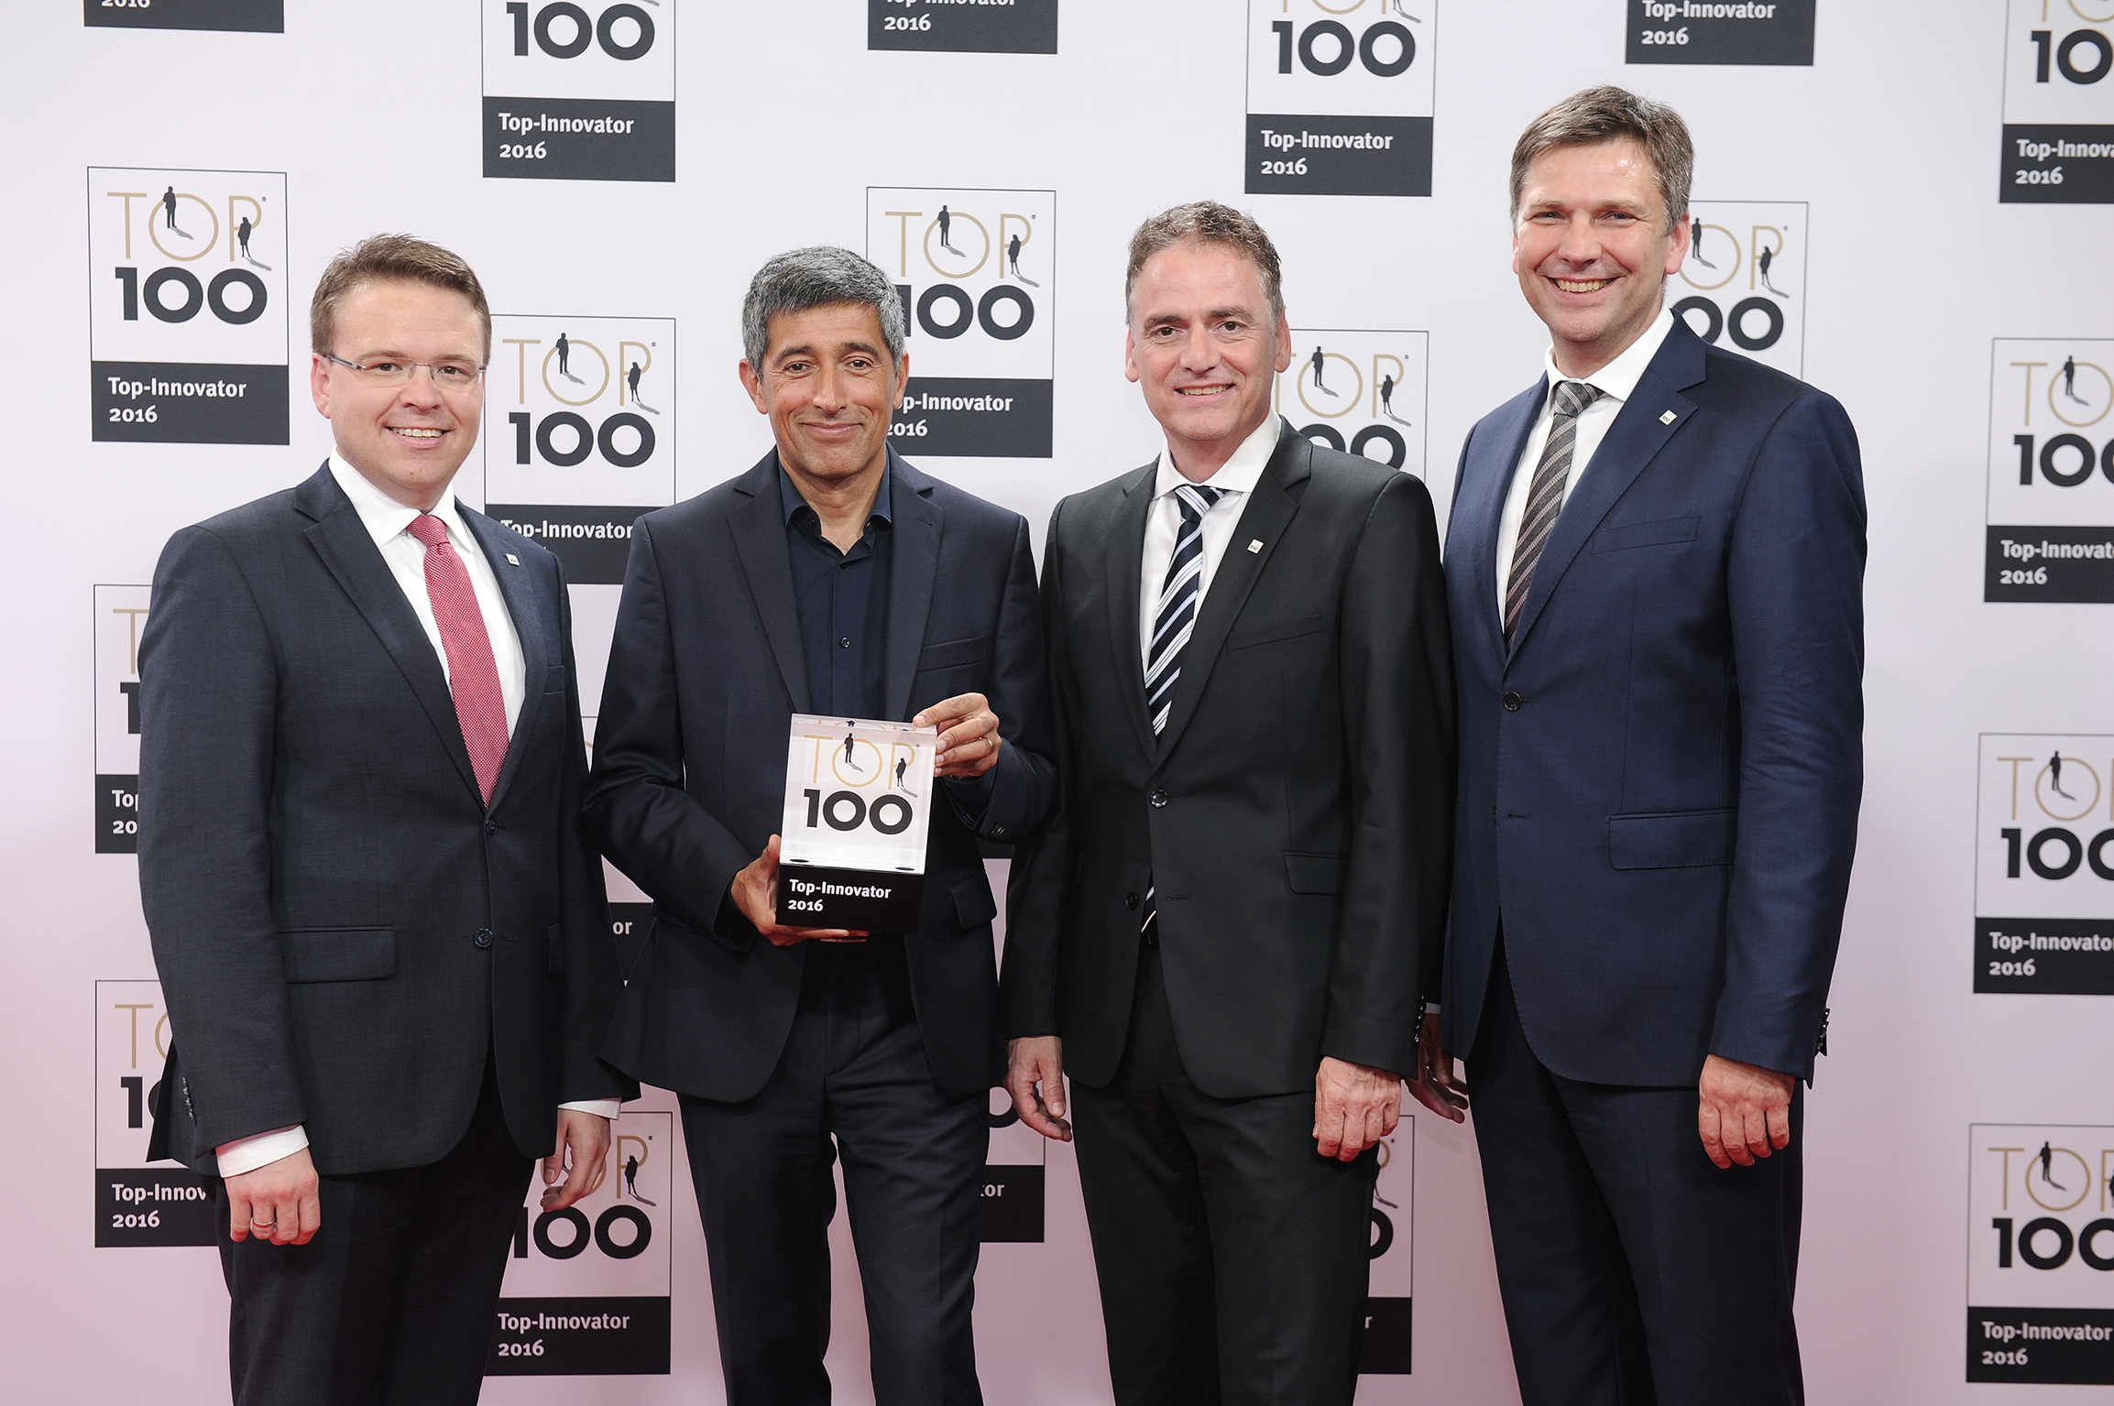
Caption:
Lapp makes it into the TOP 100 and belongs to the most innovative German SMEs. v.l. Dr. Simon Alig, Assitant of the Managing Board Technology & Innovation, mentor Ranga Yogeshar, Guido Ege, Head of Product Management and Product Development, and Georg Stawowy, Member of the Board for Technology and Innovation. Picture: KD Busch/comamedia

The image is available in printable quality here
www.lappkabel.de/presse

TOP 100: the competition
compamedia has been awarding the TOP 100 seal for high innovative capacity and outstanding success in innovation to SMEs since 1993. Professor Nikolaus Franke from the Institute for Entrepreneurship and Innovation of Vienna University of Economics and Business has been the competition’s Scientific Director since 2002. Science journalist and TV presenter Ranga Yogeshwar is the mentor of TOP 100. The Fraunhofer Society for the Promotion of Applied Research and the German Association for Small and Medium-Sized Businesses (BVMW) are project partners. manager magazin also supports the competition as a media partner. More information is available at www.top100.de.

About the Lapp Group:
Headquartered in Stuttgart, Germany, the Lapp Group is a leading supplier of integrated solutions and branded products in the field of cable and connection technology. The Group’s portfolio includes standard and highly flexible cables, industrial connectors and screw technology, customized system solutions, automation technology and robotics solutions for the intelligent factory of the future, as well as technical accessories. The Lapp Group’s core market is in the industrial machinery and plant engineering sector. Other key markets are in the food industry as well as the energy and the mobility sector.

The Lapp Group has remained in continuous family ownership since it was founded in 1959. In the 2014/15 business year, it generated consolidated revenue of 886 million euros. Lapp currently employs approximately 3,300 people across the world, has 17 production sites and over 40 sales companies. It also works in cooperation with around 100 foreign representatives.

