Federal Ministry for Families honours Germany’s most family-oriented companies
Lapp wins “Success Factor Family 2016” competition

Stuttgart, 28 June 2016

The Stuttgart-based cable manufacturer U.I. Lapp GmbH won the “Success Factor Family 2016” (Erfolgsfaktor Familie 2016) corporate competition in the SME category. U.I. Lapp GmbH is one of the companies within the Lapp Group, the world’s leading manufacturer of cables, connectors and connectivity solutions. Owner Andreas Lapp personally accepted the award issued by the Federal Ministry of Family Affairs, Senior Citizens, Women and Youth in Berlin yesterday. More than 400 companies throughout Germany had applied for the award by providing information on their measures and concepts for balancing work and family life.

Sabine von Rechenberg, Head of Human Resources at U.I. Lapp GmbH, believes that the company’s family orientation can be seen in several ways. The Stuttgart-based cable manufacturer has implemented a variety of measures aimed at balancing work and family life under the heading “HR policy based on the various life phases”. Von Rechenberg added that in addition to implementing measures such as flexible working hours; family-conscious shift planning with a shift exchange option in logistics; programmes aimed at keeping in contact with and reintegrating parents on parental leave; a workshop offering advice on care-related topics; staff training on searching for care options; courses on health-related topics; or even the provision of a parent and child room, the company also aims to raise awareness about how to manage in a “family- and health-conscious” way among management on an ongoing basis.

“Having a sense of family is in Lapp’s DNA,” said Andreas Lapp, Chairman and Owner of Lapp Holding AG, who accepted the top prize in Berlin yesterday. “We are very proud of this award and feel honoured that our commitment has been acknowledged in this way. A sustainable HR policy is the underlying factor behind our success. Our plans for the future will see us systematically continuing along this path.”

berufundfamilie Service GmbH issued U.I. Lapp GmbH with the “Work and Family” (berufundfamilie) certificate for its family-oriented working conditions in 2013 and again in 2016 under the auspices of the Federal Ministry of Family Affairs, Senior Citizens, Women and Youth.

U.I. Lapp GmbH’s family orientation is not the company’s only forward-looking policy. The Lapp Group’s innovation policy is also setting standards. The company received the TOP 100 award in 2016 and is thus one of the most innovative SMEs in Germany. Ranga Yogeshwar, mentor of the innovation competition, presented the Top Innovator award during the German SME Summit on 24 June in Essen. 4,000 companies had applied for the prize. A total of 238 companies in three size categories were successful in being named in the TOP 100 list.
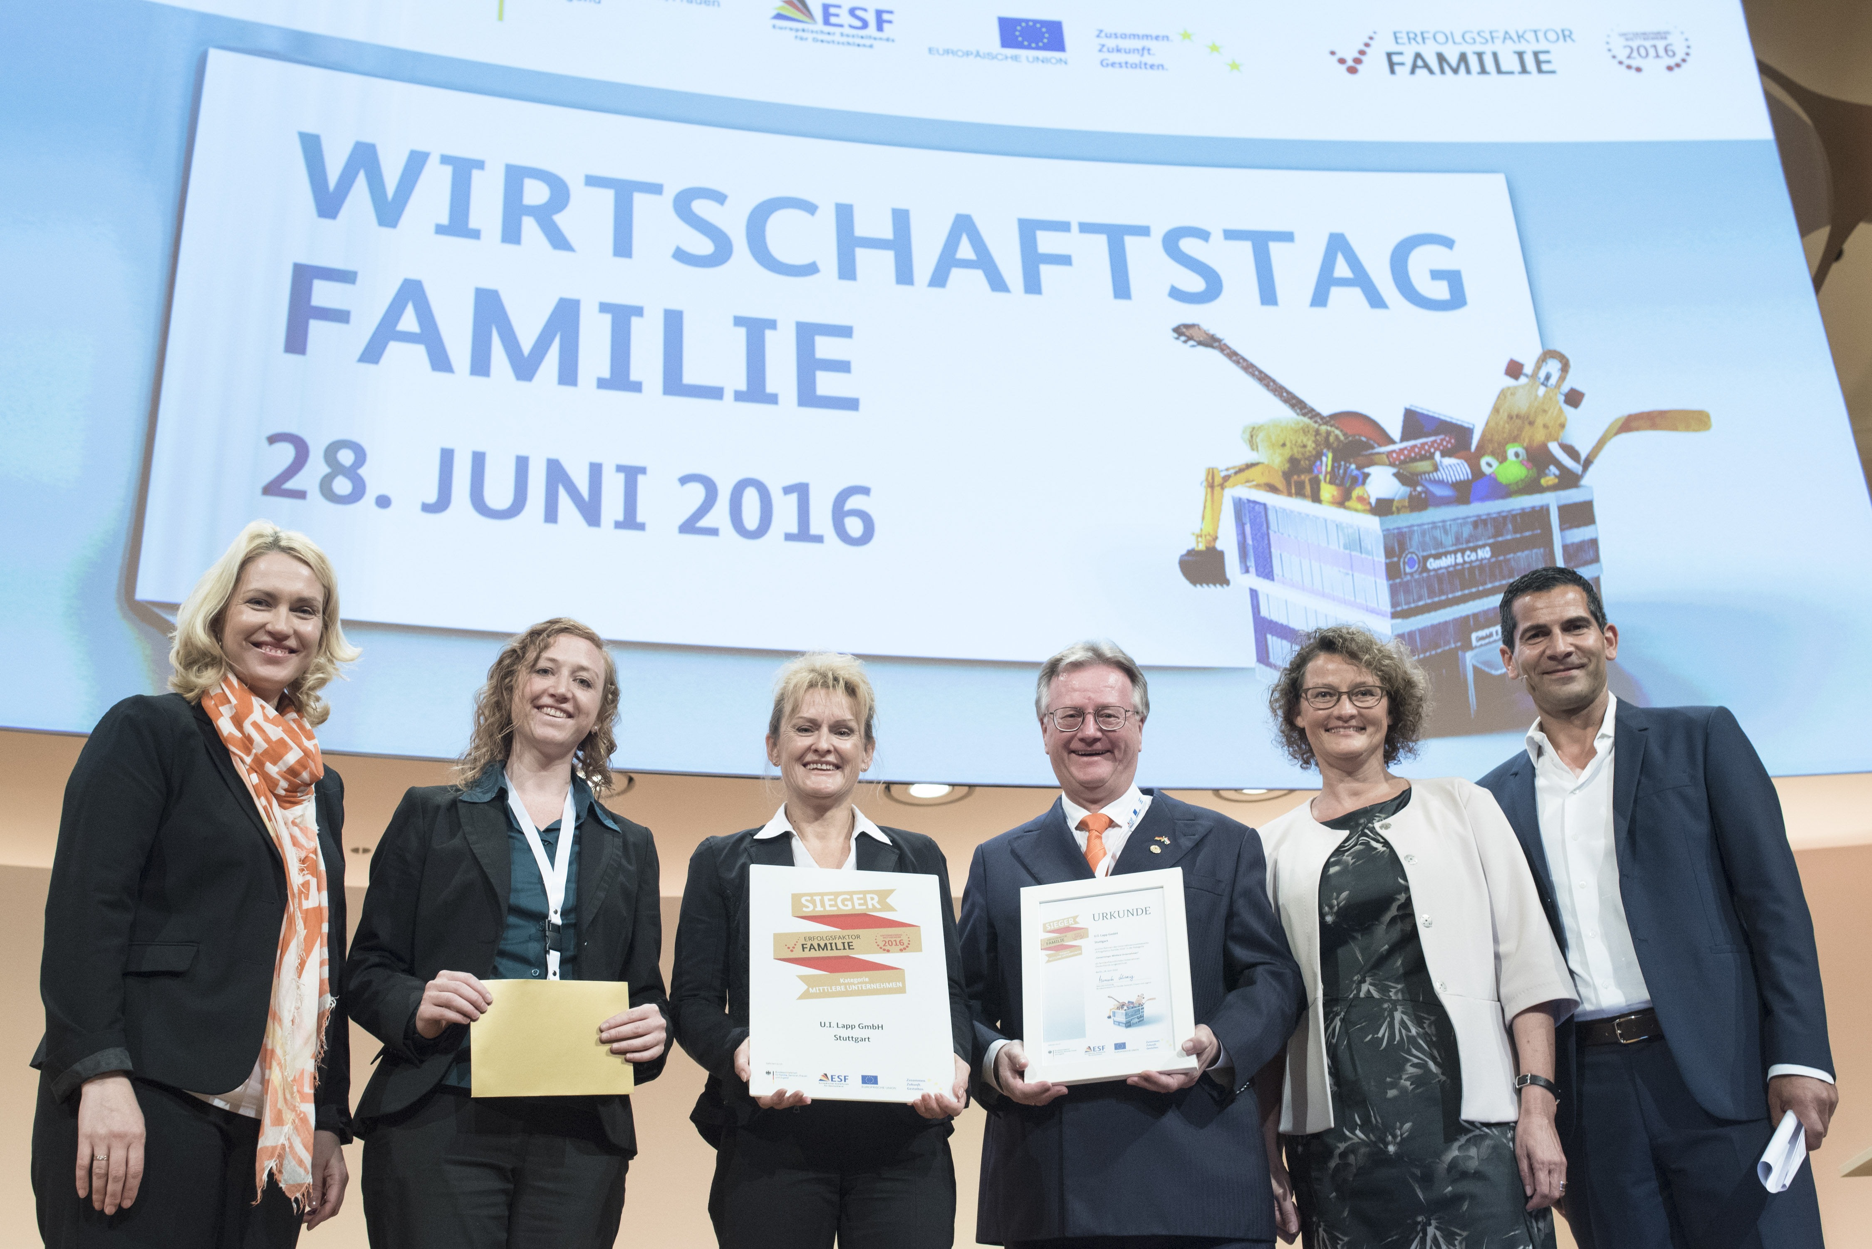
Capture:
Award ceremony in Berlin: f. l. Minister Manuela Schwesig, project leader Iris Lange, Head of Human Resources Sabine von Rechenberg, owner Andreas Lapp, Dr. Elke Eller (Federal Association of Human Recources Manager) and moderator Sirin Mitri. Picture: H C Plambeck

www.lappkabel.de/presse

About the Lapp Group:
Headquartered in Stuttgart, Germany, the Lapp Group is a leading supplier of integrated solutions and branded products in the field of cable and connection technology. The Group’s portfolio includes standard and highly flexible cables, industrial connectors and screw technology, customized system solutions, automation technology and robotics solutions for the intelligent factory of the future, as well as technical accessories. The Lapp Group’s core market is in the industrial machinery and plant engineering sector. Other key markets are in the food industry as well as the energy and the mobility sector.

The Lapp Group has remained in continuous family ownership since it was founded in 1959. In the 2014/15 business year, it generated consolidated revenue of 886 million euros. Lapp currently employs approximately 3,300 people across the world, has 17 production sites and over 40 sales companies. It also works in cooperation with around 100 foreign representatives.

