Lapp at Hannover Messe 2017
A connector for (almost) everything

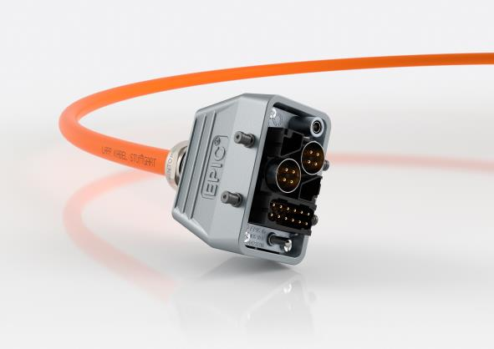

All-round talent: The new EPIC® MH rectangular connector system can
be equipped with various modules for performance and data in a few simple steps.

Stuttgart, April 18, 2017

Power, signals and data: the new EPIC® MH rectangular connector from the Stuttgart-based Lapp Group is a truly talented all-rounder.

Users can combine the tasks performed by various cables in a single connector and assemble modules in whatever way they please. All of this is guaranteed by a connector frame that can be equipped with both Lapp connector modules and standard modules available on the market – and assembly is far easier compared to the conventional folding and sliding frames. 2 to 36 poles, currents of up to 100 A, voltages of up to 1,000 V, Cat. 5 data transfer at 100 MHz/s – there are almost no limits to the potential combinations available to users.

The modular connector system particularly benefits customers who are developing new machinery. They can adjust the connector slightly during the development process, so they don’t have to constantly assemble new cables when changes need to be made. The online catalogue and the product finder provide user support to make sure the selection process doesn’t become an awful ordeal, and Lapp’s product and application advisors are on hand to help with trickier configurations.

These and many other innovations from Lapp will be on show at Lapp’s stand (C03) in Hall 11 at Hannover Messe.

You will find the image in printable quality here.

Press contact
Dr Markus Müller Irmgard Nille
Tel.: +49 (0)711/7838-5170 Tel.: +49 (0)711/7838–2490
Mobile: +49 (0)172/1022713 Mobile: +49 (0)160/97346822
markus.j.mueller@lappgroup.com irmgard.nille@in-press.de

U.I. Lapp GmbH
Schulze-Delitzsch-Straße 25
70565 Stuttgart
Germany

You will find further information on this topic here: www.lappkabel.de/presse

About the Lapp Group:
The Lapp Group based in Stuttgart, Germany, is a world market leader for integrated solutions and branded products in the field of cable and connection technology. The Group’s portfolio includes standard and highly flexible cables, industrial connectors and screw technology, customized system solutions, automation technology and robotics solutions for the intelligent factory of the future, as well as technical accessories. The Lapp Group’s core market is in the industrial machinery and plant engineering sector. Other key markets are in the food industry as well as the energy and the mobility sector.
The Lapp Group has remained in continuous family ownership since it was founded in 1959. In the 2015/16 business year, it generated consolidated revenue of 901 million euros. Lapp currently employs approximately 3,440 people across the world, has 17 production sites and over 40 sales companies. It also works in cooperation with around 100 foreign representatives.

