Lapp Group presents globally available system solutions at EMO 2017
Lean processes with ÖLFLEX® CONNECT

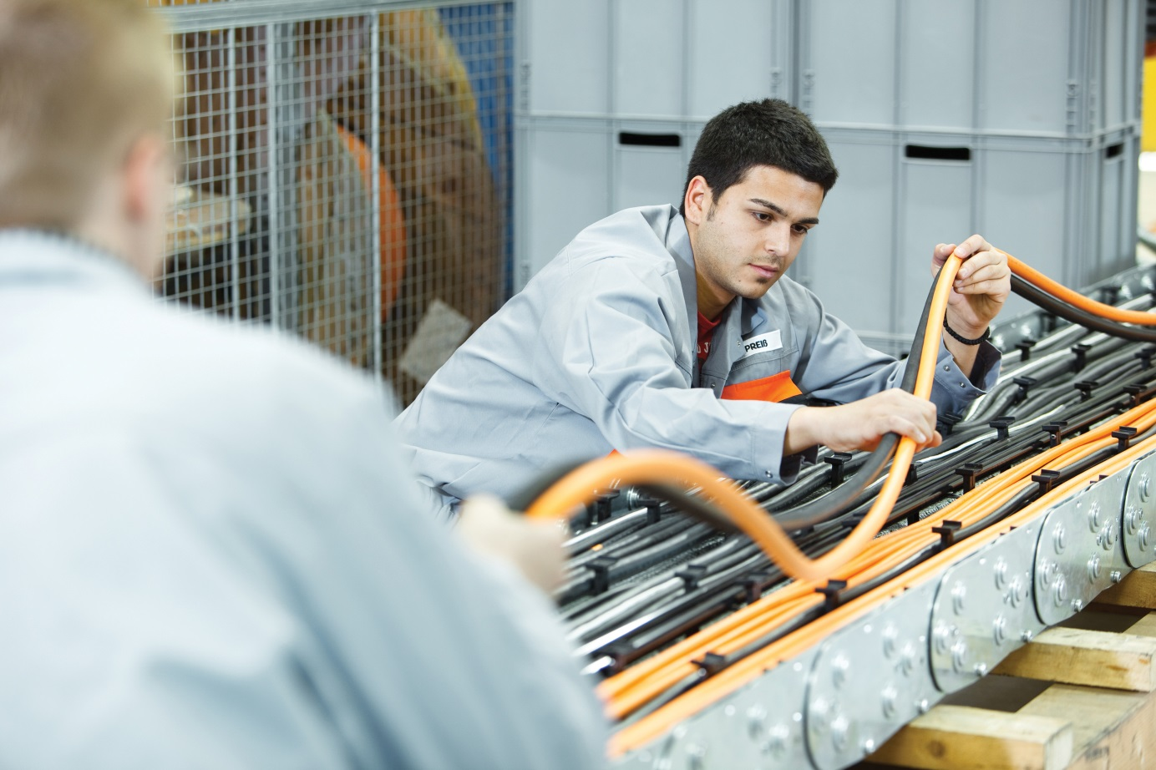
Image 1: Complete connection solutions from Lapp help machine tool manufacturers save time and costs. They also benefit from the Lapp Group’s manufacturing expertise.

Stuttgart, September 6, 2017

For machine tool manufacturers, lean processes are a vital part of staying competitive on the international market. The Lapp Group, global market leader for integrated cabling and connectivity solutions, will show how the sector can make connection technology more efficient at EMO Hannover 2017, the world’s leading trade fair for metalworking (hall 25, stand E 35). The Stuttgart-Based company will present its ÖLFLEX® CONNECT range of system solutions. Lapp offers its customers tailored, complete cable assemblies and power chains, allowing them to concentrate on what they do best rather than assembling cables and connectors themselves.

As a brand manufacturer of various cabling components, Lapp can also produce cutting-edge solutions with special properties, in a way that other companies who simply provide assemblies are incapable of. One of the highlights at the Lapp stand is the smart ÖLFLEX® CONNECT SERVO assembly series for connecting servo drives. Thanks to a partially automated production process and new, specially developed cables and connectors, those assemblies achieve electromagnetic screening that is at least 400 percent better than that of standard solutions. In addition, Lapp’s international production and sales network allows it to offer these solutions around the world in consistently high quality, while remaining close to the customers. ÖLFLEX® CONNECT SERVO, for example, are currently produced in Stuttgart and Singapore in a new, partially automated process. Preparations are also under way to start production at Lapp USA in New Jersey.

“This is especially important for those customers who have production facilities all over the world. These global players do not want to have to use different solutions at different locations that need to be verified every time. In addition, working with a system supplier is easier for them than procuring individual components from different providers”, explains Rolf Haldemann, Manager Business Development ÖLFLEX® CONNECT for Europe, Africa, Middle East and South America.

Meantime, leading machine tool manufacturers are successfully using ÖLFLEX® CONNECT SERVO system solutions. In drives, Lapp offers connectors that comply with Siemens, SEW Eurodrive and Rockwell standards, with further variants due to follow. Another addition to the portfolio is the EPIC® Motion Control connector for the new generation of booksize-format Siemens controllers. Customers can also choose between the Basic Line, Core Line and Extended Line variants, which differ in properties such as sheath material or levels of flexibility.

Lapp’s ÖLFLEX® CONNECT strategy is built on three elements: ÖLFLEX® CONNECT SERVO for servo cable assemblies, ÖLFLEX® CONNECT CABLES for classic cable assemblies and ÖLFLEX® CONNECT CHAIN for the design and assembly of complete power chains.

Georg Stawowy, member of the board at Lapp Holding AG for technology and innovation: “Consistent quality and global availability are particularly important for our customers”. That is why Lapp is continuing to expand its international network of production facilities for cable assemblies. Lapp currently has three competence centres, located at Lapp Asia Pacific in Singapore, Lapp USA in New Jersey and the European competence centre based in Stuttgart, Germany. Further production and engineering capacities are available in Otrokovice (Czech Republic), Desio (Italy), Nyköping (Sweden), Shanghai (China) and Bangalore (India).

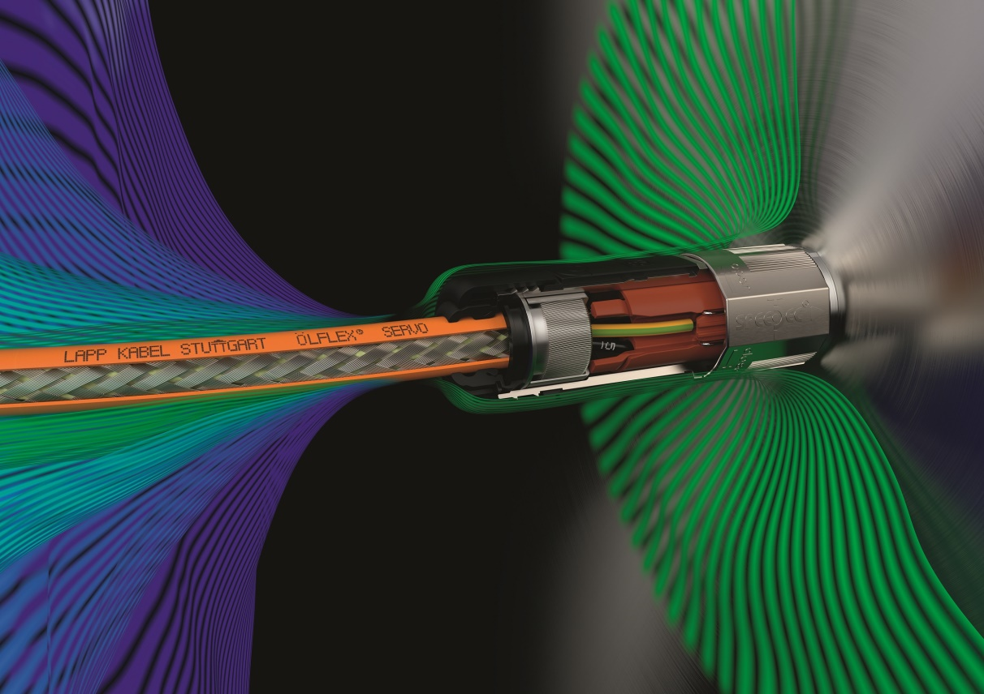
Image 2: The new ÖLFLEX® CONNECT SERVO harnesses achieve electromagnetic screening that is at least 400 percent better than that of standard solutions.

You can find image 1 in printable quality here
You can find image 2 in printable quality here

Press contact:
Dr. Markus Müller Irmgard Nille
Tel: +49(0)711/7838-5170 Tel.: +49(0)711/7838–2490
Mobil: +49(0)172/1022713 Mobil: +49(0)160/97346822
markus.j.mueller@lappgroup.com irmgard.nille@in-press.de

U.I. Lapp GmbH
Schulze-Delitzsch-Straße 25
D-70565 Stuttgart

Here you find more information: www.lappkabel.com/press

About the Lapp Group:
Headquartered in Stuttgart, Germany, the Lapp Group is a leading supplier of integrated solutions and branded products in the field of cable and connection technology. The Group’s portfolio includes standard and highly flexible cables, industrial connectors and cable entry systems, customized system solutions, automation technology and robotics solutions for the intelligent factory of the future, as well as technical accessories. The Lapp Group’s core market is in the industrial machinery and plant engineering sector. Other key markets are in the food industry as well as the energy and the mobility sector.
The Lapp Group has remained in continuous family ownership since it was founded in 1959. In the 2015/16 business year, it generated consolidated revenue of 901 million euros. Lapp currently employs approximately 3,440 people across the world, has 17 production sites and over 40 sales companies. It also works in cooperation with around 100 foreign representatives.

