SPS 2017: new data cables from Lapp
Fast PROFINET® Cables for Industrial Networks
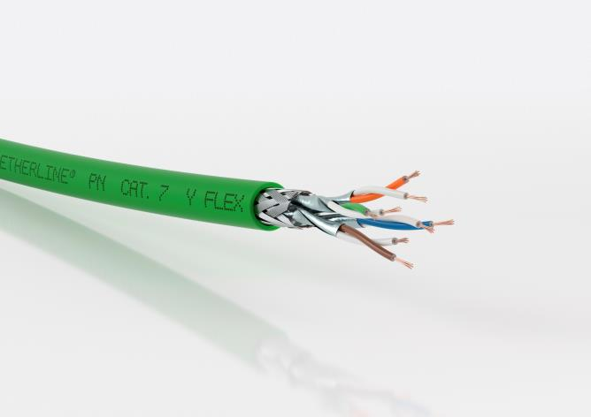
The ETHERLINE® PN Cat.7 cables are suitable for applications in which large amounts of data are transferred, such as from high-resolution cameras.

Stuttgart, November 21, 2017

Above all, PROFINET® cables must be fast and guarantee secure data transmission. The new ETHERLINE® PN Cat.7 cables presented by Lapp at SPS IPC Drives 2017 (hall 2, stand 310) are outstanding models in this regard. The cables are primarily intended for use in machines, systems and network infrastructure, especially in cases where large amounts of data are transferred at high speed. For example, this is the case in systems with numerous sensors or with high-resolution cameras for quality control. With the new cables, Lapp expands its PROFINET® range and covers a large proportion of potential applications.

The new PROFINET® cables from Lapp achieve the highest data rates, delivering 10 gigabits per second according to the Cat.7 standard. Although Cat.6_{A} cables achieve comparable speeds, Cat.7 cables feature larger reserves in terms of performance and transmission security as they operate at a much higher transmission frequency of 600 MHz. As a result, the cables still achieve maximum performance even if they age or are damaged over the course of time. The cables remain remarkably thin, however, with outer diameters ranging from 8.1 mm for fixed cables to 8.7 mm for flexible cables. This helps save space in the event of cramped conditions in machines or control cabinets.

The new cables comply with the PROFINET® standard, which is why their names also contain the abbreviation “PN”. PROFINET® is the standard that has been agreed on by a large number of manufacturers and has recorded the highest growth rates for data cables in industrial applications. For users, this means that all products within the PROFINET® universe are compatible with one another. Another positive aspect of the new PROFINET® cables from Lapp is that they are also certified for the North American market, meaning that users can deploy a single product in all markets without needing to concern themselves with further approval procedures. The issue of parts and inventory management is also simplified, as companies are only required to manage a smaller number of different part variants.

There are five variants of the ETHERLINE® PN Cat.7: for fixed installation it can be flame-retardant with a PVC sheath with the name affix “Y”, it can be halogen-free and flame-retardant with an FRNC sheath, or it can have a PUR sheath meaning it is halogen-free, flame-retardant and more mechanically robust. There are also two variants for flexible installation (“FLEX”) with a flame-retardant PVC sheath or with a halogen-free and flame-retardant FRNC sheath.

You can find the image in printable quality here

Press contact:
Dr. Markus Müller Irmgard Nille
Tel: +49(0)711/7838-5170 Tel.: +49(0)711/7838–2490
Mobil: +49(0)172/1022713 Mobil: +49(0)160/97346822
markus.j.mueller@lappgroup.com irmgard.nille@in-press.de

U.I. Lapp GmbH
Schulze-Delitzsch-Straße 25
D-70565 Stuttgart

Here you find more information: www.lappkabel.com/press

About the Lapp Group:
Headquartered in Stuttgart, Germany, the Lapp Group is a leading supplier of integrated solutions and branded products in the field of cable and connection technology. The Group’s portfolio includes standard and highly flexible cables, industrial connectors and cable entry systems, customized system solutions, automation technology and robotics solutions for the intelligent factory of the future, as well as technical accessories. The Lapp Group’s core market is in the industrial machinery and plant engineering sector. Other key markets are in the food industry as well as the energy and the mobility sector.
The Lapp Group has remained in continuous family ownership since it was founded in 1959. In the 2015/16 business year, it generated consolidated revenue of 901 million euros. Lapp currently employs approximately 3,440 people across the world, has 17 production sites and over 40 sales companies. It also works in cooperation with around 100 foreign representatives.

