For SPS IPC DRives 2017
Industrial switches for high-availability networks

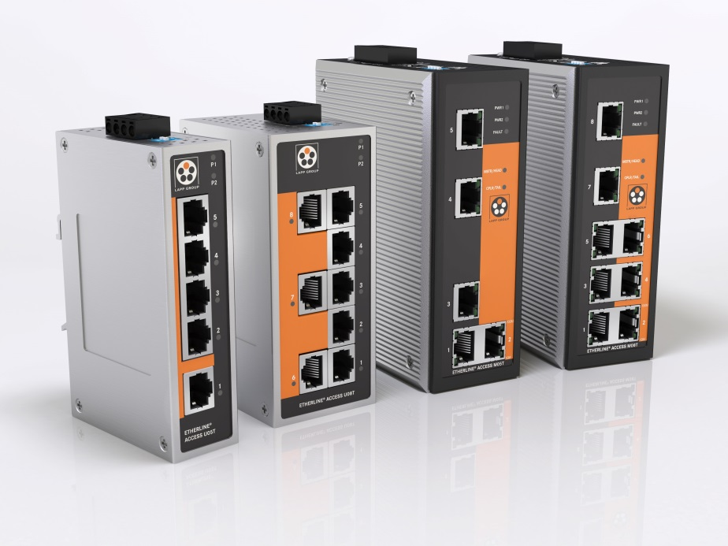
At SPS IPC Drives 2017, Lapp is presenting its own industrial Ethernet switches for the first time under the name ETHERLINE® ACCESS.

Stuttgart, October 19, 2017

Switches serve as pilots of data traffic in Ethernet networks. At SPS IPC Drives 2017 in Nuremberg, Lapp is presenting its own models for the first time under the name ETHERLINE® ACCESS. Their performance characteristics are impressive, even to demanding users in industry. Accordingly, the critical reconfiguration time needed for communication to be re-established after an interruption is only 20 milliseconds with 250 active components in the network. Besides this, the switches are fully equipped with cutting-edge diagnostic and redundancy features.

Lapp has decided to offer its own switches because only the combination of an industrial-grade switch and industrial branded cables such as the Lapp ETHERLINE® models can guarantee the very highest performance in terms of transmission quality and reliability. The customer does not need to purchase individual components from different suppliers. Instead, they can procure a complete communication solution from a single source for the highest demands in industrial applications.

Lapp supplies the switches in four variants: “managed”, i.e. with the option of configuration and five or eight RJ45 ports, designated ETHERLINE® ACCESS M05T or M08T respectively. By contrast, the ETHERLINE® ACCESS U05T and U08T switches are “unmanaged”. All four are fan- and maintenance-free and have two redundant connections to ensure a reliable power supply.

Visit Lapp at Stand 310 in Hall 2 of SPS IPC Drives in Nuremberg between 28 and 30 November

You can find the image in printable quality here

Press contact
Dr Markus Müller Irmgard Nille
Tel.: +49 (0)711/7838-5170 Tel.: +49 (0)711/7838–2490
Mobile: +49 (0)172/1022713 Mobile: +49(0)160/97346822
markus.j.mueller@lappgroup.com irmgard.nille@in-press.de

U.I. Lapp GmbH
Schulze-Delitzsch-Strasse 25
70565 Stuttgart, Germany

You will find further information on this topic here: www.lappkabel.com/press

About the Lapp Group:
Based in Stuttgart, Germany, the Lapp Group is the global market leader in integrated solutions and branded products in the field of cable and connection technology. The Group's portfolio includes standard and highly flexible cables, industrial connectors and screw technology, customised system solutions, automation technology and robotics solutions for Industry 4.0 and the Smart Factory. The Lapp Group’s core market is in the industrial machinery and plant engineering sector. Other important sales markets include the food, energy, mobility and life sciences industries.
The Lapp Group has remained in continuous family ownership since it was founded in 1959. In the 2015/16 business year, it generated a consolidated turnover of €901 million. Lapp currently employs approximately 3,440 people around the world and has 17 production sites and 40 distribution companies; the company also works in cooperation with around 100 foreign representatives.

