Staff news about Arnold Büscher
New Chief Sales Officer Germany at Lapp strengthens all sales channels

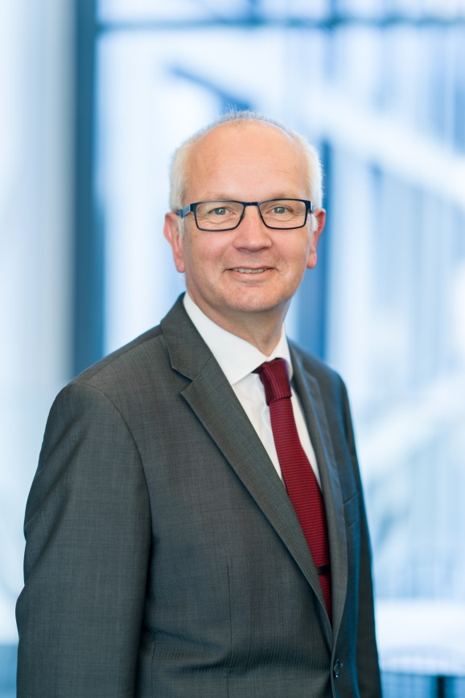
Arnold Büscher is U.I. Lapp GmbH’s new Chief Sales Officer for Germany

Stuttgart, May 3rd, 2017

Arnold Büscher has taken over the role of Chief Sales Officer for Germany at U.I. Lapp GmbH, a Lapp Group company. Mr Büscher, a mechanical Engineer by training, has previously held various managerial posts in big-name industrial companies. He acquired international experience in his role as Managing Director of Rittal Corp. in the USA, to name but one example. He was most recently responsible for business operations in Germany and Central Europe as Managing Director of Weidmüller GmbH & Co. KG.
“We are delighted to have Mr Büscher on board, as he is an experienced manager who is very well acquainted with our market and will promote our transformation to becoming a system provider,” said Andreas Lapp.
Arnold Büscher is keen to strengthen all the sales channels and the focus on the growth markets in the railway, food and robotics industries. His activities also include establishing and expanding on system solutions under the ÖLFLEX® CONNECT name with an extensive range of products and services relating to pre-assembled cables.

“Lapp has strong customer relationships as well as remarkable potential for growth. I would like to intensify our approach to addressing customers across all channels, increase our focus on potential and promote the new customer business,” said Mr Büscher, discussing his new role.

The image is available in printable quality here

Press contact:
Dr. Markus Müller Irmgard Nille
Tel: +49(0)711/7838-5170 Tel.: +49(0)711/7838–2490
Mobil: +49(0)172/1022713 Mobil: +49(0)160/97346822
markus.j.mueller@lappgroup.com irmgard.nille@in-press.de

U.I. Lapp GmbH
Schulze-Delitzsch-Straße 25
D-70565 Stuttgart

Here you find more information: www.lappkabel.com/press

About the Lapp Group:
Headquartered in Stuttgart, Germany, the Lapp Group is a leading supplier of integrated solutions and branded products in the field of cable and connection technology. The Group’s portfolio includes standard and highly flexible cables, industrial connectors and screw technology, customized system solutions, automation technology and robotics solutions for the intelligent factory of the future, as well as technical accessories. The Lapp Group’s core market is in the industrial machinery and plant engineering sector. Other key markets are in the food industry as well as the energy and the mobility sector.
The Lapp Group has remained in continuous family ownership since it was founded in 1959. In the 2015/16 business year, it generated consolidated revenue of 901 million euros. Lapp currently employs approximately 3,440 people across the world, has 17 production sites and over 40 sales companies. It also works in cooperation with around 100 foreign representatives.

