Lapp Panamá becomes fully-fledged distribution company
Bridge between North and South America

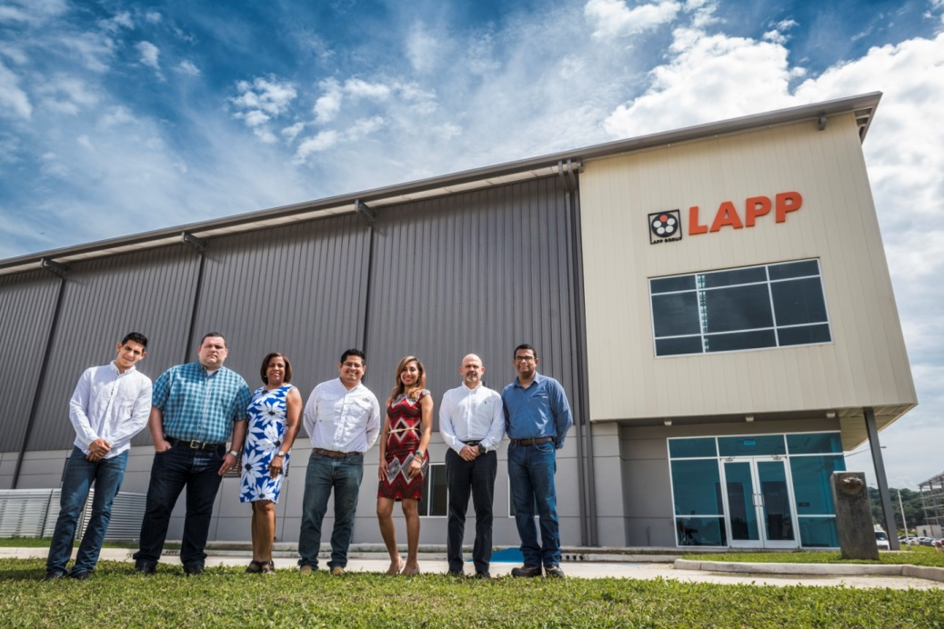
The team of Lapp Panamá in front of the new warehouse building

Stuttgart, August 21, 2017

The Lapp Group is further expanding its global distribution network: Lapp Panamá is now a fully-fledged distribution company. At the opening of the new distribution centre in early June, which now includes its own warehouse, Matthias Lapp, CEO of U.I. Lapp GmbH said: “Throughout the world we are there for our customers, and they value our short response and delivery times, along with our in-depth understanding of their markets and industries.” The site upgrade will significantly reduce delivery times from now on - “Instead of the several weeks it takes for a delivery from Europe, it will now be a matter of days”, said Matthias Lapp. This is an important competitive advantage for Lapp, one the company utilizes to distinguish itself from competitors in other continents as well. The Lapp Panamá warehouse has an area of 1,300 square metres, plus 250 square metres for offices and training rooms.

Employees will also now be providing some of the key customer service functions locally. “We are now even closer to our customers and can take action in the same time zone”, says Javier Rodriguez, Head of Sales at Lapp Panamá. The time difference to Stuttgart, which is up to eight hours, is now irrelevant.
The distribution centre in the “Panamá Pacífico” customs-free trade zone is an important element of the Lapp Group’s growth strategy for Central and South America. It creates a bridge between the production and distribution company to the South in Brazil and the one to the North in Mexico. The team of Lapp Panamá currently look after trade partners and customers in Central America and the Caribbean. Customers are primarily from the food and beverage industry, including sugar mills, beer and meat producers, and producers of biomass for energy generation.

The expansion is a big step towards greater autonomy for the team. Lapp has had a presence in Panamá since 2011, with an office to support its trade partners for technical product support.

You can find the image in printable quality here

Press contact:
Dr. Markus Müller Irmgard Nille
Tel: +49(0)711/7838-5170 Tel.: +49(0)711/7838–2490
Mobil: +49(0)172/1022713 Mobil: +49(0)160/97346822
markus.j.mueller@lappgroup.com irmgard.nille@in-press.de

U.I. Lapp GmbH
Schulze-Delitzsch-Straße 25
D-70565 Stuttgart

Here you find more information: www.lappkabel.com/press

About the Lapp Group:
Headquartered in Stuttgart, Germany, the Lapp Group is a leading supplier of integrated solutions and branded products in the field of cable and connection technology. The Group’s portfolio includes standard and highly flexible cables, industrial connectors and cable entry systems, customized system solutions, automation technology and robotics solutions for the intelligent factory of the future, as well as technical accessories. The Lapp Group’s core market is in the industrial machinery and plant engineering sector. Other key markets are in the food industry as well as the energy and the mobility sector.
The Lapp Group has remained in continuous family ownership since it was founded in 1959. In the 2015/16 business year, it generated consolidated revenue of 901 million euros. Lapp currently employs approximately 3,440 people across the world, has 17 production sites and over 40 sales companies. It also works in cooperation with around 100 foreign representatives.

