Oskar Lapp Foundation supports cardiovascular research
Oskar Lapp Research Prize for Frankfurt Heart Scientists

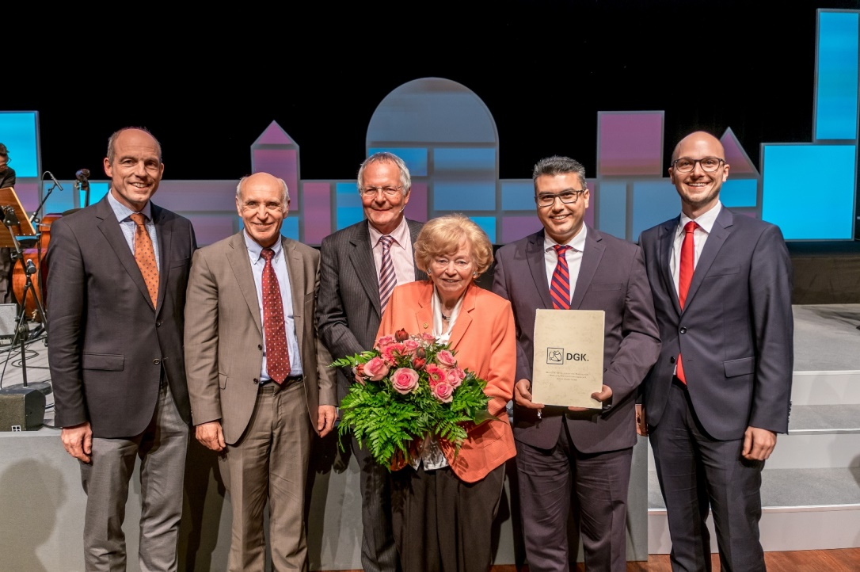
Award ceremony: from left to right Prof. Thomas Nordt, Prof. Hugo A. Katus, Prof. Martin Borggrefe, Ursula Ida Lapp, prize winner Prof. Konstantinos Stellos, Alexander Lapp (Photo: DGK/Thomas Hauss)

Stuttgart, May 17, 2017

The Oskar Lapp Research Prize 2017 was awarded at the 83rd annual conference of the Deutsche Gesellschaft für Kardiologie – Herz und Kreislaufforschung e.V. (DGK) in Mannheim a few days ago. It was presented to Prof. Konstantinos Stellos, a cardiologist at the Johann Wolfgang Goethe University Hospital in Frankfurt. The award, which is endowed with EUR 12,000, is presented annually by the Oskar Lapp Foundation to young scientists who are specifically involved in cardiovascular research.

The Oskar Lapp Foundation was set up in 1992 in memory of the Stuttgart based entrepreneur Oskar Lapp who died of a heart attack thirty years ago on 25th April. Further research into cardiovascular diseases is therefore a very personal matter for the founding family. "Cardiovascular diseases are still the most common cause of death in Germany today. Better research into prophylaxis, diagnostics, therapy and rehabilitation for coronary heart disease is still needed. There's still so much to be done," says Ursula Ida Lapp about her commitment. A festive event will be held at the New Palace (Neues Schloss) in Stuttgart on 22 October 2017 to celebrate the 25th anniversary of the Oskar Lapp Foundation.

Prof. Dr. Stellos is a Cardiologist in the III Medical Dept./Cardiology and Group Leader at the Institute of Cardiovascular Regeneration at the Goethe University in Frankfurt. In his research, he was able to prove that the gene expression in healthy patients differs to those suffering from arteriosclerotic heart diseases. He demonstrated that cathepsin S expression, an enzyme that also enables cell migration, is controlled and increased in patients by RNA modifications. The findings obtained identify a new gene regulatory mechanism and contribute significantly to understanding the pathogenesis of arteriosclerosis. The research was published in the renowned Nature Medicine journal.

Along with the founding family, the members of the Oskar Lapp Foundation Board of Trustees are Prof. Gunther Arnold (former Director of the Deutsche Gesellschaft für Kardiologie – Herz und Kreislaufforschung e.V.), Prof. Anton Both (retired Medical Director, Klinikum Stuttgart, Katharinenhospital), Dr. Rolf Thieringer (former first mayor of the state capital of Stuttgart), Prof. Roderich C. Thümmel (lawyer), Prof. Thomas Nordt (Medical Director, Klinikum Stuttgart, Katharinenhospital) and Konstantinos Papoutsis (Director of the Deutsche Gesellschaft für Kardiologie – Herz und Kreislaufforschung e.V.). For donations, the Oskar Lapp Foundation's bank details are as follows: IBAN: DE68600501010002076087, BIC: SOLADEST600.

Press contact:
Dr. Markus Müller Irmgard Nille
Tel: +49(0)711/7838-5170 Tel.: +49(0)711/7838–2490
Mobil: +49(0)172/1022713 Mobil: +49(0)160/97346822
markus.j.mueller@lappgroup.com irmgard.nille@in-press.de

U.I. Lapp GmbH
Schulze-Delitzsch-Straße 25
D-70565 Stuttgart

Here you find more information: www.lappkabel.com/press

The image is available in printable quality here

About the Lapp Group:
Headquartered in Stuttgart, Germany, the Lapp Group is a leading supplier of integrated solutions and branded products in the field of cable and connection technology. The Group’s portfolio includes standard and highly flexible cables, industrial connectors and cable entry systems, customized system solutions, automation technology and robotics solutions for the intelligent factory of the future, as well as technical accessories. The Lapp Group’s core market is in the industrial machinery and plant engineering sector. Other key markets are in the food industry as well as the energy and the mobility sector.
The Lapp Group has remained in continuous family ownership since it was founded in 1959. In the 2015/16 business year, it generated consolidated revenue of 901 million euros. Lapp currently employs approximately 3,440 people across the world, has 17 production sites and over 40 sales companies. It also works in cooperation with around 100 foreign representatives.

