Broadband Infrastructure Day held by LAPP and Netze BW
“We need gigabit broadband networks”

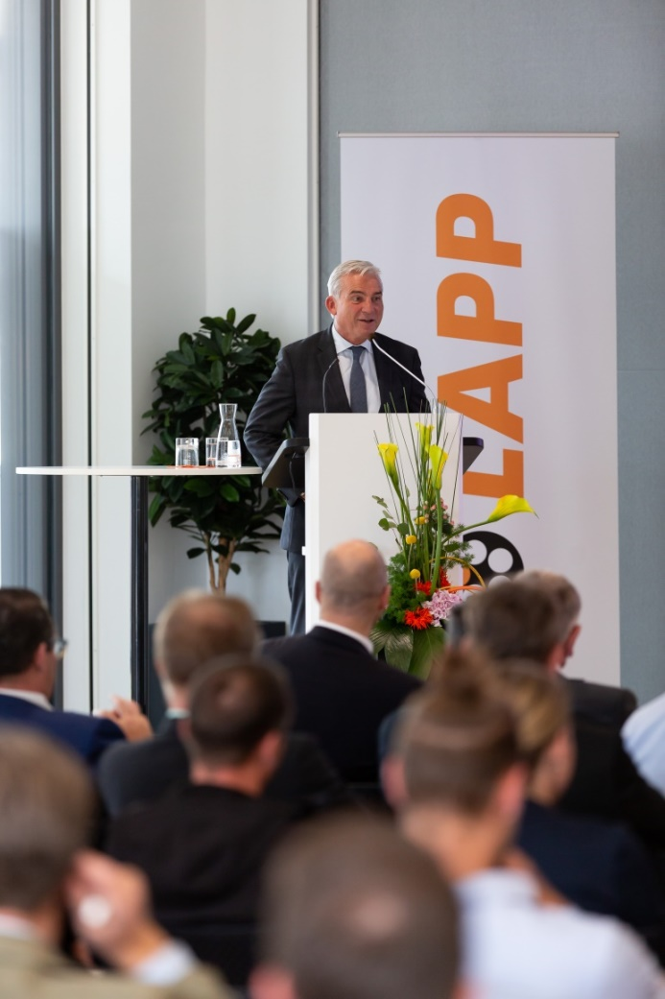

“We need gigabit broadband networks”, emphasised Thomas Strobl, State Minister for Digitalisation.

Stuttgart, October 22nd, 2018

Broadband expansion is gaining momentum in Baden-Württemberg. Broadband availability of 50 Mbit/s increased by 3.3 per cent in the second half of 2017 alone. Nevertheless, there are still a lot of “blank spots”, especially in rural areas. The fourth Broadband Infrastructure Day was held at LAPP’s European headquarters to boost further expansion.

The world leader for integrated solutions in the field of cable and connection technology and the distribution network operator, Netze BW, sent out invitations to attend the event. More than 100 representatives from local and regional authorities, public utilities and construction service providers learned about funding opportunities as well as constructional and legal options. “This event enables us to bring all partners together at one table and the platform concept backs faster implementation,” explains Norbert Krämer, Key Account Manager EVU/Telecom, who is responsible for the broadband market at LAPP. Matthias Groß, Head of Service Management and Telecommunication at Netze BW also emphasised: "Broadband expansion is a monumental task. It requires willingness on the part of everyone involved to cooperate.”

Thomas Strobl, Deputy Minister President and Minister for Digitalisation of the state of Baden-Württemberg, underlined at the event just how important the rapid expansion of broadband is for the sate. “We need gigabit broadband networks. Particularly for industry in the region, that is a decisive factor when choosing a location.” According to the Minister, more than 6,000 kilometres of glass fibre cables have been constructed in the region over the last two and a half years alone.

Network expansion reaches its limits though, especially in rural areas, where expansion is often not profitable. “That’s why the public sector needs to subsidise network expansion,” explains Strobl. This is necessary where telecommunication providers do not invest and where accordingly the market does not function. “My aim is to ensure equal living conditions throughout the whole of Baden-Württemberg also, and particularly, where this is concerned. Fast Internet must be available in rural areas to the same extent that it is here in Stuttgart or in other urban areas", says Thomas Strobl.

The event also included workshops where participants were shown new methods for broadband network construction and given a practical demonstration of air assisted installation of LAPP glass fibre cables into the connecting pipes. Netze BW also provided lots of practical tips on planning construction and operations.

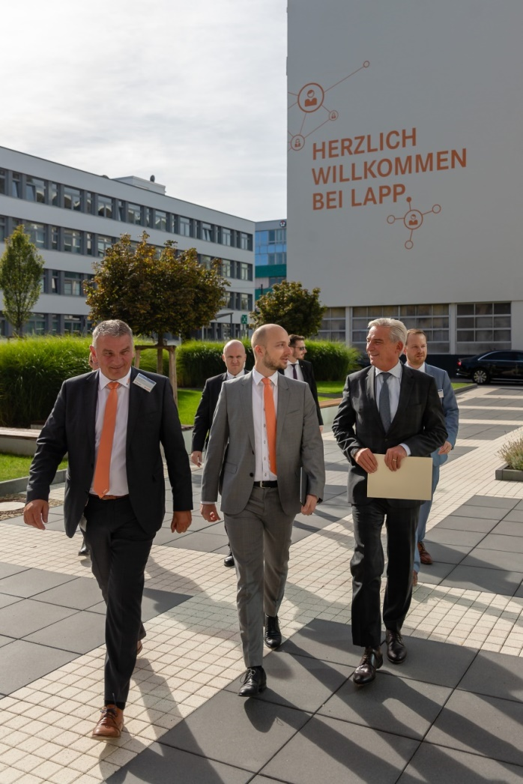

Norbert Krämer and Alexander Lapp accompanying the Digitalisation Minister Thomas Strobl to the LAPP European headquarters

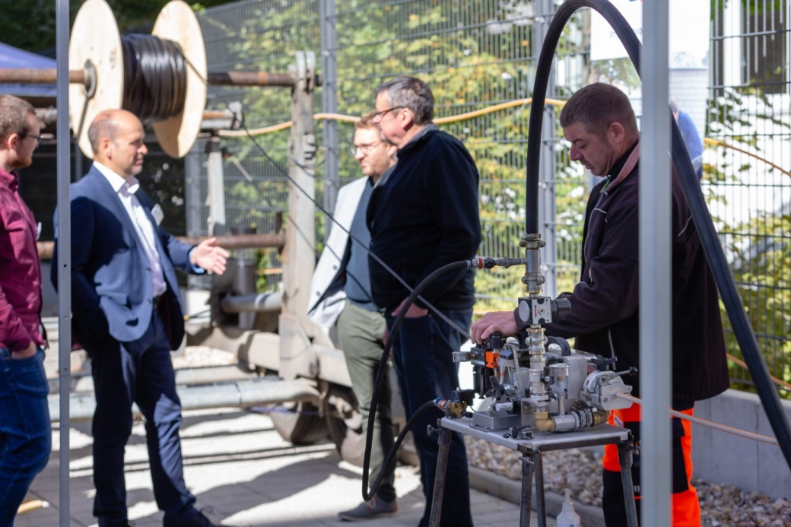
Rhön-Montage Fernmeldebau GmbH showing the workshop participants how air assisted installation of LAPP’s glass fibre cables works

You can find image 1 in printable quality here

You can find image 2 in printable quality here

You can find image 3 in printable quality here

Press contact:
Dr. Markus Müller Irmgard Nille
Tel: +49(0)711/7838-5170 Tel.: +49(0)711/7838–2490
Mobil: +49(0)172/1022713 Mobil: +49(0)160/97346822
markus.j.mueller@lappgroup.com irmgard.nille@in-press.de

U.I. Lapp GmbH
Schulze-Delitzsch-Straße 25
D-70565 Stuttgart

Find more information here: www.lappkabel.com/press
About LAPP:
Headquartered in Stuttgart, Germany, LAPP is a leading supplier of integrated solutions and branded products in the field of cable and connection technology. The company’s portfolio includes standard and highly flexible cables, industrial connectors and cable entry systems, customized system solutions, automation technology and robotics solutions for the intelligent factory of the future, as well as technical accessories. LAPP’s core market is in the industrial machinery and plant engineering sector. Other key markets are in the food industry as well as the energy and the mobility sector.
LAPP has remained in continuous family ownership since it was founded in 1959. In the 2016/17 business year, it generated consolidated revenue of 1,027 million euros. LAPP currently employs approximately 3,770 people across the world, has 17 production sites and around 40 sales companies. It also works in cooperation with around 100 foreign representatives.

