New from LAPP at SPS IPC Drives 2018

Configuring Cable Chains with just a few Mouseclicks

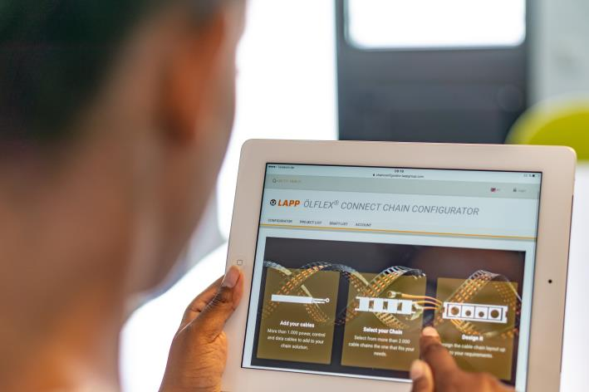
The ÖLFLEX® CONNECT CHAIN online configurator makes it easy to design fully assembled cable chains. Trade visitors can test the configurator live at the LAPP stand at the SPS IPC Drives exhibition.

Nuremberg, November 22nd, 2018

Previously, configuring a cable chain was a complicated undertaking, but now ÖLFLEX CONNECT CHAIN from LAPP turns it into child's play. The tool lets users engineer a cable chain online with just a few clicks of the mouse. The configurator automatically eliminates risks of error and always finds the best solution. It's an important addition to LAPP's growing range of finished items. These kinds of systems solutions developed by a single company are growing in popularity because they deliver excellent quality and save time. LAPP was quick to recognise their importance for connection technology, and along with custom cables for clients, it also offers ready-to-install cable chain systems and servo products for connecting servo motors that conform with the standards laid down by leading manufacturers. Machinery and plant engineers will be able to see solution examples and test the ÖLFLEX CONNECT CHAIN configurator at the LAPP stand (Hall 2, Stand 310) at the SPS IPC Drives 2018 exhibition.

No more incorrect configurations, ever
The ÖLFLEX CONNECT CHAIN configurator guides you step by step through the choice of cable chains, cables and appropriate accessories. It makes sure that components are compatible every step of the way, e.g. when it comes to the cables’ minimum bend radius. The cable chain must not have a smaller bend radius than the cables, otherwise malfunctions may occur and the cables’ life cycle will be curtailed. If this is the case, the configurator will display a warning message and suggest other types of cable chain. Other criteria include the travel length, acceleration, temperature properties and shielding. The configurator automatically excludes cables that are not suitable for the application. If required, it can position separators and shelves and makes sure that the weight of the cables is evenly distributed in the cable chain. When the configuration is complete, the customer receives a personalised quotation. The customer can then choose whether they want to purchase the cable chain fully assembled by LAPP or as individual components, with the option of having the cables pre-cut to the appropriate lengths. If the customer opts for the former, all components are guaranteed to be in perfect working order and the fully assembled chain will undergo extensive testing before it is shipped.

Top-notch quality everywhere and every time
LAPP systems solutions are available worldwide and are always supplied in the consistently high quality that customers expect from LAPP. Alongside the competence centre in Stuttgart, the company has two other competence centres in the USA and Singapore, as well as a global network of production sites for ÖLFLEX CONNECT and other products. No matter where in the world items are produced, LAPP customers benefit from fast delivery times and proximity to experts who know every last detail about local conditions. LAPP will be exhibiting a selection of these products at SPS IPC Drives 2018 in Hall 2, Stand 310.

Find the image in printable quality here

Press contact:
Dr. Markus Müller Irmgard Nille
Tel: +49(0)711/7838-5170 Tel.: +49(0)711/7838–2490
Mobil: +49(0)172/1022713 Mobil: +49(0)160/97346822
markus.j.mueller@lappgroup.com irmgard.nille@in-press.de

U.I. Lapp GmbH
Schulze-Delitzsch-Straße 25
D-70565 Stuttgart

Find more information here: www.lappkabel.com/press

About LAPP:
Headquartered in Stuttgart, Germany, LAPP is a leading supplier of integrated solutions and branded products in the field of cable and connection technology. The company’s portfolio includes standard and highly flexible cables, industrial connectors and cable entry systems, customized system solutions, automation technology and robotics solutions for the intelligent factory of the future, as well as technical accessories. LAPP’s core market is in the industrial machinery and plant engineering sector. Other key markets are in the food industry as well as the energy and the mobility sector.
LAPP has remained in continuous family ownership since it was founded in 1959. In the 2016/17 business year, it generated consolidated revenue of 1,027 million euros. LAPP currently employs approximately 3,770 people across the world, has 17 production sites and around 40 sales companies. It also works in cooperation with around 100 foreign representatives.

