Over 1,100 applications for ten training streams

23 new trainees kick-start their careers at LAPP

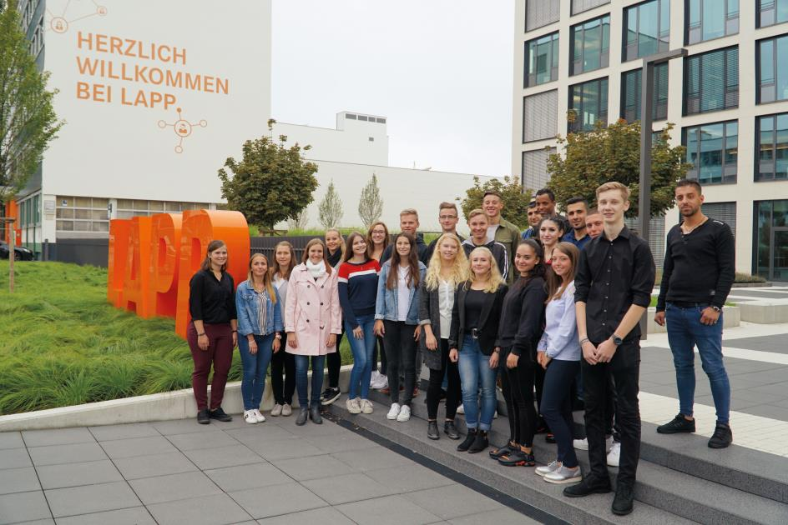
23 young men and women started their vocational training at LAPP in Stuttgart today.

Stuttgart, September 3, 2018

23 young men and women started their vocational training at LAPP in Stuttgart today. The global market leader for integrated cable and connection technology solutions is offering ten different training streams for this intake year. These enable trainees and apprentices to qualify in commercial or business/technical vocations, such as Industrial Clerk, Warehouse Logistics Specialist, Machinery and Plant Operator or Mechatronics Engineer. Apart from these, LAPP also runs cooperative degree courses such as Business Administration with Service Management, Logistics and Supply Chain Management or Engineering and Business Studies with a major in Electrical Engineering. Four refugees from Eritrea and Syria are among the new recruits. After completing their 12-month entry-level qualification, they are now starting to train as Machinery and Plant Operators and IT Specialists for Systems Integration.

At LAPP, vocational training enjoys a very high status. “We strive to offer young people good future prospects with our qualified training. We mainly train staff to meet our own requirements. LAPP is a learning organization, in which employees’ lifelong learning and the continuous, systematic development of the organization form the cornerstone of its corporate success,” explains Matthias Lapp, CEO der U.I. Lapp GmbH.
63 young men and women are currently being trained by LAPP at the site in Stuttgart. Over the past few years, over 90 percent of trainees have been offered permanent employment afterwards.

Training courses at LAPP begin with an introductory seminar week, in which the new recruits are given an initial insight into the structures, processes and characteristics of the company. Joint team training with members of all training stages at the Regional Academy for Youth Education in the town of Weil der Stadt follows on from this.

Another important component of training at LAPP takes the form of regular seminar weeks and team training sessions, not to mention a number of events and projects in which the trainees are purposefully involved. Examples of this are the organization of the company’s annual anniversary celebration, appearances at career fairs such as “HORIZON Stuttgart”, “TRAUMBERUF IT & TECHNIK Stuttgart” (which promotes careers in IT and Engineering), “vocatium Stuttgart”, or events aimed at young children like the “Tüftler- und Forscherinnentag Baden-Württemberg” (Baden-Württemberg Inventor and Researcher Day). Trainees always make up an important part of the team at LAPP’s trade fair stand at the renowned Hannover Messe. Projects that see the trainees assume social responsibilities are another key component of the training. For example, in the social project “Open up! Für Azubis”, they volunteer for two weeks in a social institution of their choice.

As a globally active group of companies, LAPP also grants trainees and cooperative degree students the opportunity to spend stints abroad. They are either able to work in various departments at a LAPP company outside Germany for between four and twelve weeks, or have the option to visit a foreign company thanks to the EU funding program “ERASMUS+”, which includes a language course. 15 trainees took full advantage of this opportunity during the financial year 2017/18.

“We also go to great lengths to attract trainees in the first place,” emphasizes Anne Voigt, Training Coordinator at LAPP. To this end, the company also exhibits at training & education fairs, and supports careers-guidance campaigns such as “Girls’Day”, the “MINT-Dialog-Days” or “Schüler im Chefsessel” (which grants students a day’s corporate work experience). Internships for students are also an option: To this end, LAPP has entered into training partnerships with numerous high schools in Stuttgart, including the Anne-Frank-Gemeinschaftsschule and the Hegel-Gymnasium. Cooperative training schemes with four other schools in Stuttgart exist alongside these. A total of 1,117 young men and women applied for this year’s training intake at LAPP.

You can find the image in full print quality here

Press contact
Dr. Markus Müller Irmgard Nille
Tel.: +49(0)711/7838-5170 Tel.: +49(0)711/7838–2490
Mobile: +49(0)172/1022713 Mobile: +49(0)160/97346822
markus.j.mueller@lappgroup.com irmgard.nille@in-press.de

U.I. Lapp GmbH
Schulze-Delitzsch-Straße 25
D-70565 Stuttgart, Germany

You can find further information on this topic here: www.lappkabel.de/presse

About LAPP:
Headquartered in Stuttgart, LAPP is one of the leading suppliers of integrated solutions and branded products for cable and connection technology. The company’s portfolio includes special-purpose and highly flexible cables, industrial connectors and cable-gland technology, custom-tailored assembly solutions, technical accessories, and automation technology and robotics solutions for the smart production lines of tomorrow. LAPP’s core market focus is mechanical and systems engineering. Other markets with a significant share of turnover include those for the food industry, the energy sector and mobility.

The company was founded in 1959 and is still fully owned by the founding family to this day. In the financial year 2016/17, it generated a consolidated turnover of €1,027 million. LAPP employs around 3,770 staff members worldwide, operates 17 manufacturing sites, has some 40 sales subsidiaries, and cooperates with around 100 authorized representatives abroad.

