New from LAPP at SPS IPC Drives

A servo motor cable for everything (including the USA!)

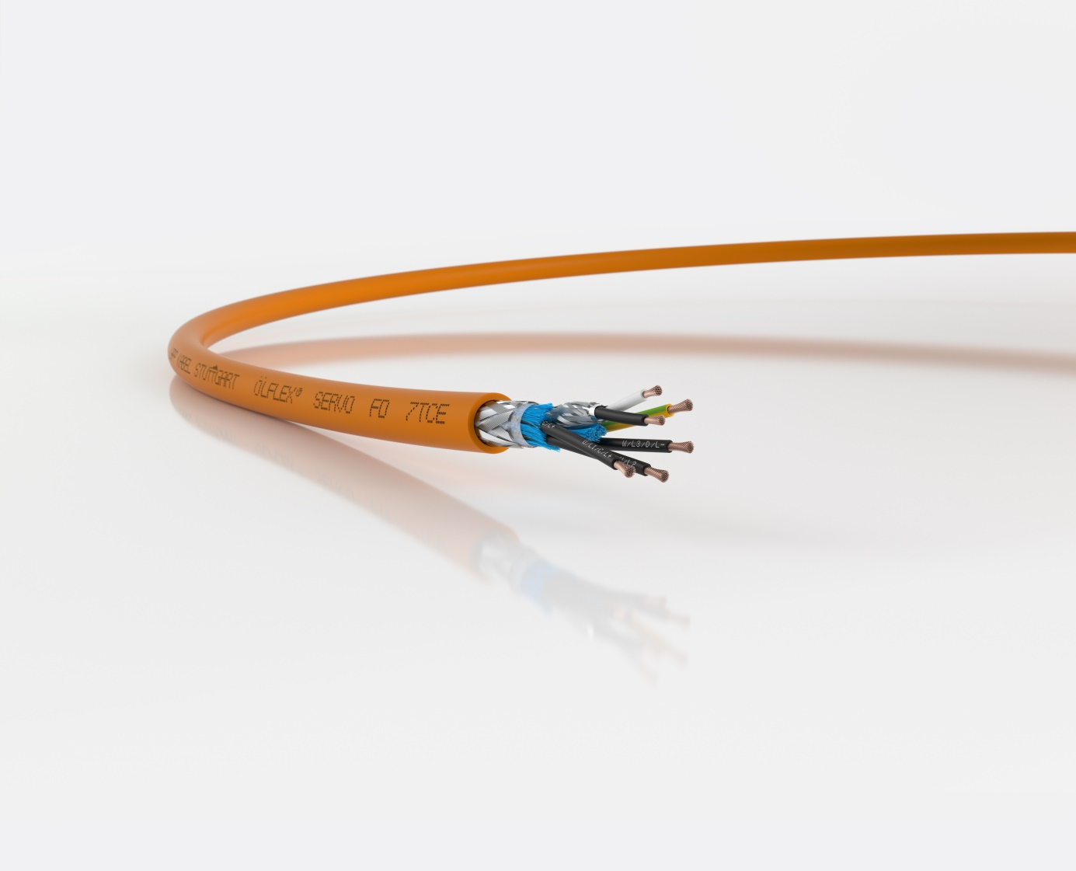
ÖLFLEX SERVO FD 7TCE is a cable for control cabinets, racks and cable chains
Nuremberg, November 21st, 2018

The new ÖLFLEX SERVO FD 7TCE from LAPP is a unique all-in-one product: a single cable running from the control cabinet or inverter to the machine via the cable rack. Ideal for static, flexible and highly flexible deployment, it can form part of a movable cable chain that conforms to a host of standards, making procurement and storage easier for engineers and machine builders as they no longer have to stock a range of different cable types. The cable is available with and without control pairs for connection to a brake or temperature sensor. This also makes wiring machinery easier stateside, where this work has until now often been very complex and time-consuming due to strict regulations and a variety of application standards.

The new addition to the LAPP portfolio of UL-listed servo motor cables offers a range of properties that have not previously been available in combination. The cable is resistant to UV light, is flame retardant in compliance with the FT4 fire test, and has increased oil resistance in line with Oil Res I/II. The conductors are made up of ultra-fine copper wires, which makes the cable exceptionally flexible and suitable for tight bending radii, i.e. in cable racks, and even for cable chains with several million bending cycles. Another new feature is the low-capacitance core insulation material. This minimises the voltage drop over longer distances and reduces unwanted leakage currents at the screening. In addition, the material is electron-beam cross-linked, making it especially resistant against mechanical stress.

Suitable for on-site cabling in the USA
The ÖLFLEX SERVO FD 7TCE is UL-listed as a TC-ER rack cable and flexible motor supply cable. Thanks to these designations, it can be cabled on-site for US-based customers. This is particularly useful in large installations, which are delivered as individual parts and only assembled by the user, or if an installation is expanded at a later date. This is not possible with cables that are AWM-certified only; the cables have to be completely installed in the factory during production of a machine.

The employees responsible for the development of the ÖLFLEX SERVO FD 7 TCE won the Eddie Lapp Award, LAPP’s internal innovation prize. The ÖLFLEX SERVO FD 7 TCE is now in stock and available to order.

LAPP will be exhibiting the new ÖLFLEX SERVO FD 7 TCE at SPS IPC Drives 2018 in Nuremberg, in Hall 2, Stand 310.

Find the image in printable quality here

Press contact:
Dr. Markus Müller Irmgard Nille
Tel: +49(0)711/7838-5170 Tel.: +49(0)711/7838–2490
Mobil: +49(0)172/1022713 Mobil: +49(0)160/97346822
markus.j.mueller@lappgroup.com irmgard.nille@in-press.de

U.I. Lapp GmbH
Schulze-Delitzsch-Straße 25
D-70565 Stuttgart

Find more information here: www.lappkabel.com/press

About LAPP:
Headquartered in Stuttgart, Germany, LAPP is a leading supplier of integrated solutions and branded products in the field of cable and connection technology. The company’s portfolio includes standard and highly flexible cables, industrial connectors and cable entry systems, customized system solutions, automation technology and robotics solutions for the intelligent factory of the future, as well as technical accessories. LAPP’s core market is in the industrial machinery and plant engineering sector. Other key markets are in the food industry as well as the energy and the mobility sector.
LAPP has remained in continuous family ownership since it was founded in 1959. In the 2016/17 business year, it generated consolidated revenue of 1,027 million euros. LAPP currently employs approximately 3,770 people across the world, has 17 production sites and around 40 sales companies. It also works in cooperation with around 100 foreign representatives.

