New from LAPP at SPS IPC Drives

One cable for control cabinet, rack and cable chain

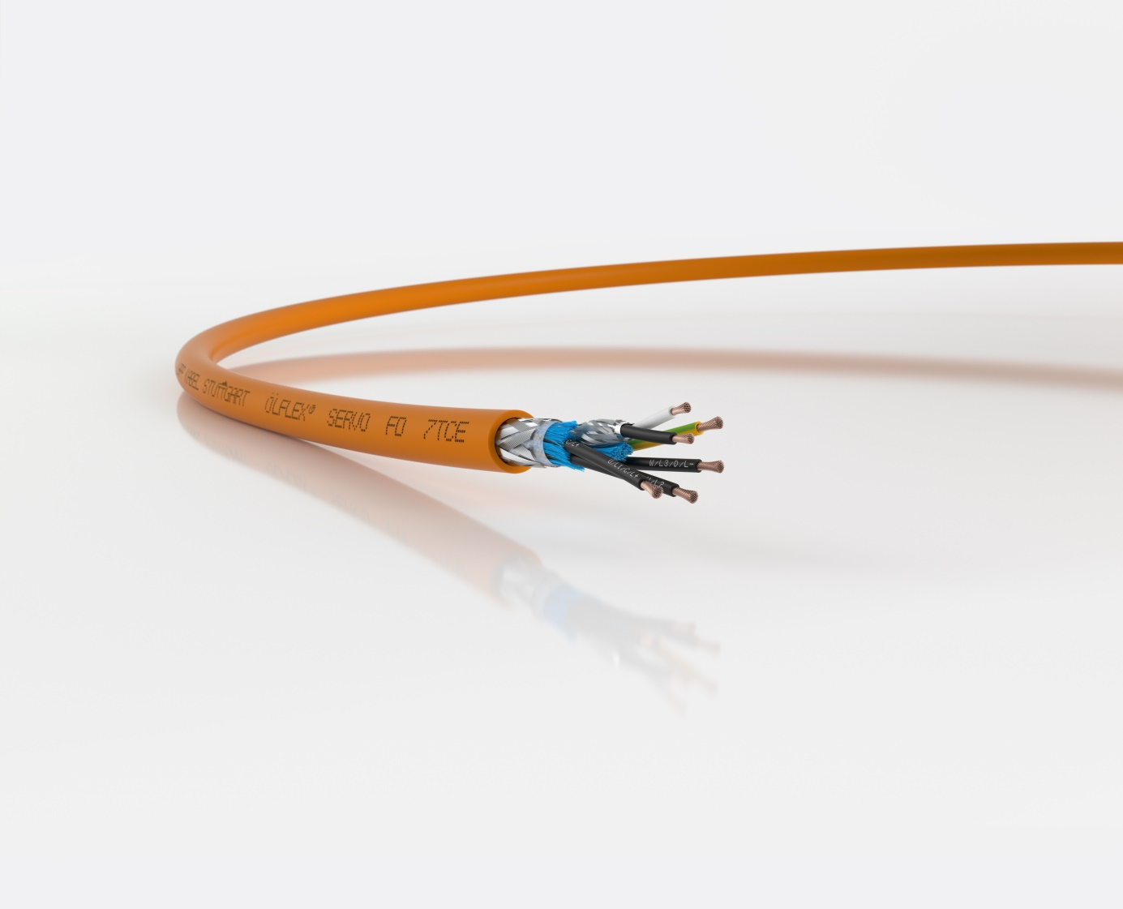
ÖLFLEX SERVO FD 7TCE is a cable for control, rack and cable chain

Nuremberg, 24th of September 2018

In the past, the large number of stringent regulations have often made cabling for machines in the USA a very complex and time-consuming task, as numerous different cable types had to be used, depending on where they were installed. But the ÖLFLEX SERVO FD 7TCE from LAPP meets a range of standards, making it possible to use a single cable from the control cabinet or inverter to the cable rack right through to the machine - even in a moving cable chain - regardless of whether it is for static, flexible or highly flexible applications. Machine and plant manufacturers no longer have to stock different cable types, making procurement and storage much simpler. The cable is available with and without control pairs for connection to a brake or temperature sensor.

The new addition to the LAPP portfolio of UL-listed servo motor cables offers a range of properties that have not previously been available in combination. The cable is resistant to UV light, flame retardant in compliance with the FT4 fire test, and has increased oil resistance in line with Oil Res I/II. The conductors are made up of ultra-fine copper wires, which makes the cable exceptionally flexible and therefore suitable for tight bending radii such as those that can occur in cable racks, and even for use in cable chains with several million bending cycles. Another new feature is the carefully selected cross-linked core insulation material, which gives the cable a low capacitance. This minimises the voltage drop over longer installation distances and reduces unwanted leakage currents at the screening.

Also available for on-site cabling in the USA
Because the ÖLFLEX SERVO FD 7TCE is UL-listed as a “TC-ER” rack cable and a “Flexible Motor Supply Cable”, it can be installed on site in the field. This is particularly useful in large installations, which are delivered as individual parts and only assembled by the user, or if an installation is extended at a later date. With cables that are only AWM certified, the standard does not permit this; the cables have to be completely installed in the factory during production of a machine.

The employees responsible for the development of the ÖLFLEX SERVO FD 7 TCE won the Eddie Lapp Award, LAPP’s internal innovation prize. The ÖLFLEX SERVO FD 7 TCE is now in stock and available to order.

LAPP will be exhibiting the new ÖLFLEX SERVO FD 7 TCE at SPS IPC Drives 2018 in Nuremberg, in Hall 2, Stand 310.

You can find the image in printable quality here

Pressekontakt
Dr. Markus Müller Irmgard Nille
Tel: +49(0)711/7838-5170 Tel.: +49(0)711/7838–2490
Mobil: +49(0)172/1022713 Mobil: +49(0)160/97346822
markus.j.mueller@lappgroup.com irmgard.nille@in-press.de

U.I. Lapp GmbH
Schulze-Delitzsch-Straße 25
D-70565 Stuttgart

Weitere Informationen zum Thema finden Sie hier: www.lappkabel.de/presse

Über LAPP:
LAPP mit Sitz in Stuttgart ist einer der führenden Anbieter von integrierten Lösungen und Markenprodukten im Bereich der Kabel- und Verbindungstechnologie. Zum Portfolio des Unternehmens gehören Kabel und hochflexible Leitungen, Industriesteckverbinder und Verschraubungstechnik, kundenindividuelle Konfektionslösungen, Automatisierungstechnik und Robotiklösungen für die intelligente Fabrik von morgen und technisches Zubehör. LAPPs Kernmarkt ist der Maschinen- und Anlagenbau. Weitere wichtige Absatzmärkte sind die Lebensmittelindustrie, der Energiesektor und Mobilität.
Das Unternehmen wurde 1959 gegründet und befindet sich bis heute vollständig in Familienbesitz. Im Geschäftsjahr 2016/17 erwirtschaftete es einen konsolidierten Umsatz von 1.027 Mio. Euro. Lapp beschäftigt weltweit rund 3.770 Mitarbeiter, verfügt über 17 Fertigungsstandorte sowie rund 40 Vertriebsgesellschaften und kooperiert mit rund 100 Auslandsvertretungen.

