New from LAPP at SPS IPC Drives 2018

Robust and Practical: the Quick-Connect System from LAPP
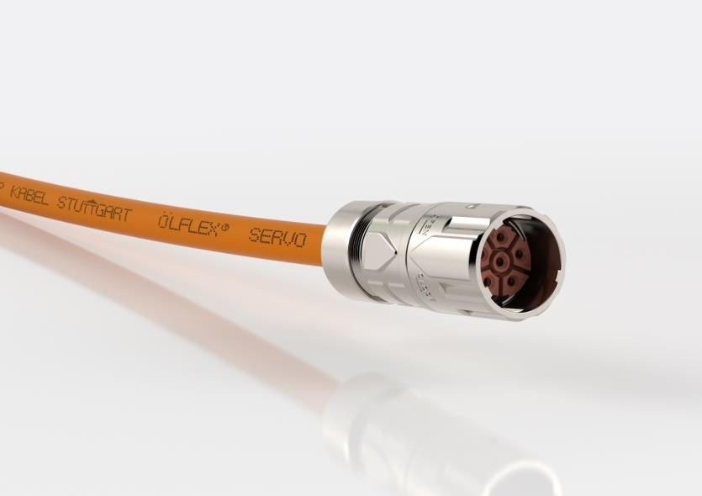

The EPIC POWER LS1 Twist connector: robust and practical locking mechaniscm

Nuremberg, November 20th, 2018

Quick-connect circular connectors are becoming an increasingly popular solution for cabling in servo drives: plug in, turn the housing to the right, done. Users have been frustrated with the small number of manufacturers who offer this standard. Until now. “The market is extremely interested in a high-quality alternative”, says Joachim Strobel, product manager for EPIC connectors at LAPP. That alternative is now available in the form of the EPIC POWER LS1 TWIST. It gives users the freedom of choice while at the same time delivering LAPP’s high quality and global service for this connector standard.

LAPP has developed a robust and practical locking mechanism. It is compatible with the market standard and makes connection child’s play. Both halves of the connector are securely locked and protected against vibration. The EMC version prevents electromagnetic interference generated by high currents. Circular connectors for power supply are used in robots and machinery, as well as in wind turbines and other applications where a compact and powerful connection system is required.

The EPIC POWER LS1 Twist line caters to all contact configurations. Rounding out LAPP’s portfolio of high-performance LS1 connectors, it will be available for international delivery ex warehouse as of December.

LAPP will be exhibiting the new EPIC POWER LS1 with quick-connect system at SPS IPC Drives 2018 in Nuremberg, in Hall 2, Stand 310.

Find the image in printable quality here

Press contact:
Dr. Markus Müller Irmgard Nille
Tel: +49(0)711/7838-5170 Tel.: +49(0)711/7838–2490
Mobil: +49(0)172/1022713 Mobil: +49(0)160/97346822
markus.j.mueller@lappgroup.com irmgard.nille@in-press.de

U.I. Lapp GmbH
Schulze-Delitzsch-Straße 25
D-70565 Stuttgart

Find more information here: www.lappkabel.com/press

About LAPP:
Headquartered in Stuttgart, Germany, LAPP is a leading supplier of integrated solutions and branded products in the field of cable and connection technology. The company’s portfolio includes standard and highly flexible cables, industrial connectors and cable entry systems, customized system solutions, automation technology and robotics solutions for the intelligent factory of the future, as well as technical accessories. LAPP’s core market is in the industrial machinery and plant engineering sector. Other key markets are in the food industry as well as the energy and the mobility sector.
LAPP has remained in continuous family ownership since it was founded in 1959. In the 2016/17 business year, it generated consolidated revenue of 1,027 million euros. LAPP currently employs approximately 3,770 people across the world, has 17 production sites and around 40 sales companies. It also works in cooperation with around 100 foreign representatives.

