New LAPP products at SPS IPC Drives 2018

ÖLFLEX cable for the direct current era
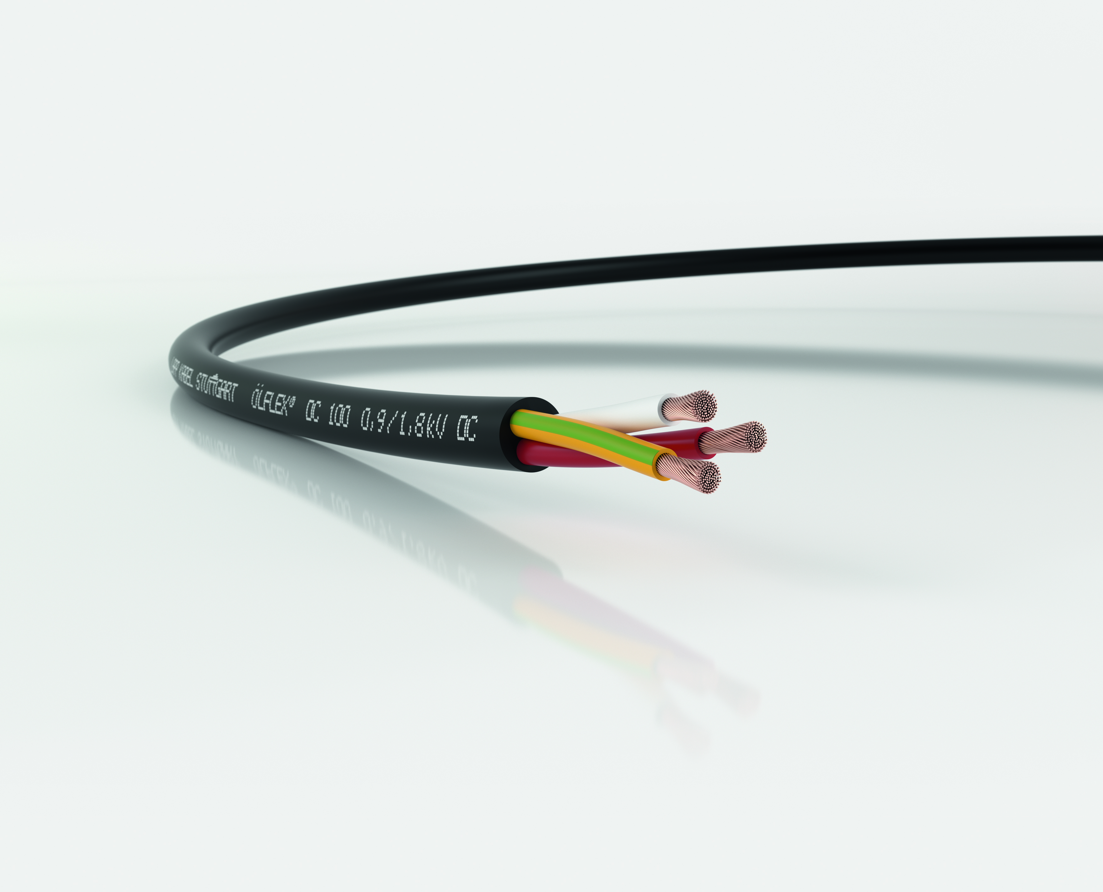

In future, direct current will increasingly be used for energy distribution. This requires special cables, such as the ÖLFLEX DC 100

Nuremberg, 19 September 2018

Alternating current is the blood that flows through the veins of our power grid. It conveys electrical energy across great distances from the power station to our homes. But the monopoly of alternating current is coming to an end. Consumers such as mobile phone chargers, LED lamps and electric vehicle batteries increasingly require direct current. There is also an increasing number of power generators that supply direct current instead of alternating current, such as photovoltaic units. The necessary conversion between alternating and direct current consumes huge amounts of energy. That is why energy experts are campaigning for the construction of direct-current grids. The industrial sector, especially the automotive industry, has also begun to equip factories to run on direct current. But there is a problem: direct current places new demands on infrastructure, including cables.

The first series cable for direct current
Leading connection systems manufacturer LAPP has taken a close look at these challenges. The company is due to showcase its first series product at SPS IPC Drives 2018. The ÖLFLEX DC 100 is specially developed for supplying motors and systems with direct current. The cable is the first result of comprehensive experiments in the LAPP laboratory and at the Ilmenau University of Technology, where Prof. Frank Berger researches the influence of direct current on the ageing process in cables. “In principle, cables for alternating current can also be used for direct current”, explains Berger.

In terms of long-term durability, however, there are still many open questions and very little in the way of knowledge, even though direct current has been around since the 19th century. Researchers have found evidence that direct current fields place different strains on the plastic of the insulation than alternating current fields. “It is very important to precisely understand this correlation, which is why we are paying so much attention to this issue that will shape the future”, says Guido Ege, Head of Product Management and Product Development at LAPP.

Similar, but not identical
The new ÖLFLEX DC 100 is designed to withstand decades of use with direct current, just like its alternating current equivalent the ÖLFLEX Classic 100. The two cables feature different insulation but otherwise share similar properties. They both have PVC sheaths and offer identical dielectric strength, for example. The only visible difference can only be seen once the sheath is removed. The colour coding of the wires is different: red, white and green/yellow according to the standard DIN EN 60445 (VDE 0197):2018-02 that was updated in February 2018.

The ÖLFLEX DC 100 is available now. LAPP will present the cable at SPS IPC Drives 2018 in Nuremberg in hall 2, stand 310.

You can find the image in printable quality here

Press contact
Dr Markus Müller Irmgard Nille
Tel.: +49 (0)711/7838-5170 Tel.: +49 (0)711/7838–2490
Mobile: +49 (0)172/1022713 Mobile: +49(0)160/97346822
markus.j.mueller@lappgroup.com irmgard.nille@in-press.de

U.I. Lapp GmbH
Schulze-Delitzsch-Strasse 25
70565 Stuttgart, Germany

You will find further information on this topic here: www.lappkabel.de/presse

About LAPP:
With its headquarters in Stuttgart, Germany, LAPP is a leading supplier of integrated solutions and branded products in the field of cable and connection technology. The company’s portfolio includes standard and highly flexible cables, industrial connectors and screw technology, customised system solutions, automation technology and robotics solutions for the intelligent factory of the future, as well as technical accessories. LAPP’s core market is machine and equipment manufacture. Other key markets are in the food industry as well as the energy and the mobility sector.
The company has remained in continuous family ownership since it was founded in 1959. In the 2016/17 business year, it generated a consolidated turnover of € 1,027 million. LAPP currently employs approximately 3,770 people around the world and has 17 production sites and 40 distribution companies; the company also works in cooperation with around 100 international representatives.

