**The Lapp Group Adapts to Changes in Society**

**Transformation and Generational Change**

Stuttgart, 13 March 2018

The Lapp family, the owners of the Lapp Group, started planning for the generational change at an early stage. At Lapp, that is simply part of the response to rapid social and economic change. This change entails enormous adjustments for the family-owned company as well as the economy at large. Since 2017, the third generation of the Lapp family has also been taking up responsibility within the company.

For almost 60 years, Ursula Ida Lapp (87) worked to build up the company, mould it and turn it into a global player. In 2015, she passed the role of Chair of the Supervisory Board of Lapp Holding AG on to her eldest son, Siegbert Lapp (65). His younger brother Andreas Lapp (63) is Chairman of the Board of Lapp Holding AG. Ursula Ida Lapp maintains her link with the company as Honorary Chair of the Supervisory Board.

Until June 2017, Ursula Ida Lapp remained Chair of the Supervisory Board of U.I. Lapp GmbH, which was named after her and is the single largest company within the Lapp Group. Andreas Lapp assumed this role in July 2017. At the same time, he transferred his role as CEO of U.I. Lapp GmbH to Ursula Ida Lapp’s grandson Matthias (35). This makes Matthias Lapp responsible for Europe, the Middle East, Africa and South America. In addition, his brother Alexander Lapp (33), who is the second member of the third generation of the founding Lapp family, assumed global responsibility for the future topic of digitalisation and the further development of e-business.

“Lapp is a family company and will stay that way. It was always important to us for younger generations to be introduced when the time was right,” says Andreas Lapp. “Particularly in light of rapid digital change and a globalised economy, it’s now more important than ever to incorporate the knowledge, new ideas and perspective of the younger generations into our company.”

**Lapp and social change**

Lapp isn’t just concerned with its founding family, however: “If we want to attract the best employees – which we definitely do – then we need to fulfil the wishes of every generation,” says Andreas Lapp. Yet the wishes of different generations are very varied. The members of so-called Generation Z (born around 1995 and after) who are currently flooding onto the job market have very specific preconceptions of their career development and the part that work should play in their lives, just like the Baby Boomers and Generations X and Y. On the other hand, members of Generation X (born roughly between 1963 and1981) attach more importance to their free time, flexibility and a good “work/life balance” than the Baby Boomers (born approximately 1955-1969), who mainly value pay and status. Generation Y (1980-2000), on the other hand, is very tech-savvy. These “millennials” are the first “digital natives” and have never known a life without the Internet. It is important to them that their jobs fill their lives with meaning and offer variety. They are career-minded and don’t push so hard to combine a career with family life. Generation Z, however, is even more adept at using new technologies. They aren’t just digital natives: they took mobile Internet for granted before they even learned to crawl. Instead of status symbols and material wealth, Generation Z strives towards recognition in both social and professional terms. For the very confident children of Generation Z, a career doesn’t need to give their life meaning: it should be clearly separated from their private lives and adhere to specific rules.

Andreas Lapp: “We need a good mix of generations and people in the company, which is why we want to offer all of our employees attractive job prospects. This is no mean feat, especially in light of the very varied and often contradictory wishes and preconceptions of the various generations.” For example, Lapp pays particular attention when training junior members of staff to sensitise them to the ways in which they can use digital media to best effect at work – and also to point out the risks and legal limitations that exist. That’s why Lapp’s training officers themselves are continuously trained to use new technologies and discuss the different ways in which the members of the respective generations communicate. The goal is to ensure perfectly attuned cooperation, in which young and old alike can learn from one another.

For members of Generation X and the Baby Boomers, the ability to combine family life with a career is often vital. At Lapp, there are many opportunities to make this happen as well. Alongside flexible working hours, these include measures such as shift schedules with a shift exchange option in Logistics. Lapp has programmes aimed at keeping in contact with and reintegrating parents on parental leave, a workshop offering advice on questions relating to caring for loved ones, staff training on searching for care options, courses on health topics and even the provision of a parent/child room for employees at the European headquarters in Stuttgart. In addition, employees can choose from around 40 different part-time work models. In 2016, U.I. Lapp GmbH was awarded first place in the corporate competition *Erfolgsfaktor Familie* (“Family as a Factor for Success”) in recognition of its HR policy, which is tailored to the various stages of life.

Another important matter for Andreas Lapp is the diversity of the population in the Stuttgart Metropolitan Region, where the Lapp Group has its headquarters. “People living here originate from 180 different countries and speak more than 120 languages. 45 per cent of the population has a migrant background. These different cultural backdrops also bring with them a variety of perspectives, experiences and expectations. However, I’m sure that it will represent a huge opportunity for us if we can integrate these diverse groups and be an attractive employer for them.”

**Lapp and the new working environment**

The digital world is also increasingly dominating day-to-day work: “Lapp’s new European headquarters are symbolic of change. We are offering entirely new forms of cooperation; with short distances and an open, flexible office environment. This will reinforce communication and cooperation, while our modern IT concept and the overall office environment are intended to inspire and motivate. In turn, this will give innovation a shot in the arm and increase the commitment of our employees,” explains Andreas Lapp. The new working environment also fosters international cooperation. Employees from all over the world work together on specific projects. “This enables us to be as close to our customers as possible and to guarantee them the very best consultation,” says Andreas Lapp.

Many companies find it difficult to draw up a succession plan as early as the Lapp Group has. According to a study carried out by the German development bank KfW, 1.3 million owners of medium-sized German enterprises are already aged 55 or older. A panel of experts on medium-sized enterprises at KfW said the following[1]: “The ageing process places huge challenges in the way of all those involved. After all, it slows both investment and innovation.” The Lapp Group, on the other hand, ushers the younger generation into the management of the company at an early stage and has drawn up a long-term plan for generational change which it is putting into practice one step at a time.

For example, Matthias Lapp, the eldest son of Siegbert Lapp, has already gained experience abroad, including at Coca-Cola in Mexico. After doing so, he worked for seven years in a variety of positions at Lapp. Andreas Lapp’s children are still in training.

Andreas Lapp: “My brother and I also assumed responsibility very early on – when he was 34 and I was 31. At the time, this was a necessity after our father Oskar Lapp sadly passed away in 1987. That was a hard time for us to begin with. Our young successors can now make targeted preparations for assuming responsibility in the company.”

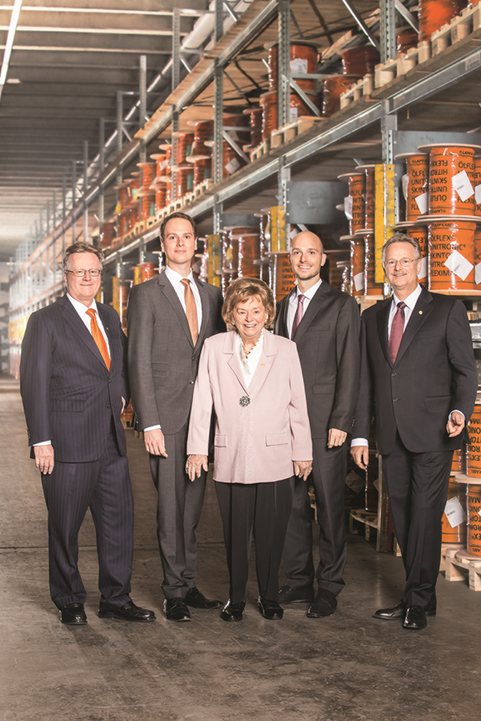

**The company’s founding family, with Andreas Lapp, Matthias Lapp, Ursula Ida Lapp, Alexander Lapp and Siegbert Lapp**

**Find the image in printable quality** [**here**](https://www.lappkabel.de/fileadmin/DAM/Global_Media_Folder/news/press/2018/Familie_Lapp.jpg)

**Press contact:**

**Dr. Markus Müller Irmgard Nille**

Tel: +49(0)711/7838-5170 Tel.: +49(0)711/7838–2490  
Mobil: +49(0)172/1022713 Mobil: +49(0)160/97346822  
markus.j.mueller@lappgroup.com irmgard.nille@in-press.de

**U.I. Lapp GmbH**Schulze-Delitzsch-Straße 25D-70565 Stuttgart

**Find more information here: [www.lappkabel.com/press](http://www.lappkabel.com/press/latest-press-releases.html)**

**About the Lapp Group:**

Headquartered in Stuttgart, Germany, the Lapp Group is a leading supplier of integrated solutions and branded products in the field of cable and connection technology. The Group’s portfolio includes standard and highly flexible cables, industrial connectors and cable entry systems, customized system solutions, automation technology and robotics solutions for the intelligent factory of the future, as well as technical accessories. The Lapp Group’s core market is in the industrial machinery and plant engineering sector. Other key markets are in the food industry as well as the energy and the mobility sector.

The Lapp Group has remained in continuous family ownership since it was founded in 1959. In the 2016/17 business year, it generated consolidated revenue of 1,027 million euros. Lapp currently employs approximately 3,770 people across the world, has 17 production sites and around 40 sales companies. It also works in cooperation with around 100 foreign representatives.

**[](https://www.facebook.com/LappGroup) [](https://de.linkedin.com/company/lapp-group) [](https://twitter.com/lappkabel_de)**

[](https://www.youtube.com/user/OLFLEXWorldTour)

[](http://www.lappkabel.com/)**[](https://plus.google.com/u/0/115503638081752240614)**

1. *Fokus Volkswirtschaft*, Issue 92, dated 23 April 2015: *Demografie im Mittelstand – Alterung der Unternehmer ist nicht nur Nachfolgethema* (only available in German)