Girls' Day: Schoolgirls explore career prospects in MINT areas
LAPP awakens girls’ interest for MINT professions
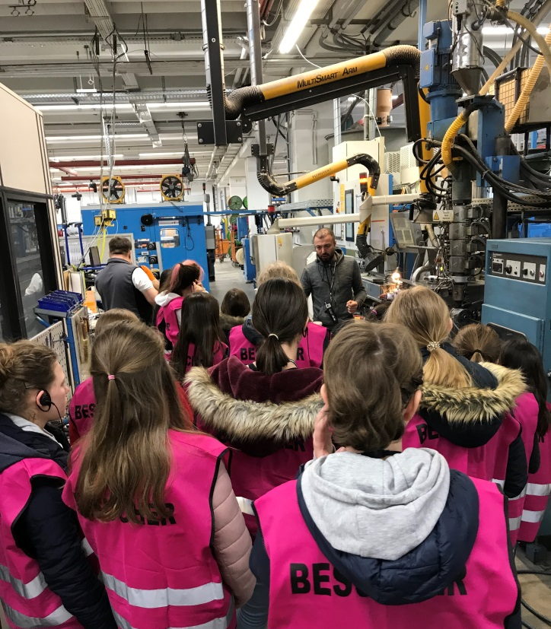
Exploring the cable works: On Girls' Day at LAPP, the pupils see how a cable is made.

Stuttgart, April 30th 2019

Which profession suits me? What are exciting tasks that could challenge me professionally? And what does the day-to-day work in technical and scientific professions look like? These and many other questions are buzzing in the minds of many young girls who are already thinking about their professional future at school. To get girls more interested in so-called MINT professions (mathematics, computer science, natural sciences and technology) the Girls' Day is held every year in Germany. LAPP, the world market leader for integrated cable and connection solutions, also wants to inspire young girls to take up scientific careers and therefore invited them to attend the Girls' Day at its European headquarters in Stuttgart.

In two exciting workshops 16 schoolgirls between the ages of ten and 19 were able to experience how LAPP moves from brainstorming to the finished product and what working in IT could be like. In the first workshop the schoolgirls invented their own product and two LAPP product managers were on hand to explain the process so that the girls could proudly present their new product developments at the end of the first workshop. From the product development department they went directly to the IT department where the girls created their own e-learning tool in a second workshop. For them, it was also exciting to see the making of a cable which the girls could observe during a guided tour through LAPP's cable works.

Afterwards, they also had the opportunity to ask questions to the human resources department and thus take a closer look at LAPP as a potential employer and establish contacts for internships and training. "The feedback from the schoolgirls was consistently positive and the girls said that they had a clearer idea of what working in a MINT profession would be like," reports Nicole Maric, personnel officer at LAPP, and explains: "Although girls in Germany are very well educated, they rarely take up scientific or technical apprenticeships. For this reason, we at LAPP invite schoolgirls to visit us especially on this day to show them exciting perspectives in professions in which women tend to be underrepresented.”

Find the image in printable quality here

Press contact:
Dr. Markus Müller Irmgard Nille
Tel: +49(0)711/7838-5170 Tel.: +49(0)711/7838–2490
Mobil: +49(0)172/1022713 Mobil: +49(0)160/97346822
markus.j.mueller@lappgroup.com irmgard.nille@in-press.de

U.I. Lapp GmbH
Schulze-Delitzsch-Straße 25
D-70565 Stuttgart

Find more information here: www.lappkabel.com/press

About LAPP:
Headquartered in Stuttgart, Germany, LAPP is a leading supplier of integrated solutions and branded products in the field of cable and connection technology. The company’s portfolio includes standard and highly flexible cables, industrial connectors and cable entry systems, customized system solutions, automation technology and robotics solutions for the intelligent factory of the future, as well as technical accessories. LAPP’s core market is in the industrial machinery and plant engineering sector. Other key markets are in the food industry as well as the energy and the mobility sector.
LAPP has remained in continuous family ownership since it was founded in 1959. In the 2017/18 business year, it generated consolidated revenue of 1,153 million euros. LAPP currently employs approximately 4,245 people across the world, has 18 production sites and around 44 sales companies. It also works in cooperation with around 100 foreign representatives.

