Double-digit growth in employee numbers and turnover
LAPP continues growth course

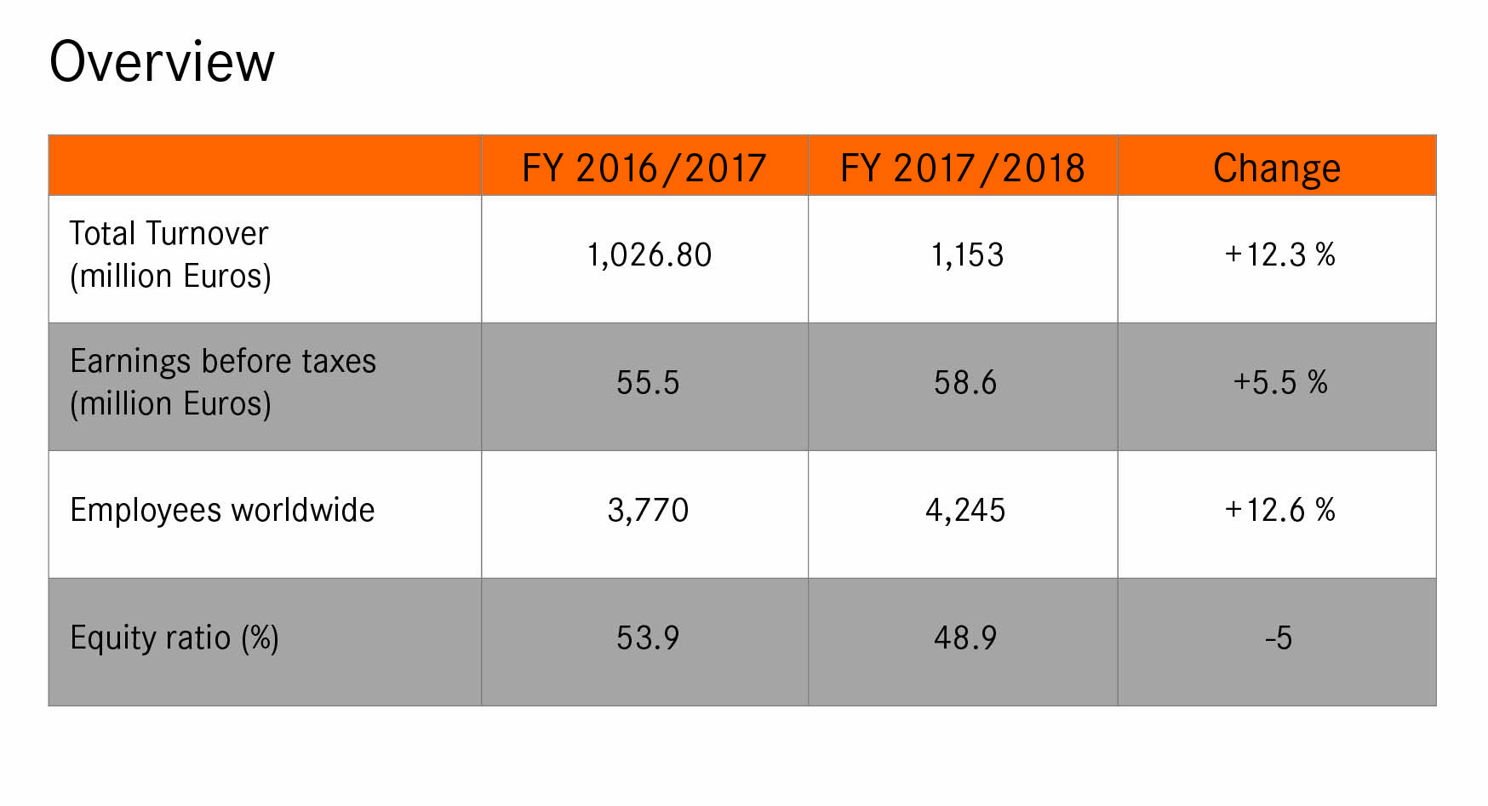
Stuttgart, 12 March 2019

LAPP has once again achieved double-digit growth. The turnover generated by the global market leader for integrated cable and connection technology solutions increased by 12.3 per cent to EUR 1,153 million in the last financial year (1 October 2017 to 30 September 2018). The number of employees increased by 12.6 per cent to 4,245. Earnings before taxes increased by 5.5 per cent to EUR 58.6 million. “We are fully on track and have been able to achieve above-average growth for several years through our strategy 2020. Europe in particular has seen positive growth. However, I still see a lot of room for improvement for LAPP in America. And I’m sure we’ve not exploited our full potential in Asia, either. We still have plenty to do in both regions,” emphasised Andreas Lapp, Chairman of the Board of LAPP Holding AG. The family-run company based in Stuttgart achieved its highest growth in Europe. And it’s all down to high demand, in particular in the sectors of industrial data communications (IDC) and ÖLFLEX® CONNECT (assembled cable systems) alongside company acquisitions in Finland, Poland and Switzerland.

Enormous increase in turnover
On balance, the considerable increase in turnover was only slightly affected by the increased copper price and currency fluctuations. As the actual price of a cable is calculated daily based on the current price of copper and copper prices were higher by 7 per cent on average throughout the year (EUR 569/100 kg), copper prices also boosted turnover by 1.9 per cent. By contrast, the currency fluctuations took their toll with a minus of 1.8 per cent. Once adjusted, the sales volume we achieved therefore increased by around 12.2 per cent. “In relation to turnover, acquisitions account for an increase of around 3 per cent. This confirms last year’s performance capacity with operational growth of around 9 per cent,” emphasised Dr Ralf Zander, Member of the board for Finance and Controlling.

Biggest success in EMEA
Growth in the EMEA region (Europe, Middle East and Africa) was particularly strong. Turnover grew here by 15 per cent to hit EUR 826 million. With a share of sales of almost 72 per cent, EMEA is LAPP’s most important market. Turnover in Germany grew by 9 per cent to hit EUR 341 million. The APAC region (Asia-Pacific plus Australia and New Zealand) increased its turnover by 9 per cent to hit just under EUR 212 million. The Central and North American region achieved an increase of 2.2 per cent and hit EUR 106 million. Due to economic crises, sales revenue in South America fell by 18 per cent to EUR 8.2 million.

A solid financial footing
Like the previous years, the 2017/2018 financial year was characterised by a solid financial footing. Earnings before interest, tax, depreciation and amortisation (EBITDA) increased to EUR 89.6 million (+10.6 per cent). Earnings before taxes (EBT) were at EUR 58.6 million (+5.5 per cent). The equity ratio decreased slightly to 48.9 per cent (previous year: 53.9 per cent) due to the increased balance sheet total and acquisition finance through third parties. However, it continues to be very high. Dr Ralf Zander, Head of Finance and Controlling, said: “Overall, LAPP’s financial position remained extremely robust in the last financial year.”

Investments in the future
In the last financial year, LAPP increased its investments by 29 percent to EUR 31 million. Alongside the necessary investments based on acquisitions and further global rollout of the SAP ECC 6.0 software, investments were made in machines, plants and logistics in the sales and manufacturing companies. Production capacity was doubled at the Indian production plant in Bhopal, for example, and the warehouse capacity there was expanded by 70 per cent. To support the expansion of the project business, a new warehouse was opened in Satteldorf in South-West Germany. A new logistics centre has also been set up in Poland for customers in industrial plant engineering and project business, for example for the construction of wind turbines, new production plants and tunnel projects. A number of projects concerning the digital transformation of the company have also been launched in the past year.

Significant increase in employees worldwide
The number of employees was increased in almost all companies. The number of employees worldwide rose by around 13 per cent to 4,245. Recruitment figures in the EMEA region were above average, with an increase of 16 percent, although company acquisitions also contributed to growth here. Work in HR largely focused on the development of human resources and the organisation. “We want to make LAPP a learning organisation where our employees’ life-long learning and the organisation’s ongoing systematic development are closely interlinked,” emphasised Dr Hilmar Döring, Member of the Board for Human Resources and Organisational Development. He added: “LAPP’s success can only continue if we make people our focus.” As such, a global training initiative was launched so that all employees with direct or indirect contact with customers can receive training on automation and industrial data communications.

Many success factors
The last financial year was influenced by many positive factors:
- Acquisitions & joint ventures: LAPP acquired both SKS Automaatio and SKS Connecto (now LAPP Automaatio and LAPP Connecto) in Finland and Poland in late 2017. LAPP Automaatio specializes in industrial data communication (IDC). LAPP Connecto is a leader in cables and cable harnesses. So LAPP can use this to strengthen its position in these sectors. LAPP Australia, a joint venture with LAPP’s New Zealand sales partner ECS, was founded in February 2018. LAPP purchased its long-term Swiss distribution partner Volland in July 2018.
- Improved production processes: Process stability and productivity were improved at all 18 production sites. Work has also already started on bringing the factories into the digital age: Two smart factory pilot projects were launched in France and China. They are aimed at demonstrating the opportunities and challenges of global and digital networking for the manufacturing sites.
- Successful expansion of special offers for growth markets: In its work with industrial data communications (IDC), LAPP was able to achieve 24 per cent growth in Ethernet-based products in the last financial year. LAPP’s IDC portfolio contains all the key components a user needs to design their factory according to Industry 4.0 principles, including a huge selection of data cables to comply with different standards, such as PROFINET or CC-Link, and now also switches for distributing data in harsh industrial environments. Georg Stawowy, Head of Technology & Innovation, said: “We supply the neural pathways for the smart factory. It is important to have an overall understanding that goes beyond mere product know-how. We understand our customers and see ourselves as a pilot for Industry 4.0.” There is also huge demand for pre-assembled cable systems with the ÖLFLEX CONNECT brand. LAPP saw an increase of 12 per cent here. There was also double-digit growth in logistics services (e.g. Kanban systems for customer warehouses, specially assembled containers and customised bay solutions for single cores).
- Innovative new products: Innovative new products were presented in all product ranges. The ETHERLINE PN CAT.6_{A} Fast Connect data cable, for example, is new to LAPP’s IDC portfolio. It enables quick and easy assembly and high data transfer rates of 10 gigabits per second – currently the maximum transfer rate in copper cables in industry. LAPP was also the first company to present an off-the-shelf cable for direct current: The ÖLFLEX DC 100 was specially developed to provide motors and appliances with direct current (see the separate press release on DC for details).
- New brand presence for LAPP: LAPP is now operating under the same name and logo worldwide. Chairman of the Board Andreas Lapp commented: “These days, the country in which our customers buy our products and the delivery destination are no longer so important – we’ve been working as an international team for a long time. It is a logical progression for our external identity to reflect that. And what’s more: that is exactly what our customers expect.”

Outstanding application examples
- Logimat storage lifts by SSI Schäfer are popular as they have a huge storage volume but a small storage space. With the ready-to-install ÖLFLEX CONNECT CHAIN energy chain, LAPP has helped cut manufacturing times from what used to be twelve weeks down to just four weeks from order to delivery.
- LAPP is increasingly being asked to solve customers’ problems. The company develops customised solutions tailored specifically to customers. For example, a manufacturer of noodle production plants recently asked the company to design EPIC connectors made of a special copper alloy for a noodle drying machine.
- Hekla is one of Iceland’s most active volcanoes. Scientists hope to use a network of seismometers to peer into the belly of the mountain and warn of an impending eruption. The system is networked using one of LAPP’s very robust data cables that can withstand icy temperatures and excessive heat as well as mechanical strain from the sharp-edged volcanic rock.

Outlook for the current financial year
LAPP got off to another good start in the 2018/2019 financial year. “Provided that the global economy doesn’t suffer another major downturn, we are expecting further growth throughout the current financial year,” said Andreas Lapp. Huge momentum is expected in Asia-Pacific and Europe, especially in automation and IDC.

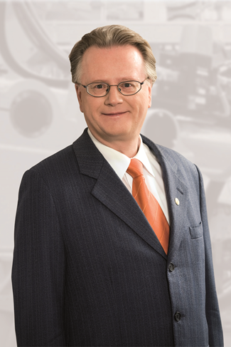
Source: LAPP
Andreas Lapp, Chairman of the Board of LAPP Holding AG and Member of the Board for Marketing and Sales
Find the image in printable quality here

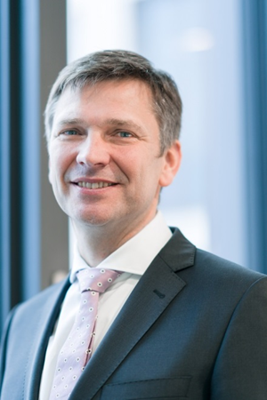
Source: LAPP
Georg Stawowy, Member of the Board for Innovation and Technology
Find the image in printable quality here

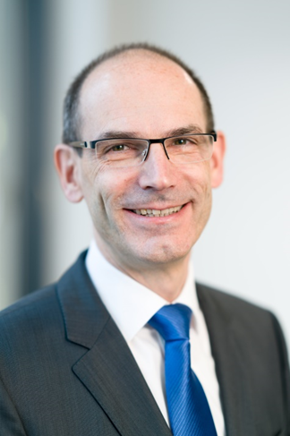
Source: LAPP
Dr Hilmar Döring, Member of the Board for Resources and Organisational Development
Find the image in printable quality here

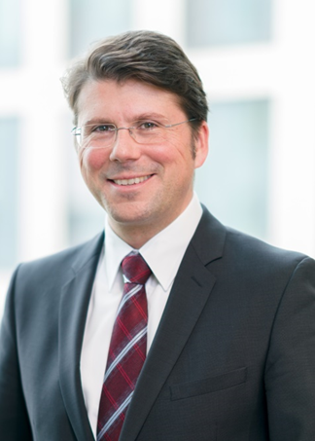
Source: LAPP
Dr Ralf Zander, Member of the Board for Finance and Controlling
Find the image in printable quality here

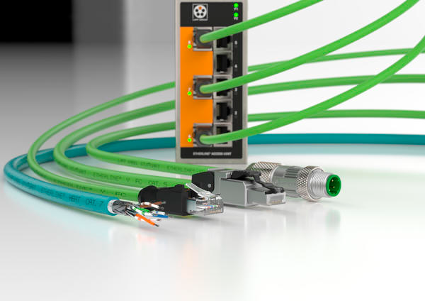
Source: LAPP
LAPP’s IDC portfolio contains all major components that users require to design their factory in accordance with Industry 4.0 principles.
Find the image in printable quality here

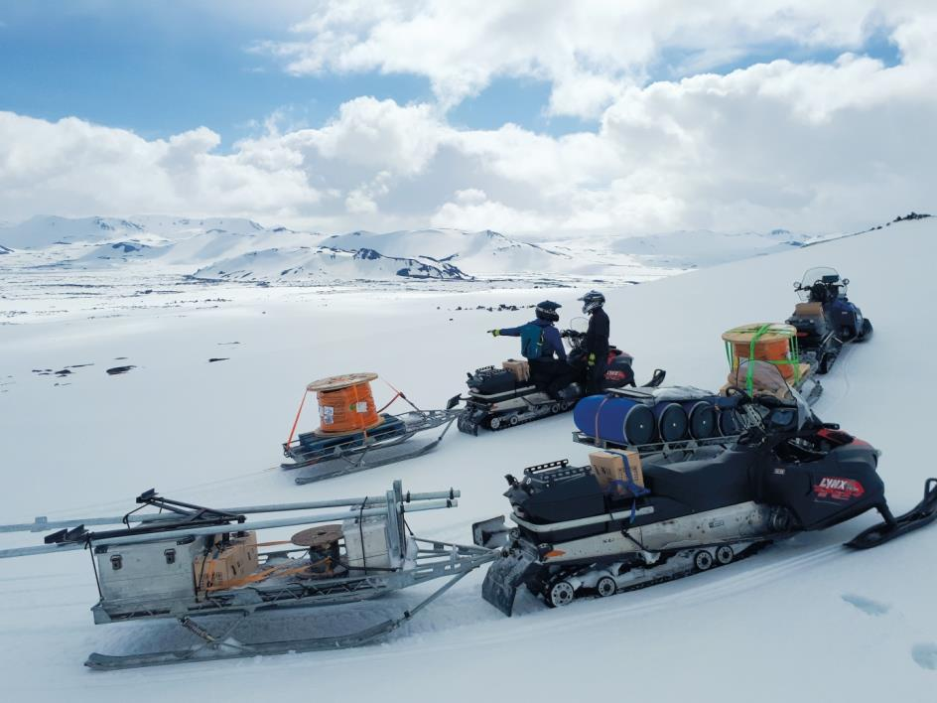
Source: Icelandic Meteorological Office.
The equipment, including 3,000 m of cable from LAPP, was transported through ice and snow up the slopes of the Hekla volcano in Iceland.
Find the image in printable quality here

Press contact:
Dr. Markus Müller Irmgard Nille
Tel: +49(0)711/7838-5170 Tel.: +49(0)711/7838–2490
Mobil: +49(0)172/1022713 Mobil: +49(0)160/97346822
markus.j.mueller@lappgroup.com irmgard.nille@in-press.de

U.I. Lapp GmbH
Schulze-Delitzsch-Straße 25
D-70565 Stuttgart

Find more information here: www.lappkabel.com/press

About LAPP:
Headquartered in Stuttgart, Germany, LAPP is a leading supplier of integrated solutions and branded products in the field of cable and connection technology. The company’s portfolio includes standard and highly flexible cables, industrial connectors and cable entry systems, customized system solutions, automation technology and robotics solutions for the intelligent factory of the future, as well as technical accessories. LAPP’s core market is in the industrial machinery and plant engineering sector. Other key markets are in the food industry as well as the energy and the mobility sector.
LAPP has remained in continuous family ownership since it was founded in 1959. In the 2017/18 business year, it generated consolidated revenue of 1,153 million euros. LAPP currently employs approximately 4,215 people across the world, has 18 production sites and around 44 sales companies. It also works in cooperation with around 100 foreign representatives.

