Lapp employees and customers celebrate ÖLFLEX success story
ÖLFLEX® cable drum on tour around the world

Stuttgart, 11 October 2010

ÖLFLEX® cable from Lapp is a success story that has now been going for more than 50 years. Ever since it was invented in 1959, it has been synonymous with quality, reliability and speed. To celebrate this, the Lapp Group is holding the ÖLFLEX® World Tour, which means that an ÖLFLEX® cable drum is visiting various Lapp sites around the globe. At each location, a variety of events are being held, based around the theme of the ÖLFLEX® product and the Lapp Group generally. A particular highlight are the performances of the Lapp Artists, who will be wowing audiences everywhere they appear on stage.

After its start in Stuttgart, the ÖLFLEX® World Tour made its first stop at the site of Lapp France in Forbach. Employees at the site enjoyed a wellness weekend, followed by a reception for customers and business partners. The Forbach audience also saw the first public appearance of Lapp Artists, who also came up with some inventive and memorable ways in which to use Lapp products. The drum then moved on to Spain, and it will also visit South Africa, India, China, Japan, Chile, the USA, Sweden and the Netherlands. It will finally return to Stuttgart in July 2011 – and employees, customers and friends of the Lapp Group there can look forward to the celebration of its return.

The Lapp Group also provides comprehensive online coverage of the ÖLFLEX® World Tour. An online newsroom has been set up at www.oelflex50.com, where visitors can find reports, pictures and video. Attendees at the events and friends of the Lapp Group can also use the social network facebook (www.facebook.com/LappGroup), or youtube and flickr to discuss their experiences and other topics relating to the company.

With its international itinerary and tight schedule, the ÖLFLEX® World Tour represents a major logistical challenge. The Lapp Group has partnered with Lufthansa Cargo to transport the drum safely around the world by air freight. Comments Konrad Moser, Key Account Manager with Lufthansa Cargo in Stuttgart: “Lapp Group and Lufthansa Cargo both have a global reputation for quality, and so we were delighted to be chosen as logistics partner for the ÖLFLEX® World Tour to accompany the cable drum on its journey.”

A global success
In 1959, Oskar Lapp (born 1921, died 1987) developed the first industrially manufactured power and control cable, and founded U.I. Lapp together with his wife Ursula Ida. The name they gave to their invention was ÖLFLEX®, and the brand has been synonymous with highly oil-resistant and flexible cabling ever since. Today, Lapp Group products are used in all kinds of devices, electrical equipment and machinery, in such diverse settings as wind and solar energy installations, the Transrapid maglev train in Shanghai, the Great Pyramid of Egypt and the cruise liner AIDAluna.

Says Lapp Holding CEO Andreas Lapp: “My parents made business and engineering history. They built a company with a global reputation – and we wanted to celebrate this achievement with as many of our customers, friends and employees around the world as possible.”

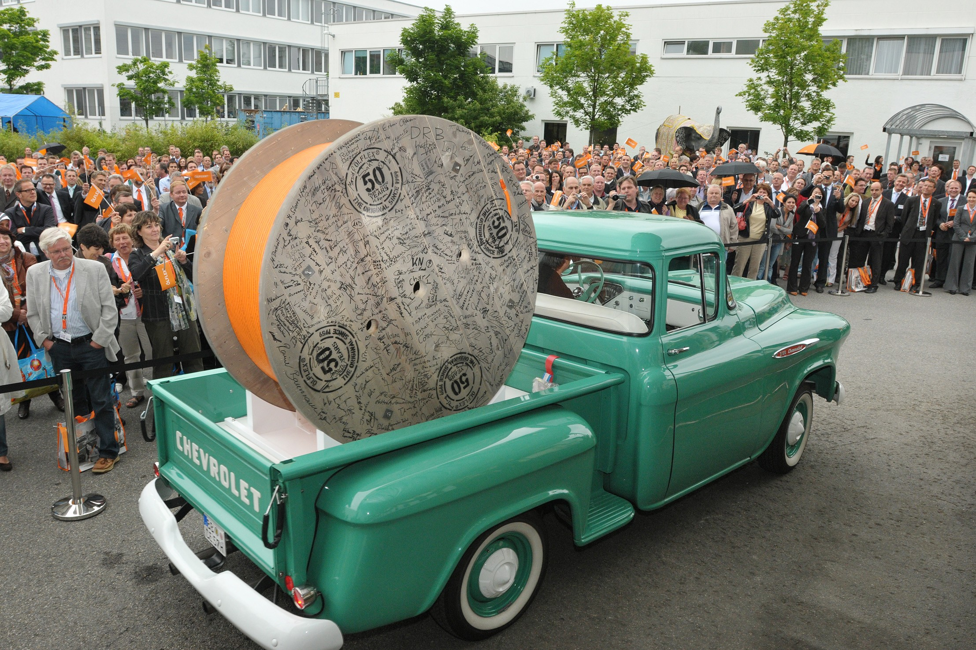
(Caption)
The ÖLFLEX® cable drum was given a big send-off at a reception for customers and employees

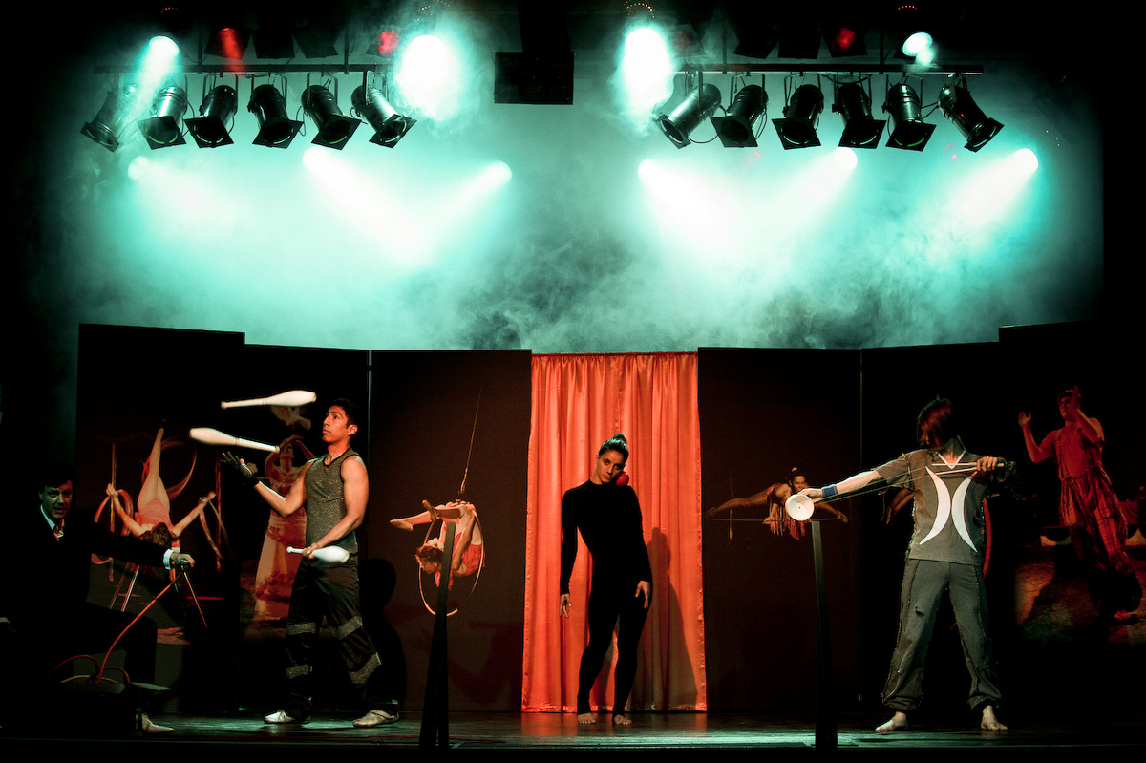
(Caption)
The Lapp Artists accompany the ÖLFLEX® cable drum, wowing audiences around the world

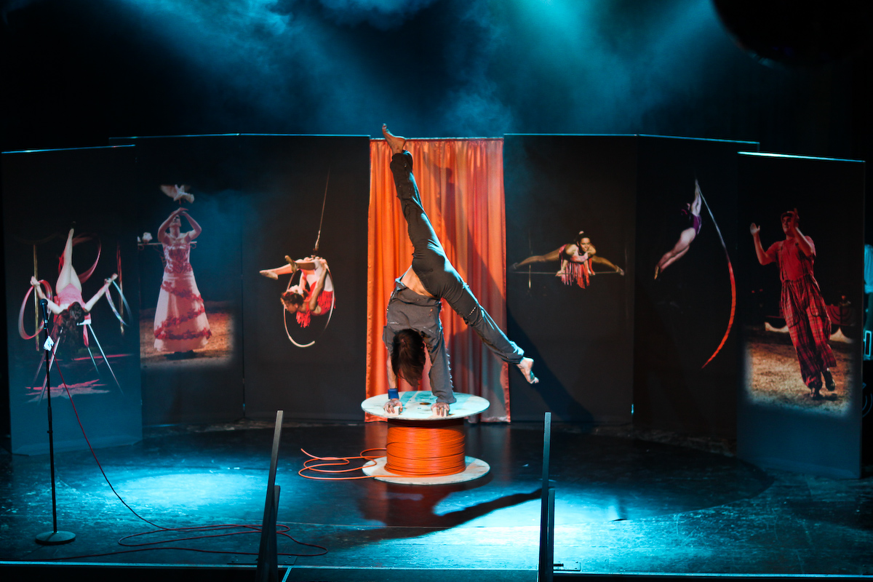
(Caption)
Lapp Artist Carlos Lilienthal came up with original uses for an ÖLFLEX® drum

About the Lapp Group:
Headquartered in Stuttgart, Germany, the Lapp Group is a leading supplier of integrated wire, cabling and connector products and solutions. Its offering includes electrical and fibre optic cables, industrial plug-in and screw connectors, cabling solutions, automation technology and technical accessories. Lapp Group’s core markets are in the mechanical and plant engineering and electronics manufacturing sectors, with rapid market expansion in the renewable energy, mobility and life science industries.

Lapp Group has remained in continuous family ownership since it was founded in 1959. In the 2008/09 financial year, it recorded total sales of 508 million euros. It employs some 2,600 people, and operates 16 manufacturing sites, 40 distribution subsidiaries and 100 representative offices.

