Stuttgart-based Lapp Group presents new multi cable bushing system with variable clamping range

SKINTOP® CUBE: It Doesn’t Come Any Quicker And Simpler Than This!

Stuttgart, November 2009

Lapp Kabel will be presenting at the SPS/IPC/DRIVES (24. – 26.11.2009) in Nuremberg, Hall 6, Stand 350, its brand-new cable multi bushing system SKINTOP® CUBE, consisting of a frame (SKINTOP® FRAME) and flexible clip sealing modules (SKINTOP® CUBE MODULES).

Fit the sealing module onto the cable and then clip it into the frame – done! The cable is then perfectly fixed, secured against vibrations, strain-relieved and sealed in accordance with IP 54. This is the simple principle for inserting cables in future with assembled connectors securely, quickly and clearly arranged into a switch cabinet. And it’s all possible without the need for special tools, sealants or lubricants.

Lapp Kabel has thereby revolutionised the multi cable bushing system. The patented flexible clip modules with variable clamping range are available in 4 sizes: 4 to 6 mm, 6 to 9 mm, 9 to 12 mm as well as 12 to 16 mm. The matching, glass-fibre-reinforced frames made of polyamide are available in two sizes for 16-pin or 24-pin connector openings. This means that 8 to 10 cables can be mounted in a clearly-arranged manner where space is at an absolute minimum.

More advantages: fewer parts through variable clamping ranges, which in turn reduces storage requirements. During maintenance and service work the frame is left on the housing. Simple, fast mounting and demounting of assembled cables. The clip modules can also be integrated into cable assembly planning. That saves time and money. SKINTOP® CUBE is resistant to oil, grease, ultraviolet rays and ozone.
About the Lapp Group:
The Stuttgart-based Lapp Group is one of the leading manufacturers and suppliers of highly flexible cables, leads, cable accessories, industrial connectors, preassembled cables and communications technology. Its world-famous brands include ÖLFLEX® connecting and control cables, UNITRONIC® data cables, HITRONIC® fibre optic cables, SKINTOP® cable glands, SILVYN® cable protection and guiding systems, FLEXIMARK® marking systems, EPIC® industrial connectors and ETHERLINE® components for active network technology.

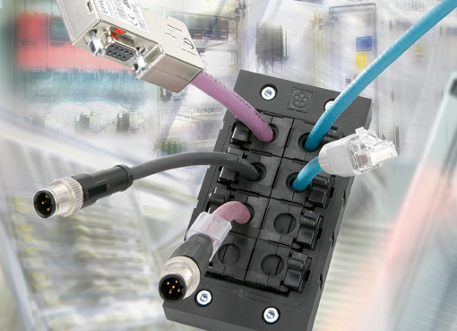
Picture (jpg) and text (doc) available from www.lappkabel.de
News / Press

