News from the Lapp Group at Hannover Fair 2010
An All-round Automation Package

Stuttgart, April 2010

The Lapp Group from Stuttgart will be showing how to save money efficiently in automation when they take to their new stand, C 03 in Hall 11, at Hannover Fair. A demonstration area extending to some six square metres will be showing a system solution for industrial automation set up specifically for mechanical and plant engineering - and any one can try it out.

The special feature of this exhibit is that as of now, the Lapp Group from Stuttgart is providing an all-round automation package: in addition to the active sensor/actuator modules for bus systems in common use throughout the world and the matching field wiring, the UNITRONIC® field bus range from Lapp now also includes gateways for coupling to higher-level Ethernet networks.

The portfolio supports all of the established field bus systems used worldwide. The extensive product range includes sensor/actuator modules for AS-Interface, Profibus, CANopen and DeviceNet. Equipped with standardized connection technology and featuring high industrial protection class ratings, they are suitable for connecting all commonly used sensors and actuators, providing you with the perfect solution for decentralized automation in mechanical and plant engineering applications. Their quick and easy assembly means that installation costs can be significantly reduced even under the most demanding conditions.

There will be a particular focus on the devices developed internally for AS-Interface. These are designed especially for rapid, efficient and economical networking of sensors and actuators. The devices can be installed in just a few steps, modules with a high protection class rating and modules for the assembly of DIN rails both being available.

The IP67 variant provides a locking mechanism which guarantees connection to the AS-i flat flexible cable without any tools. Appropriate reverse polarity-protected guides are used to connect devices to the AS-i cable by locking into place with a penetration technique. The metal housings of the IP30 devices are equipped with modular plug-in terminals. Depending on the application, therefore, connection is effected by screw or spring-type terminals.

There is also a comprehensive range of UNITRONIC® signal cables, T-pieces/Y-pieces, terminating resistors and self-assembly connectors as well as plug-and-play sensor/actuator cables and related accessories for the rapid wiring of sensors and actuators in the field.

More information is available at www.lappautomation.com

About the Lapp Group
The Lapp Group is one of the leading manufacturers and suppliers of highly flexible cables, cable accessories, industrial connectors and preassembled cables. Its world-famous brands include ÖLFLEX® connecting and control cables, UNITRONIC® data cables, HITRONIC® fibre optic cables, SKINTOP® cable glands, SILVYN® cable protection and guiding systems, FLEXIMARK® marking systems, EPIC® industrial connectors and ETHERLINE® data transmission systems for ETHERNET technology.

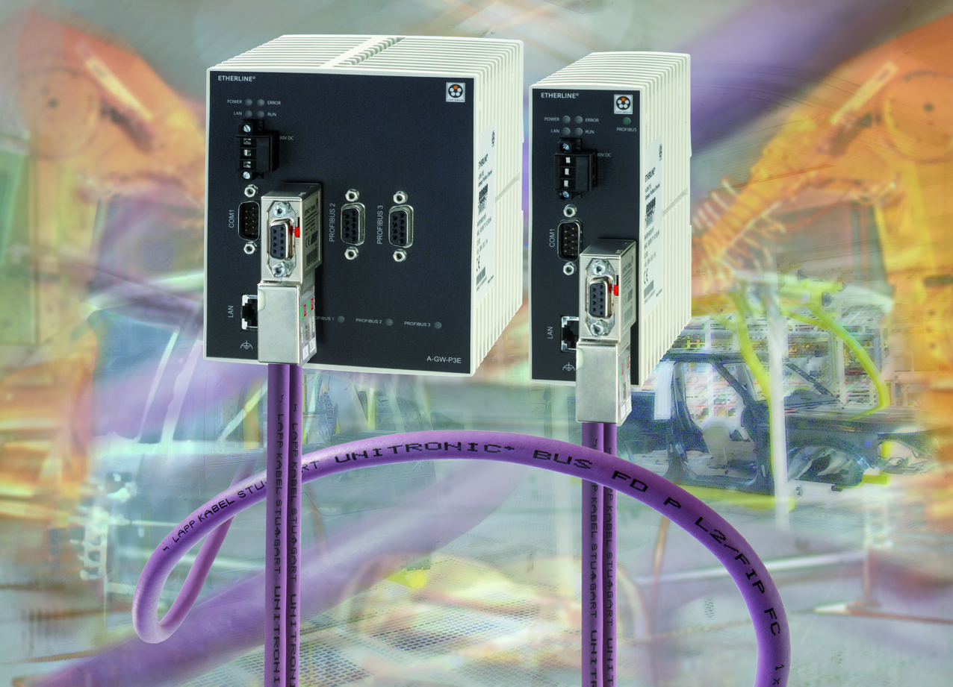

Caption: UNITRONIC® field bus gateways from Lapp for
perfect coupling to Ethernet networks

Photo (jpg) and text (doc) available from www.lappkabel.de
News/Press

