News from the Lapp Group at Hannover Fair 2010
A Powerful Foursome – New ÖLFLEX® Products

Stuttgart, April 2010

There are four new ÖLFLEX® connecting and control cable developments, including two all-rounders for the wind energy industry and two servo highlights for mechanical and plant engineering. The Lapp Group based in Stuttgart is presenting this powerful ÖLFLEX® foursome on its new stand, C 03 in Hall 11, at Hannover Fair.

Two all-rounders for wind turbines
The ÖLFLEX® TORSION FRNC was developed specifically for use in the cable loop of wind turbines between the rotating gondola and the static tower area. It turns up to +/-150 degrees per metre to compensate reliably for the continuous torsional movement. It is also highly flexible for simple cable routing, as well as being resistant to cold, oil and salt water, easy to strip and characterized by outstanding behaviour in the event of fire. The D version, with cooper screen braiding, also protects against electromagnetic interference.

ÖLFLEX® FORTIS is a weathering-resistant connecting and control cable, and with its very broad range of application temperatures between -55 °C and +105 °C, works reliably in any location in the world. However, it is not just its temperature range which makes the “strong” ÖLFLEX® FORTIS unique: specifically for the North American wind energy market, it has the UL WTTC (Wind Turbine Tray Cable) Listing to UL 2277 standard required there, so it also meets the new UL 6140 outline for wind turbines for walking on. The new wind power cable also has increased resistance to oil, high resistance to flames and resistance to torsion for use in the cable loop. As a consequence, the ÖLFLEX® FORTIS is highly versatile in use, whether for gondola wiring, for the hub or from pitch control to the slip ring.

Two servo highlights
In order to increase the efficiency of the machines and the sequences of movement in production processes, Lapp Kabel has developed a completely new generation of highly dynamic and highly flexible cables which can withstand heavy strain and suit servo drives. There’s nothing quicker, because servo cable LK SMS FX8PLUS now manages as much as 50 m/sec² instead of the previous 5 m/sec² at a maximum travel of three metres and is also extremely resistant to reverse bending (min. 5 million cycles). Acceleration values of this level were previously known only from the use of linear motors.

The servo range for NFPA 79-compliant cables for the North American market has also been expanded further. The UL-listed servo cable ÖLFLEX® VFD with signal is consequently also available with immediate effect. It is ideal for servo motor power circuits in which, for example, an electrical circuit has to be routed in a common cable to both a temperature-monitoring unit and to an electric brake. It furthermore has all the application benefits of TC-ER-listed cables and is suitable for free/open routing along the machine body.

About the Lapp Group
The Lapp Group is one of the leading manufacturers and suppliers of highly flexible cables, cable accessories, industrial connectors and preassembled cables. Its world-famous brands include ÖLFLEX® connecting and control cables, UNITRONIC® data cables, HITRONIC® fibre optic cables, SKINTOP® cable glands, SILVYN® cable protection and guiding systems, FLEXIMARK® marking systems, EPIC® industrial connectors and ETHERLINE® data transmission systems for ETHERNET technology.

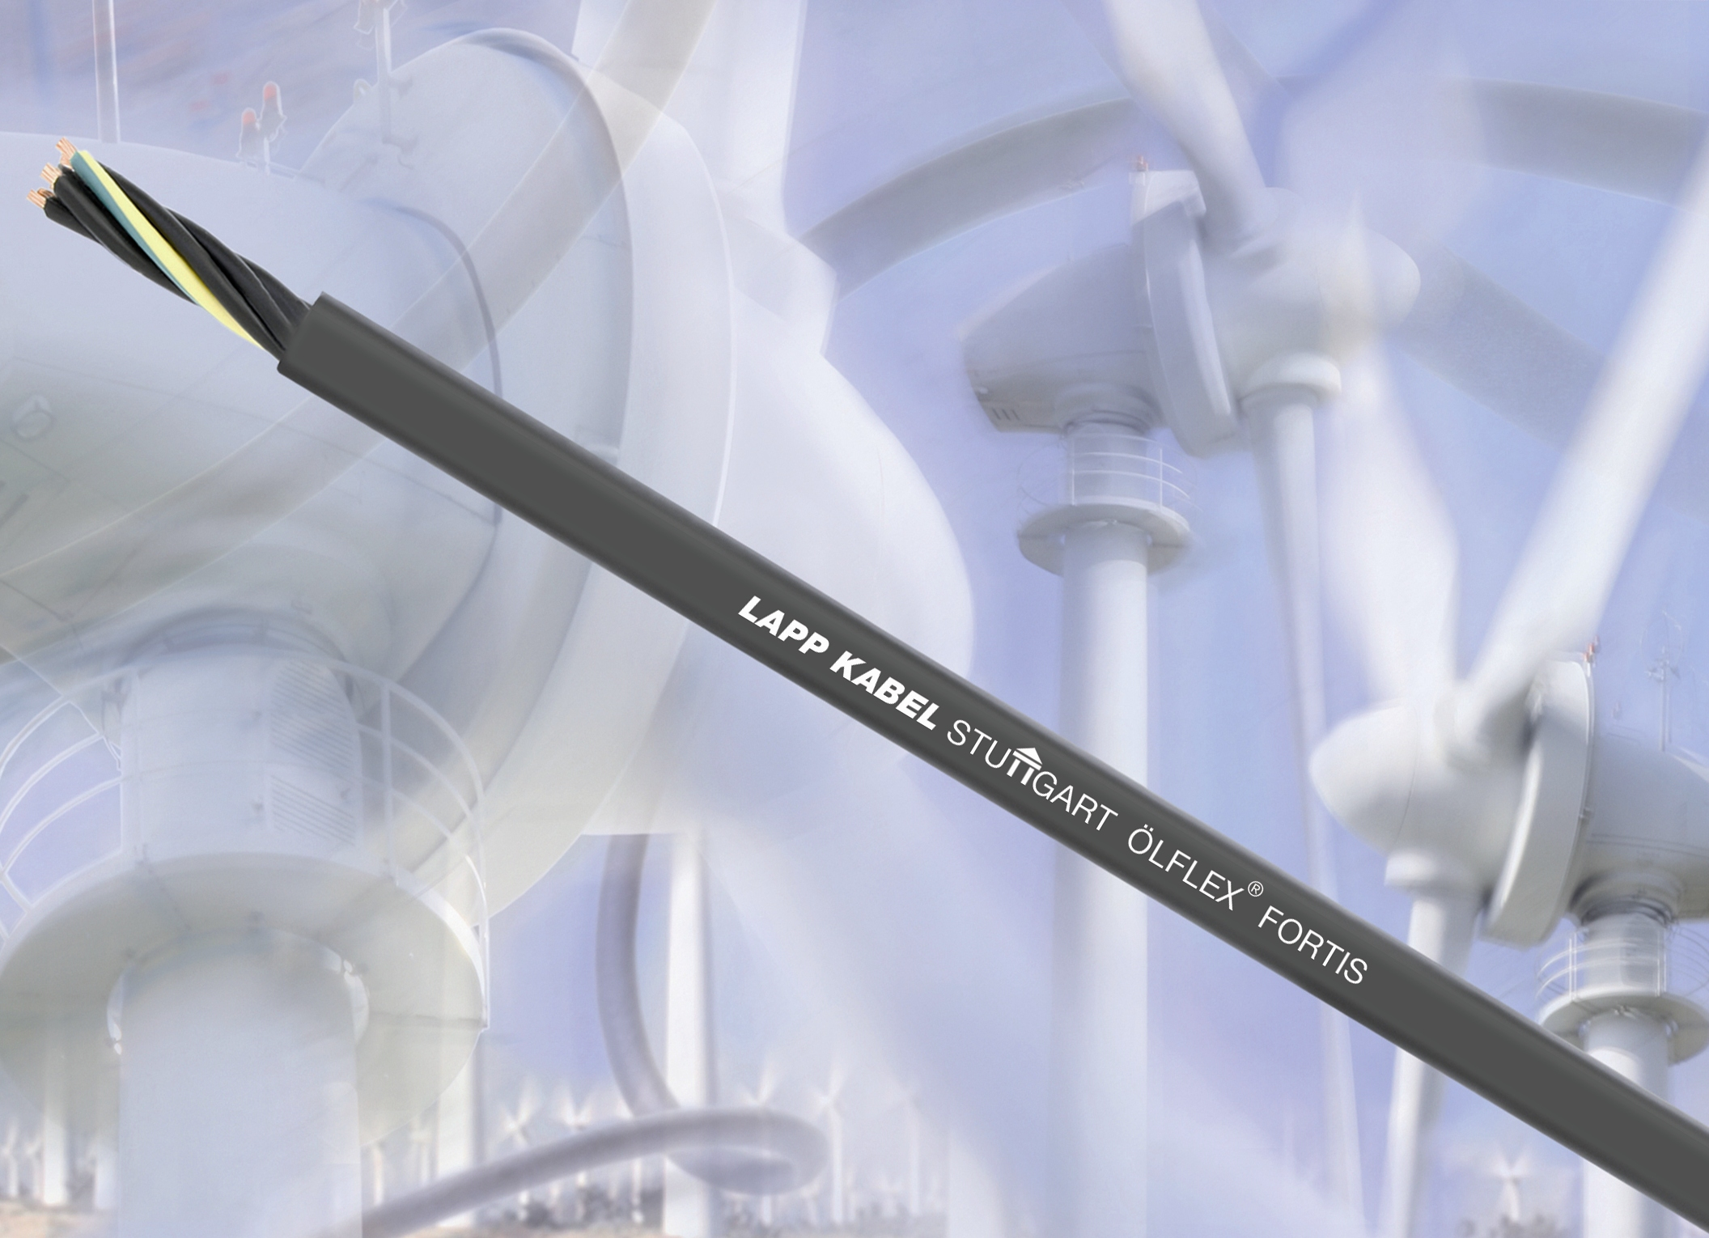

Caption: The UL/CSA-listed ÖLFLEX® FORTIS

Photo (jpg) and text (doc) available from www.lappkabel.de
News/Press

