News from the Lapp Group at Hannover Messe 2015
Smart and 'travel-friendly' innovations

Stuttgart, March 2nd, 2015
The Stuttgart-based Lapp Group is presenting new, efficient and innovative solutions for a range of industrial applications at the Hannover Messe (hall 11, stand C03). In line with the trade fair slogan 'Integrated Industry – Join the Network!', the leading provider of integrated solutions and brand products in the field of cable and connection technology is presenting its innovations for Industry 4.0.

ETHERLINE® HEAT makes buses smart
A highlight in this field is the new ETHERLINE® HEAT 6722 series, which makes buses smart. Ethernet enables buses to communicate with bus stops and passengers. An ever-growing number of intelligent systems, such as ticket systems and passenger information systems on the bus, are networked via Ethernet. At the same time, the fire protection requirements in vehicles such as buses have increased. A modified version of the European Regulation ECE-R 118-01, which regulates these requirements in vehicles, will come into force at the start of December 2015. The new ETHERLINE® HEAT series is already certified according to ECE-R 118 and enables the establishment of Ethernet networks up to Cat. 7. This guarantees data rates of 10 Gbit/s in vehicles. In addition, the cable has passed all environmental tests that are relevant for use in vehicles and is also approved for use in the passenger compartment of buses.

Lapp is once again represented at the SmartFactory^{KL} trade fair stand with a proprietary production module. The plant has been further enhanced compared with last year's trade fair and now features even more production modules with connection technology from Lapp.

Supple even at extremely low temperatures
The new ÖLFLEX® CLASSIC 110 LT control cable, which remains flexible at low temperatures, is able to withstand temperatures as low as minus 30 degrees Celsius. It is suitable for connection technology in cold stores, frozen food plants and other technical plants in which very low temperatures may predominate, such as in wind turbines. However, it also provides reliable connections in the case of outdoor use in which the cable is moved or subject to vibration. This is made possible by a particularly cold-resistant PVC sheath. In contrast, standard PVC cables should only be used at temperatures of minus 5 or minus 15 degrees. The new ÖLFLEX® CLASSIC 110 LT is also cost-effective and space-saving in the installation.

Motor cables for North America
New motor cables for frequency converter drives are available for export-oriented machinery and plant construction firms. In the case of the ÖLFLEX® VFD 2XL and the ÖLFLEX® VFD 2XL with SIGNAL, the multiple UL listing means that only one cable is required for 600 V, 1,000 V and 2,000 V applications. As a result of the XLPE insulation and the phthalate-free outer sheath, this innovative generation of motor cables is low capacitance, flame-retardant (FT4), oil-resistant (Oil Res I/II) and still extremely flexible.

Dynamic in power chains
A new ÖLFLEX® CHAIN 809 SC CY cable is also being presented at the trade fair. It is intended for dynamic use in power chains. With a range of conductor cross-sections from 6 mm² to 240 mm², it immediately boosts the product range of single-wire cables in the basic line performance class of up to two million alternating bending cycles for power circuits in converter-operated motors. For mild to moderate stress in power chains, the shielded cable is an interesting alternative to the established ÖLFLEX® FD 90 CY from the core line performance range for higher, constantly moving stress. The closely meshed, tinned copper braiding of the single-wire cable ensures that EMC is maintained even in critical environments with permanently flexible power chain operation featuring a travel path of up to 10 metres. The ÖLFLEX® CHAIN 809 SC CY, which is oil-resistant according to DIN EN 50290-2-22, is also suitable for use outdoors – provided the temperature range is observed – thanks to the UV-resistant black PVC outer sheath. The cable, which is flame-retardant and tested according to VW-1 and FT1 and is used for factory cabling with operating voltages of up to 600V (UL/CSA) or 0.6/1kV, can be used by export-oriented machinery and plant construction firms in their drag chains without any problems. It is also approved for the USA and Canada as a result of the UL certification and the cUL AWM certification. The low minimum bending radii mean that it is also suitable for internal wiring, for example in control cabinets.

New EPIC® connector housing configurator
Lapp will also be presenting the new housing configurator for EPIC® industrial connectors at its trade fair stand. This enables the user to directly put together an individual industrial connector housing with locking concept and cable entry – 138 million different configurations can be defined with the configurator. The advantage of this solution is that the result can be inspected on the screen before the order is placed. This helps avoid the placement of incorrect orders. Even unusual configurations that need to be produced specially for individual customers can be supplied within five working days thanks to the highly automated and flexible production at the Stuttgart site.
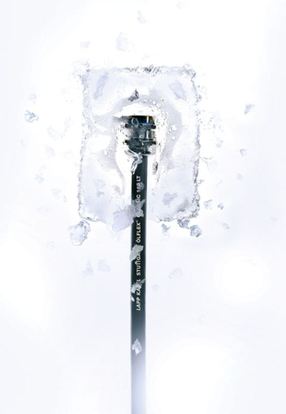
The new ÖLFLEX® CLASSIC 110 LT control cable remains flexible even at temperatures as low as minus 30 degrees Celsius

Find the image in printable quality here
www.lappkabel.com/press

About the Lapp Group:
Headquartered in Stuttgart, Germany, the Lapp Group is a leading supplier of integrated solutions and branded products in the field of cable and connection technology. The Group's portfolio includes standard and highly flexible cables, industrial connectors and screw technology, customised system solutions, automation technology and robotics solutions for the intelligent factory of the future, as well as technical accessories. The Lapp Group’s core market is in the industrial machinery and plant engineering sector. Other key markets are in the food industry as well as the energy and the mobility sector.

The Lapp Group has remained in continuous family ownership since it was founded in 1959. In the 2012/13 business year, it generated a consolidated turnover of 830 million euros. Lapp currently employs approximately 3,200 people across the world, has 18 production sites and over 40 sales companies. It also works in cooperation with around 100 foreign representatives.

