Stuttgart-based Lapp Group provides training and degrees in eleven skilled trades
18 new trainees at Lapp

Stuttgart, 1st September 2015
18 young women and men are today (1st September 2015) beginning their professional lives at Lapp, the Stuttgart-based producer of cables and connection technology. The Lapp Group offers eleven skilled trades, including machinery operator, plant operator, mechatronics engineer and industrial management assistant. Furthermore, integrated degree programmes such as Business Studies with Service Management and Logistics Management can also be undertaken at Lapp.

"Good training is the key to young people's future professional success. But well trained and qualified employees are also a vital component of our company's success", explains Andreas Lapp, Chairman of the Board of Lapp Holding AG. Therefore, he says, training plays an essential role at Lapp.

From day one, the Lapp trainees will be completely integrated into the company. Over the course of their training, they will get to know virtually all of the departments. And even before the training has officially started, the prospective Lapp employees will be invited to a welcome evening to get to know the trainers and the training officers.

The traineeship at Lapp officially starts with a training week in which the new trainees gain initial insight into the company's structures and procedures, as well as an overview of their training at Lapp. The company values, the sectors and the brand products will also be presented. The week is capped off by cooperative team building involving all trainee year groups.

"In addition to classic training, social skills are also very important to us", explains Anne Voigt, a trainer at U.I. Lapp GmbH. In order to improve teamwork skills, the trainees are actively integrated into numerous events and projects. These include the organisation of the annual anniversary celebrations, the company's appearance at the major trainee and student fair "azubi & studientage" and at "vocatium Stuttgart", a specialist trade fair for training and study, as well as the "Jobshuttle – Nächster Halt Ausbildung/Studium" ("Job shuttle - next stop training/study") careers information event. The trainees also play an active role at Hannover Messe: they are an important part of the team at the Lapp Group stand. The training programme also involves the social project "Mehrwert" ("Added value"), where the trainees carry out social work for two weeks at an institution of their choice and "Tüftler- und Forscherinnentag Baden-Württemberg" ("Tinkerers and researchers day Baden-Württemberg"), where the trainees at Lapp give nursery groups a playful introduction to the company. Additionally, the professional newcomers are allowed to participate in regular training weeks and in team training.

As part of the training programme, the trainees and integrated degree students also have the opportunity to work in one of Lapp's foreign subsidiaries for four to twelve weeks. There they not only support the employees in their day-to-day work, they are also allowed to work on concrete projects. At Lapp Limited in the United Kingdom, for example, a prospective IT business specialist from Stuttgart helped to improve the IT infrastructure. At Lapp Mexico, a trainee working towards the role of management assistant in wholesale and foreign trade had the task of improving the online presence of Lapp Mexico on search engines and in social networks, while at Lapp Southern Africa a Business Studies student worked on expanding and restructuring the warehouse. "For the trainees, activities abroad like these are not just a nice addition to their CVs, they also play a crucial role in personal development", Anne Voigt adds.

In all, 60 young men and women are currently receiving training at the Stuttgart site.

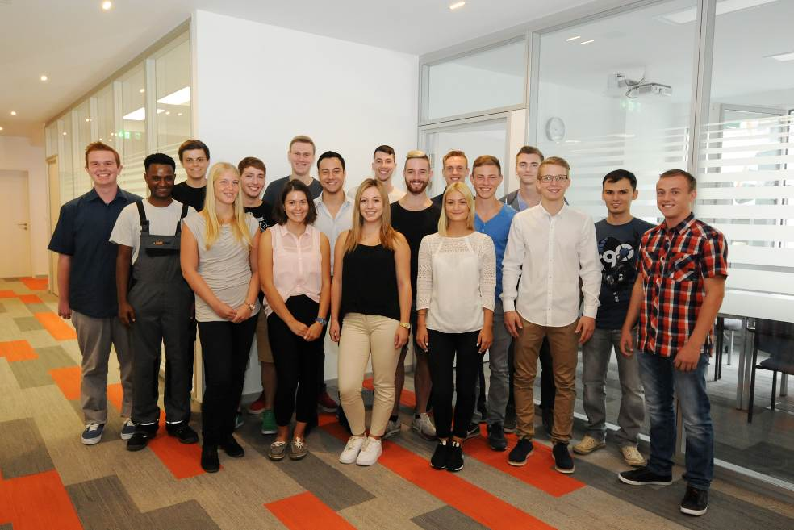
Image caption:
The Lapp traineeship begins with a training week for the new trainees

The image is available in printable quality here

The image is available in printable quality here

www.lappkabel.de/presse

Über die Lapp Gruppe:
Die Lapp Gruppe mit Sitz in Stuttgart ist einer der führenden Anbieter von integrierten Lösungen und Markenprodukten im Bereich der Kabel- und Verbindungstechnologie. Zum Portfolio der Gruppe gehören Kabel und hochflexible Leitungen, Industriesteckverbinder und Verschraubungstechnik, kundenindividuelle Konfektionslösungen, Automatisierungstechnik und Robotiklösungen für Industrie 4.0 und die Smart Factory. Der Kernmarkt der Lapp Gruppe ist der Maschinen- und Anlagenbau. Weitere wichtige Absatzmärkte sind die Lebensmittel-, Energie-, Mobilitäts- und die Life Science Industrie.

Die Unternehmensgruppe wurde 1959 gegründet und befindet sich vollständig in Familienbesitz. Im Geschäftsjahr 2013/14 erwirtschaftete sie einen konsolidierten Umsatz von 820 Mio. Euro. Lapp beschäftigt weltweit rund 3.200 Mitarbeiter, verfügt über 18 Fertigungsstandorte und mehr als 40 internationale Vertriebsgesellschaften und arbeitet mit Partnerunternehmen in weiteren 100 Ländern.

