Organic photovoltaic objects on German pavilion at the world exhibition in Milan
Connection technology for solar trees from Lapp

Stuttgart, May 12, 2015
At the world exhibition in Milan, Expo Milano 2015, the German pavilion will grab the visitors' attention with its energy-generating solar trees. These solar trees integrate organic photovoltaics (OPV) technology and, unlike conventional solar modules, are made from flexible, film-integrated OPV modules. The revolutionary connection technology needed to produce these comes from the Stuttgart-based Lapp Group.

"We have developed an entirely new process for connection and cabling that is also highly suitable for particularly delicate OPV modules", explains Stefan Koch, Product Manager at Lapp. The OPV modules come from the Nuremberg-based company BELECTRIC OPV GmbH which has produced the semi-transparent OPV modules conforming to the specifications of the design and architecture company SCHMIDHUBER. The hexagonal OPV modules for the "canopy" of the solar trees come in four different varieties, with a diameter of either 340 or 880 mm and different active areas which can be unobtrusively integrated into the architectural component made of film and wire braiding.

Conventional PV junction boxes and thick cable connections would not have been at all suitable for this design concept. Therefore Belectric approached Lapp in search of a solution. "We were impressed by the Lapp team's experience with designing and implementing connection components according to individual customer requirements. Together we developed the ideal solution for our OPV modules", states Hermann Issa, Director of Business Development Sales for Belectric OPV.

The OPV modules and the innovative connections are literally made from one cast – unlike with conventional photovoltaic modules, there is no longer a junction box attached to it, instead there is a so-called access point that is cast directly onto the flexible OPV film and merges with the film. This method prevents capillary action and therefore also damage by corrosion. Additionally, the Lapp connection components of the Belectric modules in the solar trees are, at only 30 mm x 20 mm, considerably smaller than those in conventional systems. The cables used on the modules were chosen according to customer-specific requirements and are only 2 mm wide. They have been produced in grey for use on the German pavilion so that they can be integrated virtually unnoticeably into the grey wire braiding of the design components.

Lennart Wiechell, an architect at SCHMIDHUBER, says: "Conventional photovoltaic modules are nowhere near flexible enough in terms of shape and size. On the other hand, the use of organic photovoltaics offers us architects a completely new sort of freedom, as well as creative leeway." Organic photovoltaic solutions can be fully integrated into building envelopes or objects. The flexibility of their shapes, colours and transparency opens up a diverse range of applications. Stefan Koch says: "We make our connection technology specially compatible with the diverse range of individually created OPV varieties, and we are able to make the connection technology much smaller and more inconspicuous than would be possible with conventional PV connection systems and wirings."

For over ten years, Lapp has been successfully developing connection systems for photovoltaic modules and has regularly pushed the market forward with its intelligent innovations, for example the well-known connector system EPIC® Solar and the cable series ÖLFLEX® Solar.

Further information on the innovative connection technology for organic photovoltaics can be found at the Lapp Group's fair stand (Hall A2, Stand 458) at the Intersolar Europe exhibition in Munich from 10-12 June.
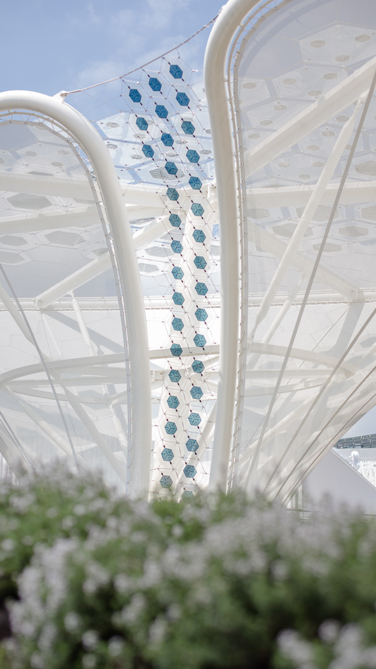
At the Expo 2015 in Milan, the energy-generating solar trees are a focal point of the German pavilion
Find the image in printable quality here

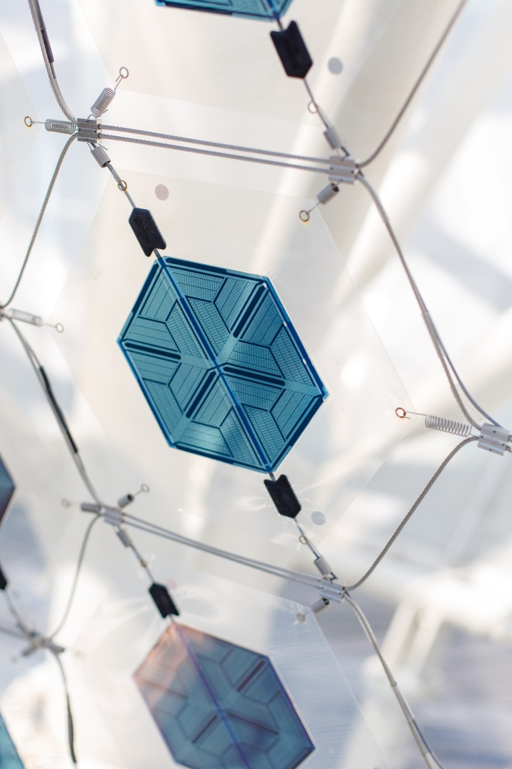
The flexible, film-integrated OPV modules can be unobtrusively integrated into the architectural concept
Find the image in printable quality here

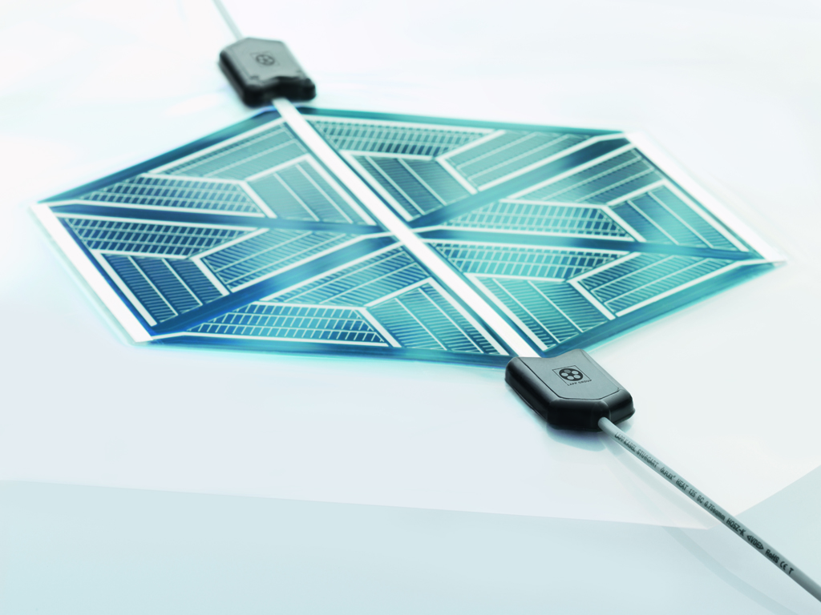
The innovative connection system for organic photovoltaics comes from the Lapp Group
Find the image in printable quality here

More photos available upon request

www.lappkabel.com/press

About the ARGE OPV:
The Organic Photovoltaic Technology Consortium (ARGE OPV) is the partner network for the development and installation of organic photovoltaic technology on the German pavilion. It is made up of the companies BELECTRIC OPV (provision of OPV modules/system, integration and installation), Carl Stahl GmbH (stainless steel cable net, construction and installation), Hager SE (energy storage and home connection technology), U.I. Lapp GmbH (electric connection technology), Merck KGaA (polymer semiconductors) and Schmidhuber (architectural integration and design). The project is supported by the Federal Ministry of Education and Research

About the German pavilion:
Commissioned by the Federal Ministry for Economic Affairs and Energy, the trade fair company Messe Frankfurt is responsible for the organisation and the operation of the German pavilion at the 2015 world exhibition in Milan. Responsibility for conceptualising, planning, and implementing the German pavilion is being taken on by the consortium (ARGE), consisting of Schmidhuber (spatial concept, architecture and general planning), Milla & Partner (creative concept, exhibition and media design) and Nüssli Germany (execution and project management).

About the Lapp Group:
Headquartered in Stuttgart, Germany, the Lapp Group is a leading supplier of integrated solutions and branded products in the field of cable and connection technology. The Group’s portfolio includes standard and highly flexible cables, industrial connectors and screw technology, customized system solutions, automation technology and robotics solutions for the intelligent factory of the future, as well as technical accessories. The Lapp Group’s core market is in the industrial machinery and plant engineering sector. Other key markets are in the food industry as well as the energy and the mobility sector.

The Lapp Group has remained in continuous family ownership since it was founded in 1959. In the 2013/14 business year, it generated consolidated revenue of 820 million euros. Lapp currently employs approximately 3,200 people across the world, has 18 production sites and over 40 sales companies. It also works in cooperation with around 100 foreign representatives.

