Lapp Group extends range for preassembled cables
From component supplier to system supplier

Stuttgart, 15 February 2016

When people think of Lapp, they normally think of cables, cable glands and connectors of excellent quality. That's certainly true, but in fact the company’s offering goes much further. Over the last 30 years, the Lapp Group has developed expertise in the field of preassembly at a number of locations – including the Stuttgart site of Lapp Systems GmbH, a Lapp Group company. With the company continuously expanding its knowledge of the industry, it is now able to meet even the most complex requirements.

Under the new name of ÖLFLEX® CONNECT, Lapp is now extending these activities and standardizing all global preassembly activities for customers, including consultation. For that purpose, the company has been increasing its corresponding production and preassembly capacities in America, Europe and Asia. As a result, the number of sites has risen from 5 in 2015 to 12 in 2016. This means that Lapp is in an even better position than before to produce preassembled cabling solutions around the world according to customer requirements. The customers benefit from customised solutions, high quality thanks to the optimum interaction of all components and expert on-site consultation. "Nobody knows Lapp products as well as ourselves: from the selection of the highest-quality copper, and granulate for the sheath, through to testing for series production. We are therefore able to select the right components, combine them in a system and ensure optimum operational safety as a result", explains Georg Stawowy, Member of the Board and CTO at Lapp Holding AG. "We do this on a global level, with local contacts boasting local market knowledge."

ÖLFLEX® CONNECT is based on three cornerstones:
- ÖLFLEX® CONNECT CABLES – classic cable preassembly. This refers to all cables for which Lapp assumes control of cutting to length, marking, stripping and connecting cables to connectors – in standardised designs or according to individual customer requirements.
- ÖLFLEX® CONNECT SERVO – preassembly of servo cables. At the Hannover Messe 2015 trade fair, Lapp presented an innovative preassembly for control cables in accordance with the Siemens standard that featured semi-automatic connection of cables and connectors, providing advantages in terms of quality and screening. Lapp now also provides this semi-automatic preassembly for other industrial control cables, with two further standards planned for the Hannover Messe 2016 trade fair.
- ÖLFLEX® CONNECT CHAIN – preassembly of entire drag chains. In this context, Lapp also assumes control of the integration of the cables into the drag chain. On request, Lapp will even perform assembly in the plant on the customer's premises. Complex solutions are also possible in this regard – for example, fully equipped steel drag chains weighing several tonnes that are used in a wide range of industries. Whichever variety Lapp customers decide to choose, they always benefit from preassembly provided from a single source, on schedule and at the highest level of quality – even in the case of complex requirements.
"We are the professionals for connectivity solutions with worldwide availability. In addition, we also have deep application knowledge and approval from manufacturers and industrial associations in many industries, such as the robotics or the food and beverage industry ", promises Matthias Kirchherr, Lapp Group CSO for Latin America and EMEA.

The entire ÖLFLEX® CONNECT range and many other innovations from Lapp are on show at Lapp's stand at the Hannover Messe trade fair – hall 11, stand C03.

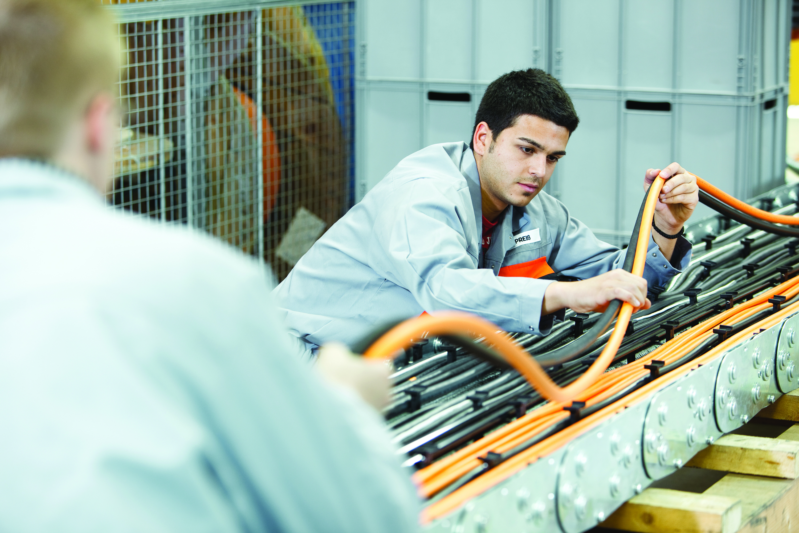
Under the new name of ÖLFLEX® CONNECT, Lapp is now extending its activities as a manufacturer of preassembled cables and bundling all global activities for customers, including consultation.

Find the image in printable quality here
www.lappkabel.com/press

About the Lapp Group:
Headquartered in Stuttgart, Germany, the Lapp Group is a leading supplier of integrated solutions and branded products in the field of cable and connection technology. The Group’s portfolio includes standard and highly flexible cables, industrial connectors and screw technology, customized system solutions, automation technology and robotics solutions for the intelligent factory of the future, as well as technical accessories. The Lapp Group’s core market is in the industrial machinery and plant engineering sector. Other key markets are in the food industry as well as the energy and the mobility sector.

The Lapp Group has remained in continuous family ownership since it was founded in 1959. In the 2013/14 business year, it generated consolidated revenue of 820 million euros. Lapp currently employs approximately 3,200 people across the world, has 18 production sites and over 40 sales companies. It also works in cooperation with around 100 foreign representatives.

