Dr Matthias Kirchherr appointed as Chief Sales Officer for Europe at U.I. Lapp GmbH
Lapp has a new European Chief Sales Officer

Stuttgart, May 8th, 2015
Since 1 April 2015, Dr Matthias Kirchherr (52) holds the position of Chief Sales Officer (CSO) for Sales and Marketing within U.I. Lapp GmbH. In this way, the Stuttgart-based family business is continuing to take strategic steps to strengthen its international sales activities. As the Chief Sales Officer of U.I. Lapp GmbH, Kirchherr is not only in charge of the geographical region of Europe, but also South America, Africa and the United Arab Emirates. Dr Matthias Kirchherr studied mechanical engineering and business administration and has previously been the Managing Director of several renowned international companies.

"With Mr Kirchherr, we have an extraordinary expert with a wealth of sales experience within mechanical and plant engineering. He is very familiar with the industry and knows how small and medium-sized companies think and behave. He will help to ensure that the family company has a steady course of growth", explains Andreas Lapp, Chairman of the Board of Lapp Holding AG.

Dr Matthias Kirchherr wants to establish new focal points within sales. "I can see great opportunities in the expansion of the solutions business. As ever, the product business remains our foundation, but we also need to work upon providing our customers with solution packages which give them added value. We want to accompany major customers who are expanding to other countries with our customised solution concepts." He also sees additional opportunities for growth in the development of new markets and industries.

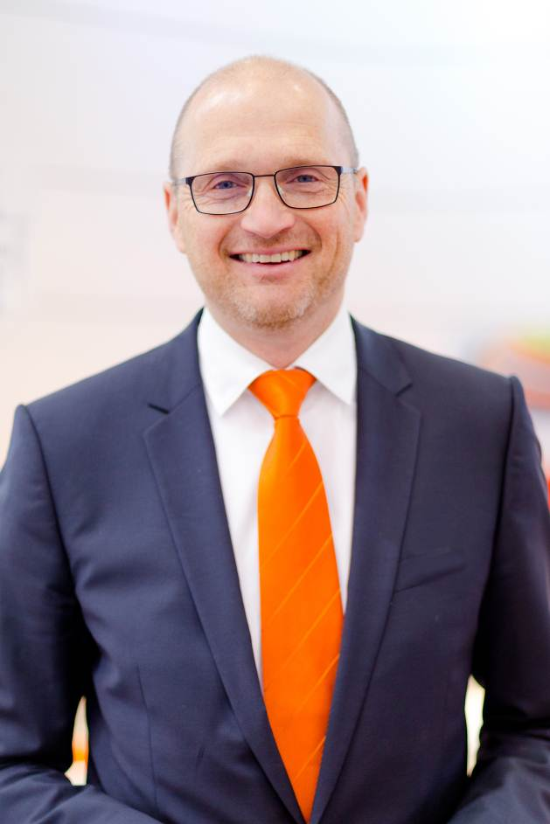
Dr Matthias Kirchherr has been appointed CSO of U.I. Lapp GmbH

Find the image in printable quality here
www.lappkabel.com/press

About the Lapp Group:
Headquartered in Stuttgart, Germany, the Lapp Group is a leading supplier of integrated solutions and branded products in the field of cable and connection technology. The Group’s portfolio includes standard and highly flexible cables, industrial connectors and screw technology, customized system solutions, automation technology and robotics solutions for the intelligent factory of the future, as well as technical accessories. The Lapp Group’s core market is in the industrial machinery and plant engineering sector. Other key markets are in the food industry as well as the energy and the mobility sector.

The Lapp Group has remained in continuous family ownership since it was founded in 1959. In the 2013/14 business year, it generated consolidated revenue of 820 million euros. Lapp currently employs approximately 3,200 people across the world, has 18 production sites and over 40 sales companies. It also works in cooperation with around 100 foreign representatives.

