Family firm shows its commitment to Stuttgart
Construction starts on Lapp’s new European headquarters

Stuttgart, Germany, 30 June 2015

Stuttgart-based Lapp Group is demonstrating its commitment to its home city by building Lapp’s new European headquarters at its premises in Vaihingen-Möhringen. The first stone was laid today, 30 June, at 11 a.m. “Today clearly marks the beginning of a new chapter in our company history. U.I. Lapp GmbH is a modern, dynamic company and we want to continue growing. The new headquarters will give us new opportunities to combine our strengths even more effectively,” explained Siegbert E Lapp, Chairman of the Supervisory Board at Lapp Holding AG.

The importance of the Lapp Group to Stuttgart, the local region and Baden-Württemberg as a whole was also underlined by the presence of several guests of honour and speakers at the event. They included Dr Nils Schmid, Deputy Minister President and Minister for Finance and Economics for Baden-Württemberg, Michael Föll, first mayor of the city of Stuttgart, and Thomas Bopp, Chairman of Stuttgart’s regional council.

“Family businesses like the Lapp Group are the backbone of the Baden-Württemberg economy. They are deeply rooted in the region, innovative, and successful worldwide. We’re lucky to have Lapp in this country,” said Dr Nils Schmid. Meanwhile, Michael Föll highlighted the firm’s significance to the city of Stuttgart: “Today is an important day for Stuttgart as a top business location. The Lapp Group is a key employer in Stuttgart and a great advertisement for our beautiful city. Their European headquarters will help secure the future of Stuttgart. And for that I’m very grateful.” Thomas Bopp was also full of praise for the company: “Lapp combines business success and innovation with the traditional values of a family business – including social and political involvement and a strong affiliation with their home in the Stuttgart region. By laying the first stone today, the Lapp family is providing a further boost to the region. It’s a foundation for a great future.”

As is customary, the Lapp family and their guests of honour inserted a time capsule into the natural stone foundation, in the presence of more than 100 guests. The copper box contained a selection of contemporary items, including building designs, a newspaper, some coins, a Lapp brochure and an ÖLFLEX® cable.

To make space for the new build, the Oskar Lapp Academy and its surrounding buildings were knocked down at the start of the year. The cleared area is now set to become home to the two wings that will form Lapp’s European headquarters – one wing with four floors, and another with six. A glass atrium will connect the two wings. The ground floor will be for general use, and will include the atrium, a large foyer, a reception, plus exhibition and conference space. The building’s floor space will total 8,340 square metres, and more than 400 employees are expected to work there.

“We’re completely on schedule with the construction work,” commented Petra Kimmerle, the head of Lapp Immobilien GmbH in charge of the project. In fact, work on the foundations is almost finished, and construction of the shell is set to start in the next few days. The building is expected to be completed by late 2016, at a total investment cost of around 20 million euros.

The new building – which has been designed by Stuttgart-based architects Schwarz Architekten – also meets the latest environmental standards. In fact, the requirements of the German Energy Savings Act have been surpassed by 20 per cent. The building will be heated and cooled using geothermal energy.

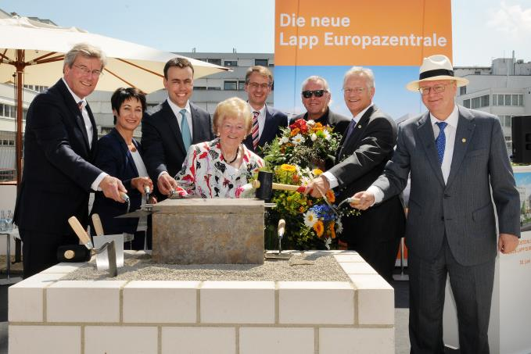
A solid base: the first stone for the new Lapp European headquarters has been laid. Thomas Bopp, Petra Kimmerle, Dr. Nils Schmid, Ursula Ida Lapp, Michael Föll, Werner Schwarz, Siegbert E. Lapp, Andreas Lapp (left to right)
Find the image in printable quality here
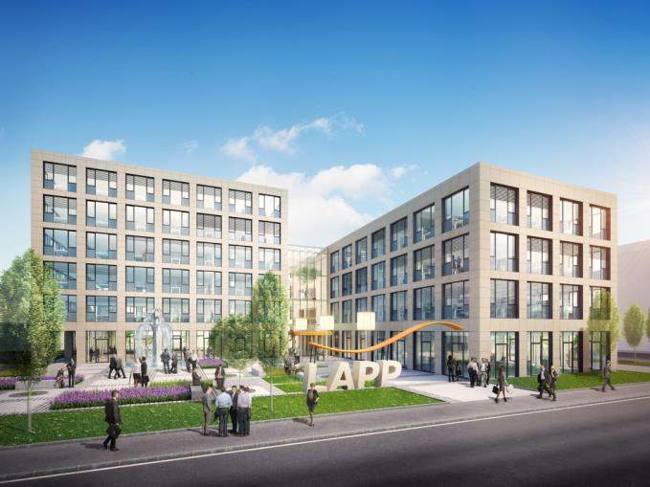
This is what the European headquarters will look like
Find the image in printable quality here
www.lappkabel.com/press

About the Lapp Group:
Headquartered in Stuttgart, Germany, the Lapp Group is a leading supplier of integrated solutions and branded products in the field of cable and connection technology. The Group’s portfolio includes standard and highly flexible cables, industrial connectors and screw technology, customized system solutions, automation technology and robotics solutions for the intelligent factory of the future, as well as technical accessories. The Lapp Group’s core market is in the industrial machinery and plant engineering sector. Other key markets are in the food industry as well as the energy and the mobility sector.

The Lapp Group has remained in continuous family ownership since it was founded in 1959. In the 2013/14 business year, it generated consolidated revenue of 820 million euros. Lapp currently employs approximately 3,200 people across the world, has 18 production sites and over 40 sales companies. It also works in cooperation with around 100 foreign representatives.

