Lapp extends its product range
Fibre optic cables for Profinet and angled connectors

Stuttgart, May 27, 2015

Lapp presented numerous new products at the Hanover Fair. With the HITRONIC® PROFINET fibre optic cable, the Stuttgart-based company has rounded off its product portfolio for the Profinet Industrial Ethernet system. Also new are the ETHERLINE® TRAY-ER, Ethernet cables specifically for the US market. With the EPIC® DATA 90 RJ45 Lapp has found an impressive solution for tight spaces in control cabinets. The new angled connector allows the cable outlet to be installed in four directions, without the need for special tools. New products in detail:

HITRONIC® fibre optic cables for Profinet applications
Lapp is extending its product range for Profinet applications with new HITRONIC® PROFINET fibre optic cables and matching connectors and assemblies. The cables cover two application classes: Type B for fixed installation or flexible use and Type C for continuous movement, for example in drag chains with vibration or torsion, complying with the specifications of the Profinet User Organisation. Alongside versions with a PUR sheath for high loads in industry, there are also versions with a PVC sheath for standard applications. This means that users only have to pay for features they really need. No matter which cable they choose, it is always compliant with the Profinet standard. The sheath is green, and inside the cable are two colour-coded single elements - one black and one orange, printed with black direction arrows. Users also have a choice of transmission medium. The cables are available with plastic fibre, glass fibre with plastic outer sheath or glass fibre. "With the HITRONIC® PROFINET we are rounding off our range and clearly positioning ourselves as a system provider for Profinet", says Jürgen Beck, product manager for fibre optic cables at Lapp. ETHERLINE® Profinet copper-based Profinet solutions have been well established in the market for some time.

EPIC® DATA 90 RJ45: Connected around corners
Things are tight in control cabinets. That's why installation engineers are increasingly demanding angled connectors for connecting Ethernet cables. Even greater flexibility can be achieved if the cable outlet can be rotated in 90 degree increments and easily changed. This is the key idea behind the EPIC® DATA 90 RJ45. The connector is made up of two parts, and the rear part can be fitted in four positions. "This means that we are effectively offering four connectors under a single item number", says product manager Thomas Plewnia. This ensures reliable network cabling even in very restricted spaces and avoids putting a strain on the bending radii of data network cables. With its metallised housing and assembly without the need for special tools, the angled EPIC® DATA 90 RJ45 is suitable for a wide range of applications in industrial and office environments. Cable strain relief using a cable gland with clamping ring allows cable diameters of 5.5 to 10 millimetres, with core cross-sections from AWG27 to AWG22. The angled EPIC® DATA 90 RJ45 is designed for transmission rates of up to 10 GBit/s. Just like the straight version, the angled connector meets the requirements for transmission category Cat.6_{A} and is also suitable for PoE+ in compliance with IEEE 802.3at.

ETHERLINE® TRAY-ER: Cables for cable conduits for the US market
We have all seen them in factories or underground car parks - cables suspended on conduits below the ceiling, sometimes installed without metal guards to the machine. These cables have to be exceptionally robust and resistant to fire and impacts, as there is no additional protection. In the USA, the NFPA and NEC standardisation bodies have set out the dedicated approval guideline PLTC-ER for cables of this type. The new ETHERLINE® TRAY-ER Ethernet cables from Lapp comply with these guidelines. Specially developed for the US market, they are available in five versions, including Industrial Ethernet and Profinet. ETHERLINE® TRAY-ER cables are based on standard products from Lapp but with slight modifications to the internal structure and the sheath.
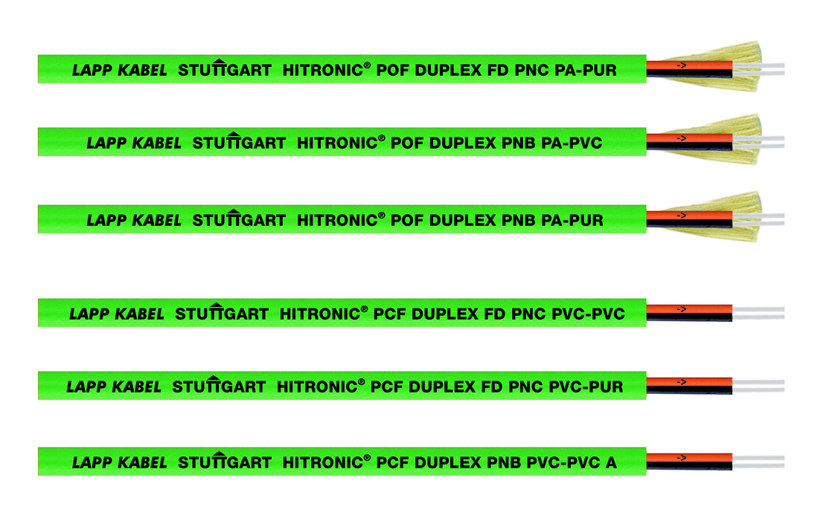
Lapp is extending its product range for Profinet applications with new HITRONIC® PROFINET fibre optic cables
Find the image in printable quality here
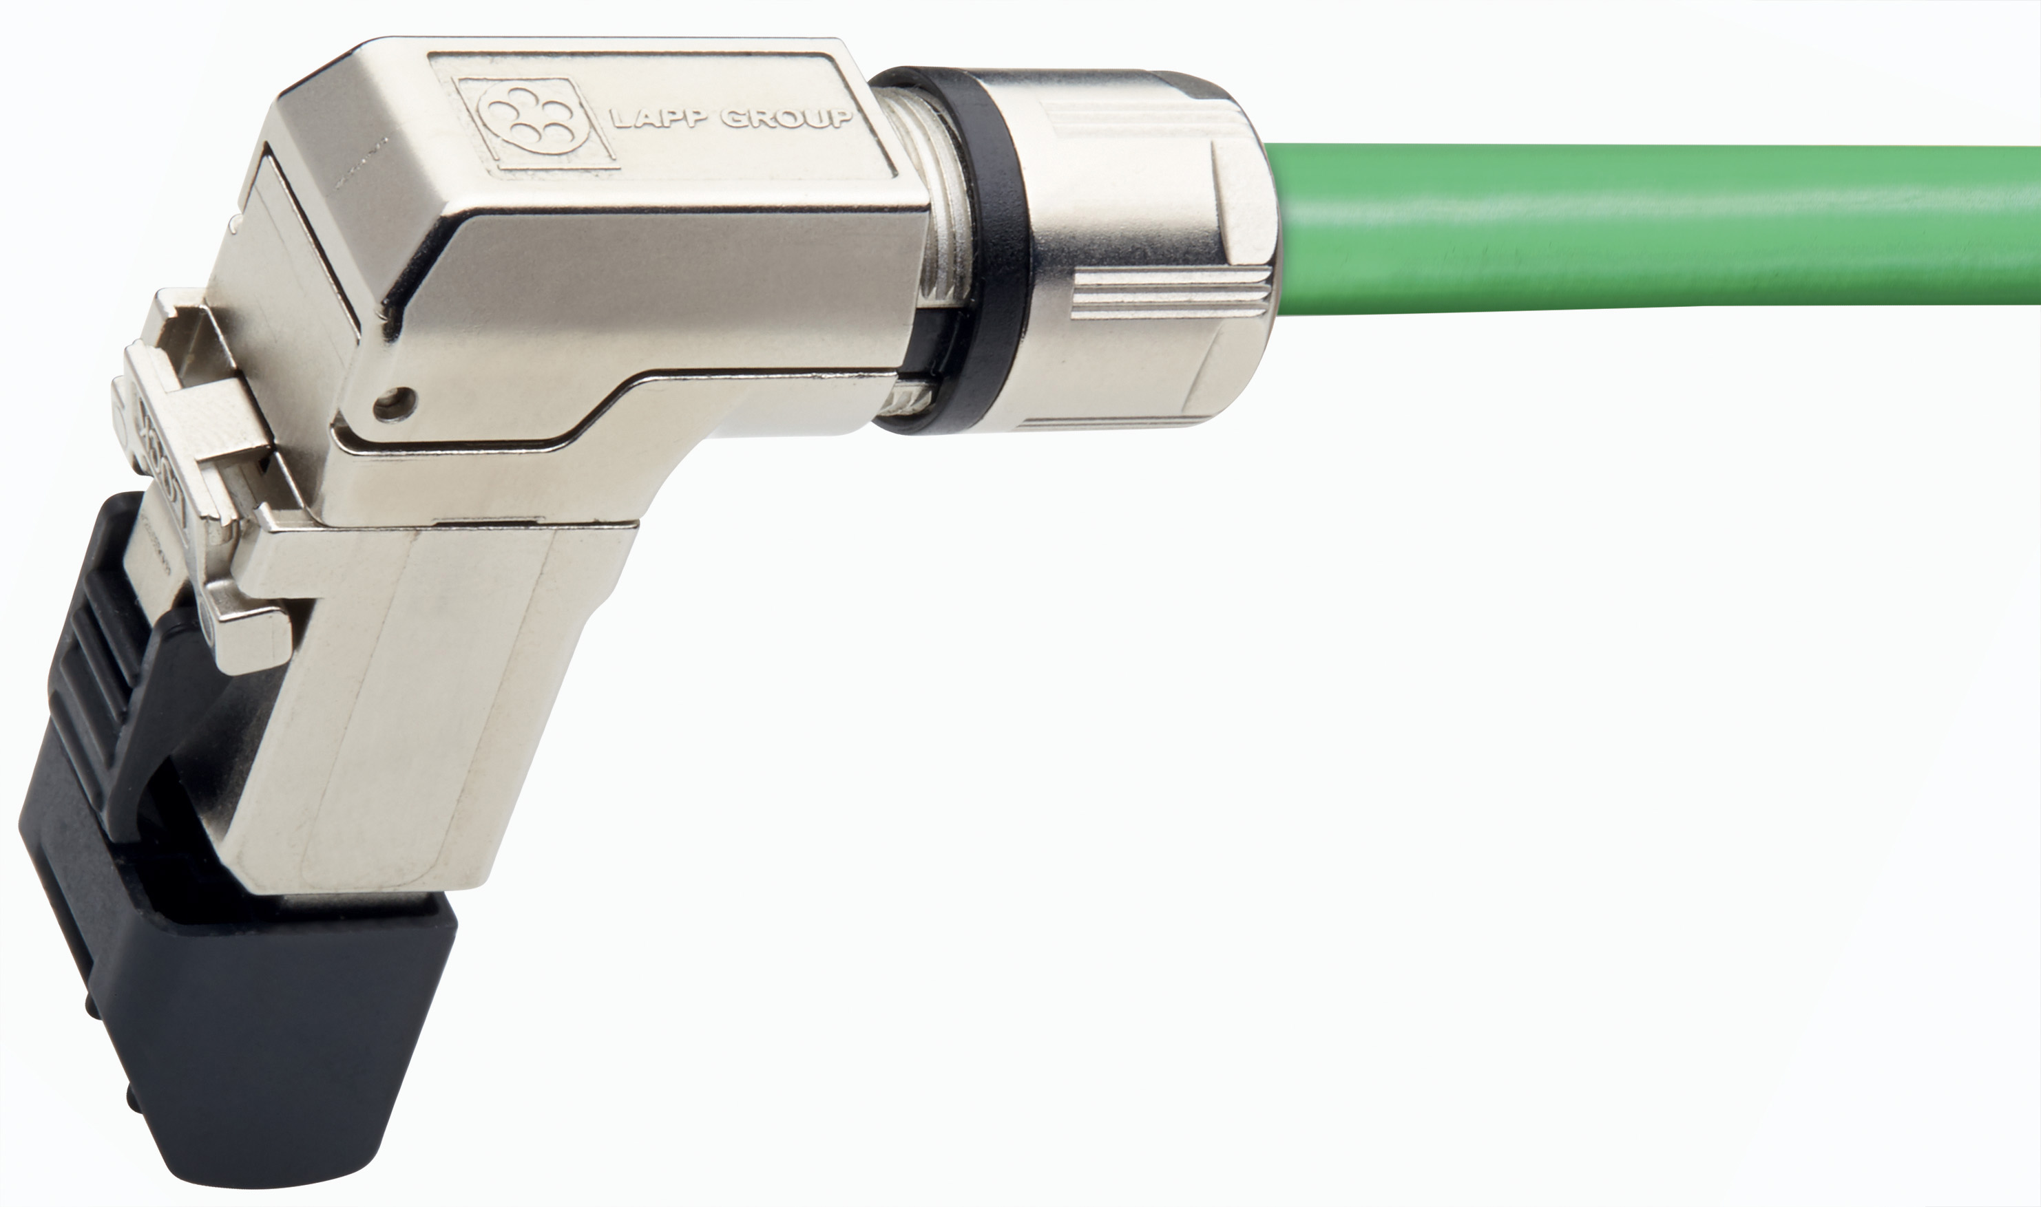
The angled connector EPIC® DATA 90 RJ45 is ideal for cramped spaces
Find the image in printable quality here
ETHERLINE® TRAY-ER comply with the American PLTC-ER guideline
Find the image in printable quality here

www.lappkabel.com/press

About the Lapp Group:
Headquartered in Stuttgart, Germany, the Lapp Group is a leading supplier of integrated solutions and branded products in the field of cable and connection technology. The Group’s portfolio includes standard and highly flexible cables, industrial connectors and screw technology, customized system solutions, automation technology and robotics solutions for the intelligent factory of the future, as well as technical accessories. The Lapp Group’s core market is in the industrial machinery and plant engineering sector. Other key markets are in the food industry as well as the energy and the mobility sector.

The Lapp Group has remained in continuous family ownership since it was founded in 1959. In the 2013/14 business year, it generated consolidated revenue of 820 million euros. Lapp currently employs approximately 3,200 people across the world, has 18 production sites and over 40 sales companies. It also works in cooperation with around 100 foreign representatives.

