Lapp Group presents research module for the intelligent factory of tomorrow

From vision to reality

Stuttgart, 7 April 2014
"Plug & Produce" – the motto of tomorrow's industrial production. The SmartFactory^{KL} research project at the German Research Center for Artificial Intelligence (DFKI) was presented at this year's Hannover Messe trade fair, demonstrating that this production model can already work today. The Lapp Group developed and adapted the entire research factory's connection technology, which was required to make the vision of Industry 4.0 a reality. The Lapp Group is also responsible for the "Quality and order picking" module, which impressively demonstrates how industrial Ethernet allows all modern production levels to communicate with each other.

With the SmartFactory^{KL}, the DFKI and around a dozen renowned industrial partners and sector heavyweights were able for the first time to implement a complete production line as part of which the individual modules from various manufacturers using a host of different control architectures work together smoothly. Digital product memories allow the fully automated production facility to manage locally controlled processes and produce different product variants, according to the needs of the individual customer. Individual production modules automatically detect the plant topology so that it can be enhanced or converted during operation and once again prepared for operation within minutes. As a result, production becomes highly flexible and efficient production with a batch size of 1 is on the verge of becoming a reality.

The intelligent infrastructure created also goes beyond manufacturer and system limits. When designing the plant, the DFKI consciously applied only a small number of standards to avoid any dependency on proprietary systems. It is this that makes modular production on the basis of individual, variable configurations a possibility in the first place.

The Lapp module is tasked with final product inspections and order picking. Using the production of a business card holder, Lapp was able to demonstrate that a consistent use of industrial Ethernet as the communication medium, and therefore linking the ERP level with individual sensors and actuators, is already a possibility today. As a result, quality control is implemented using a high-resolution camera that is compatible with Ethernet, and an intelligent, electrically powered gripper sorts the parts and dispenses the finished products to visitors. This requires Ethernet cables that are capable of transferring energy and can transmit large amounts of data as well as withstand the specific stresses of industrial environments.

The Lapp Group is already able to provide complete connection solutions for such applications, for instance the highly flexible ETHERLINE® FD Cat.6_{A} cable combined with the X-coded M12 data connector for high-resolution cameras in moving applications. The robust and easy-to-connect EPIC® Data M12 Ethernet connectors are perfect for using Ethernet outside the control cabinet. The control technology is linked using the PROFINET Industrial Ethernet system.

"Future production facilities will be made up of plug and play modules," said Prof. Detlef Zühlke, scientific director at the DFKI, summing up the phenomenon of Industry 4.0. "Communication will play an increasing role in industrial production processes, and it will be more widely used in field devices and particularly in sensors and actuators. This requires innovative solutions in multifunctional connection technology, similar to the type presented by the Lapp Group for the SmartFactory^{KL}."

"For Lapp as a provider of cabling and connection system solutions for industrial automation technology, it is vital that we understand the environment in which our products are used, both today and in the future," said Ralf Moebus, head of Automation & Networks at U.I. Lapp GmbH on the motive for participating in the research project. "The SmartFactory^{KL} demonstrates the opportunities resulting from the use of modern information technology in production environments to users," he continued. Today, Lapp already provides complete solutions for all connections in the intelligent factory of tomorrow: communication, supply and sensor connections − from a single source.

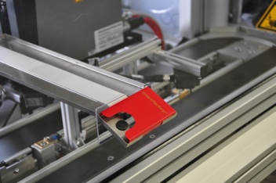
The SmartFactory^{KL} research project was presented for the first time at Hannover Messe
Find the image in printable quality here

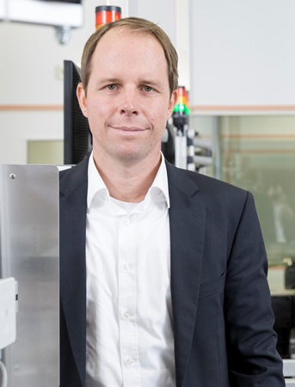
Ralf Moebus, head of Automation & Networks at U.I. Lapp GmbH

Find the image in printable quality here
www.lappkabel.com/press

About the Lapp Group:
Headquartered in Stuttgart, Germany, Germany, the Lapp Group is a leading supplier of integrated solutions and branded products in the field of cable and connection technology. The Group's portfolio includes standard and highly flexible cables, industrial connectors and screw technology, customised system solutions, automation technology and robotics solutions for the intelligent factory of the future, as well as technical accessories. The Lapp Group’s core market is in the industrial machinery and plant engineering sector. Other key markets are in the food industry as well as the energy and the mobility sector.

The Lapp Group has remained in continuous family ownership since it was founded in 1959. In the 2012/13 business year, it generated a consolidated turnover of 830 million euros. Lapp currently employs approximately 3,200 people across the world, has 18 production sites and over 40 sales companies. It also works in cooperation with around 100 foreign representatives.

