Lapp Group showcases new connectors, junction boxes and cables for solar systems at Intersolar 2014
For the right connection in the solar industry

Stuttgart, 04 June 2014
Once again, visitors at this year's Intersolar trade fair can expect to be introduced to numerous new products from the solar industry. Components from Lapp Group ensure the right connection for the new systems. The company is expanding its range for the solar market and will present two new cables from the ÖLFLEX SOLAR series, a new PV connector for systems with 1.5 kV operating voltage as well as connectors for use in inverters, string boxes and circuit breakers. The product highlight at Lapp's trade fair stand is the new, extremely compact EPIC® SOLAR MAP Easy junction box for crystalline modules.

"The Lapp product portfolio for the solar industry continues to grow, because we believe that solar energy will make a valuable contribution towards the future energy mix – and this will come about in part thanks to high-quality technical components and innovations from Germany", states Michael Collet, Managing Director of Innovation at U.I. Lapp GmbH.

EPIC® SOLAR MAP Easy is the name of the new, particularly compact, economical and automatically mountable junction box for crystalline photovoltaic modules with three cell strings. The new clinching connection system allows different materials to be fitted together quickly and easily. There is no requirement for heat as there is with welding or soldering, and no other additional materials such as welding wire, solder or flux agents are needed. The layer of tin on the ribbons remains undamaged, therefore providing permanent corrosion protection.

The new junction box occupies a mere third of the space required by comparable solutions. This means that significant cost savings can be achieved for transport and storage. At the same time, the compact size offers a design advantage which is particularly advantageous for double glass modules.

The EPIC® SOLAR MAP Easy also impresses with its very low contact resistance which remains constant for years. It has also been possible to increase the sealing tightness as measured against comparable solutions. Firstly, the compact size means that no membranes are needed for pressure compensation. Secondly, the cable entry with permanently consistent contact pressure on the seal ensures long-term and constant sealing tightness. Pre-assembled stainless-steel retaining clips guarantee a durable and stable cable strain relief.

With the EPIC® SOLAR 4PLUS PV connector for new, modern PV systems with 1.5 kV operating voltage, Lapp achieves 50% more power than conventional systems designed with a maximum output voltage of 1 kV. The solution is designed for the common pin connection based on 4 mm contacts. The connector is suitable for cross sections of 2.5 mm² for thin-film modules and up to 10 mm² for large free-standing systems. In accordance with the American NEC 2011 Standards, the connectors can only be removed with a tool. The cable is connected via a durable crimp connection. High-quality silver contacts with socket contact springs ensure low contact resistance. The TÜV and UL certifications for the new connector are currently being prepared.
Lapp also introduces two further solutions for the PV wiring system: PV splitters for the input and output for the parallel connection of strings and modules as well as new EPIC® SOLAR connectors for connecting PV systems to inverters or PV circuit breakers.

New products from ÖLFLEX® SOLAR
The ÖLFLEX® SOLAR XLR WP is the cable alternative for those applications where cables may be exposed to water for prolonged periods, for example after flooding and in protective conduits underground. The cable is therefore particularly suitable for underground installations in protective conduits where water, heat and moisture can accumulate. It impresses with the proven electron beam cross-linked quality of the ÖLFLEX® SOLAR series. A certification for the TÜV type PV1-F in accordance with 2 Pfg 1169/08.2007 is expected shortly.

The ÖLFLEX® SOLAR XLR 1.5 kV complements the ÖLFLEX® SOLAR portfolio based on the TÜV specification 2 Pfg 1990/05.12. The new cable is therefore suitable for PV systems with an operating voltage of 1,500V DC. The electron beam cross-linked quality of the cable series is guaranteed here, too. A certification for the TÜV type PV1500DC-F in accordance with 2 Pfg 1990/05.12 is expected shortly.
Visitors to the Intersolar trade fair will have the opportunity to experience the new solutions live and chat to the team at the Lapp Group stand (no. 238) in hall A3.

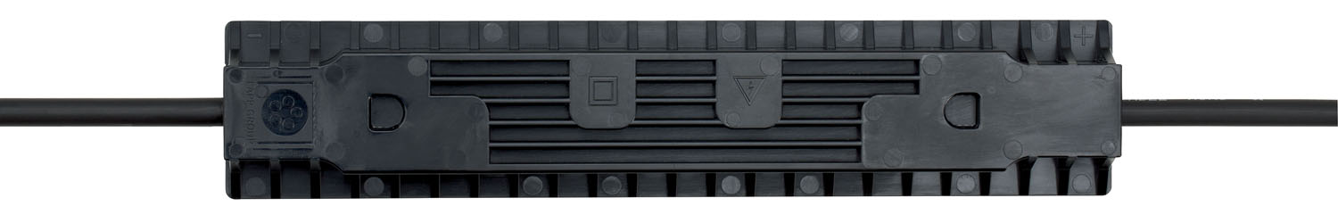
The new junction box EPIC® SOLAR MAP Easy is particularly compact, economical and automatically mountable

Find the image in printable quality here
www.lappkabel.com/press

About the Lapp Group:
Headquartered in Stuttgart, Germany, Germany, the Lapp Group is a leading supplier of integrated solutions and branded products in the field of cable and connection technology. The Group's portfolio includes standard and highly flexible cables, industrial connectors and screw technology, customised system solutions, automation technology and robotics solutions for the intelligent factory of the future, as well as technical accessories. The Lapp Group’s core market is in the industrial machinery and plant engineering sector. Other key markets are in the food industry as well as the energy and the mobility sector.

The Lapp Group has remained in continuous family ownership since it was founded in 1959. In the 2012/13 business year, it generated a consolidated turnover of 830 million euros. Lapp currently employs approximately 3,200 people across the world, has 18 production sites and over 40 sales companies. It also works in cooperation with around 100 foreign representatives.

