Lapp Group's Swiss injection moulding plant celebrates 25th anniversary and reveals big plans
Lapp Kabel AG racing ahead

Stuttgart/Diessenhofen, July 08th 2014

The Lapp Group's injection moulding plant based in Diessenhofen, Switzerland, celebrated its 25th anniversary on Friday, June 27th 2014. The production site's successful history was honoured at a special event attended by members of the Lapp family, numerous customers, neighbours and employees. "Our injection moulding plant in Diessenhofen is inextricably linked with the global success of the Lapp Group. As a supplier of integrated solutions and branded products in the cable and connection technology sector, injection moulding technology is absolutely essential to our portfolio", said Andreas Lapp, Chairman of the Board of Lapp Holding AG. Board Member Siegbert E. Lapp added: "Our employees' expertise and passion for this technology are the engine that drives our innovations in this area."

Lapp Kabel AG was founded on 28th June 1989 in Schaffhausen and moved into its own premises in Diessenhofen in 1998. The building was significantly extended in 2011. It now has a production area of 1,600 square metres, with more than 20 injection moulding machines and various assembly systems. Every year, 175 million plastic parts and 75 million finished products are manufactured there. The EPIC® and SKINTOP® range is made up of over 800 different cable glands, electrical connector components, connectors, cables and electrical accessories. To produce them, several hundred tons of polyamide and polycarbonate granulate are processed each year. A total of 36 employees keep things running smoothly at the site, which now has a turnover of around 10 million Francs. This year, Lapp Kabel AG has its first ever apprentice specialising in plastics technology.

Lapp Kabel AG is heading for a repositioning and focusing of its services outside the Lapp Group. In future, the Lapp Group production site will also be offering its expertise in development and production of technical plastic products to other customers. Its strengths are based on 25 years of know-how in plastics technology and on its position in the Lapp Group's global network, particularly in research and development. Lapp Kabel AG specialises in plastics technology and services, from product development through to fully assembled products. Production capacities are currently being increased and modernised. The aim is to increase the level of automation and to build up additional design and development capacity. As part of the repositioning, the number of employees will also be increased.

At the same time, Lapp Kabel AG is involved in various community initiatives. These include a partnership with "altra Schaffhausen", which sees people with physical or psychological impairments being employed in assembly of plastic components. This involvement is being continuously expanded.

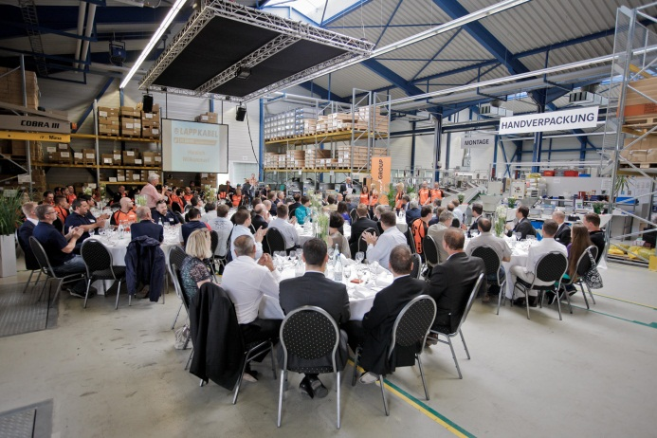
Lapp Kabel AG held its 25th anniversary celebrations in Diessenhofen, Switzerland, attended by Lapp family members, along with customers, neighbours and employees.
Find the image in printable quality here

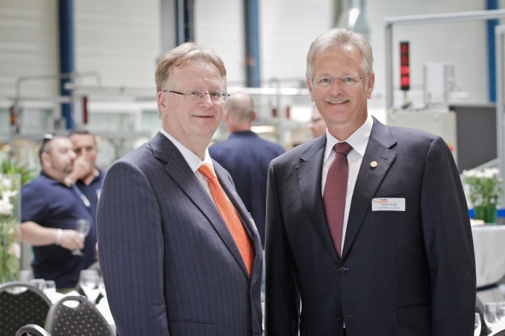
Andreas and Siegbert Lapp emphasised the production site's importance for the global success of the Lapp Group.
Find the image in printable quality here
www.lappkabel.com/press

About the Lapp Group:
Headquartered in Stuttgart, Germany, Germany, the Lapp Group is a leading supplier of integrated solutions and branded products in the field of cable and connection technology. The Group's portfolio includes standard and highly flexible cables, industrial connectors and screw technology, customised system solutions, automation technology and robotics solutions for the intelligent factory of the future, as well as technical accessories. The Lapp Group’s core market is in the industrial machinery and plant engineering sector. Other key markets are in the food industry as well as the energy and the mobility sector.

The Lapp Group has remained in continuous family ownership since it was founded in 1959. In the 2012/13 business year, it generated a consolidated turnover of 830 million euros. Lapp currently employs approximately 3,200 people across the world, has 18 production sites and over 40 sales companies. It also works in cooperation with around 100 foreign representatives.

